**Smokey the Slug: Autonomous Wildfire Detection**

UC Santa Cruz SDP 2018-19

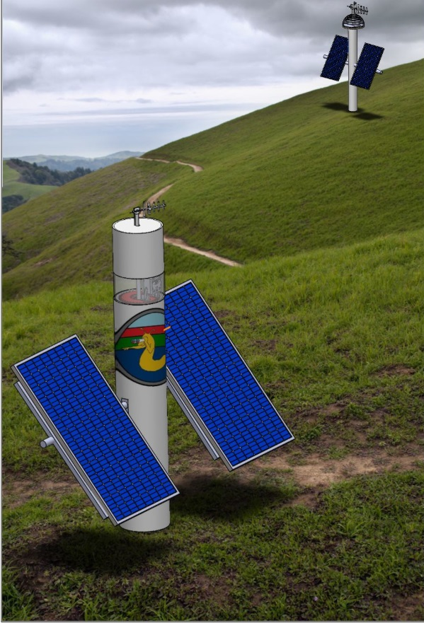

|  |  |  |
| --- | --- | --- |
| **Michaela Arellano** | **Colin Boblet** | **Andrew Calvo** |
| **Calvin Loi** | **Sean McHale** | **Quang Nguyen** |
| **Yizhang Qu** | **Jonathan Riley** | **Steven Thao** |

## 

**Chapter 1: Introduction** **6**

1.2 Stakeholder Analysis 8

1.2.1 Firefighters 9

1.2.2 Law Enforcement 9

1.2.3 Forestry Management 9

1.2.4 Homeowners & Business Owners 9

1.2.5 Public Municipalities 9

1.2.6 Potential Competitors and Sponsors 9

1.2.7 Home Insurers & Auto Insurers 9

1.2.8 Utility Companies 9

1.3 Definition of design Constraints and Challenges 9

**Chapter 2: System Overview** **12**

2.1 Solution Introduction 12

2.2 Detection System 13

2.3 Communications System 16

2.4 Power System 17

2.5 Mechanical Components 19

**Chapter 3: Detection Subsystem** **21**

3.1 Subsystem Overview 21

3.2 Detection Background 22

3.2.1 Fire Characteristics 22

3.2.2 Candidate Detection Designs 25

3.3 Hardware Overview 26

3.3.1 RGB Camera Module for Raspberry Pi 27

3.3.2 - ISL29125 Ambient RGB Brightness Sensor 31

3.3.3 FLIR Lepton 2.5 Longwave Infrared Thermal Camera 32

3.3.4 3D Printed PLA Camera Housing 33

3.3.5 3D Printed PETG Drive & Load Gears 34

3.3.6 NEMA23 Programmable Stepper Motor 35

3.3.7 Raspberry Pi Microcontroller 36

3.4 Software Description 37

3.4.1 Sampling Finite State Machine 37

3.4.2 Supporting Software 38

3.4.3 Brightness Thresholding Algorithm 39

3.4.4 Color Saturation Thresholding Algorithm 40

3.4.5 Thermal Thresholding 43

3.4.6 False positive suppression algorithm 44

**Chapter 4: Communication Subsystem** **45**

4.1 Introduction 45

4.2 Strategy for Implementation 45

4.3 Link Budget Analysis 46

4.4 System Topology 47

4.4.1 Overview 47

4.4.2 Detection Nodes 47

4.4.3 Range Extenders 48

4.4.4 End User 48

4.5 Selection of Hardware 48

4.5.1 Overview of Core Components 48

4.5.2 Short Range Communications 49

4.5.3 Long Range Communications 49

4.5.4 End User Display 50

4.5.5 Antenna 51

4.6 Software Discussion 54

4.6.1 Overview 54

4.6.2 The Network Protocol 54

4.6.3 Detection Nodes 57

4.6.4 Repeaters 58

4.6.5 End User 58

4.6.6 LCD Display 59

**Chapter 5: Power Subsystem** **62**

5.1 Introduction 62

5.2 Power Budget 62

5.3 System Overview 64

5.3.1 Selection of Photovoltaics 64

5.3.2 Selection of Lithium Titanate Oxide Battery 65

5.3.3 Battery Management System 68

5.3.4 Switching Converter for Power Delivery 72

5.3.5 System Level Solution 72

5.4 Hardware Description 73

5.4.1 Solar Panels and Charge Control 73

5.4.2 Battery Pack 77

5.4.3 BMS Hardware 79

5.4.3.1 Uno Microcontroller 79

5.4.3.2 Battery Monitoring IC 80

5.4.3.3 Temperature Sensors 87

5.4.3.4 Hall Effect Current Sensor Coulomb Counter 88

5.4.4 Power Delivery (Buck Converter and FET Cutoff) 89

5.5 Software Description 91

5.5.1 High Level Functionality 91

5.5.2 BMS 92

5.5.2.1 LTC6810-1 Firmware and SPI Communication 92

5.5.2.2 Coulomb Counting and SOC estimation 93

5.5.2.4 Power Modes of Operation and FET Cutoff Control 94

**Chapter 6: Mechanical Subsystem** **96**

6.1 Housing 96

6.1.1 SSDS 97

6.1.2 Repeater 98

6.1.3 End User 99

6.2 Mounting 100

6.2.1 Solar Panel 100

6.2.2 Rotating Rig 101

6.2.3 Battery 101

6.3 Rotating Rig and Camera Functionality  102

6.3.1 Rotation System Overview 102

6.3.2 Rotating Rig 103

6.3.3 Software Discussion of Stepper Motor 105

**Chapter 7: Results** **107**

7.1 Detection Range 107

7.2 Detection Accuracy 108

7.3 Communication Range 108

7.4 Communication Software Protocol implementation 108

7.5 Power System Capability 108

7.6 Mechanical System 109

**Chapter 8: Continuation Work** **110**

8.1 Detection Continuation 110

8.1.1 Thermal Camera Resolution 110

8.1.2 Thermal Camera Wavelength 110

8.1.3 Testing Procedures 110

8.1.4 C Code Implementation 111

8.1.5 Actuated Camera Window 111

8.2 Communications Continuation 111

Overview 111

8.2.1 Antenna Development 112

8.2.2 Software Development 112

8.2.3 Hardware Development 113

8.2.4 FCC License Obtainment 113

8.3 Power Continuation 113

8.3.1 Reducing Power Consumption 113

8.3.2 Completion of BMS Software and Implementation of Fault Analysis 114

8.3.3 Charge Controller Design 114

8.4 Mechanical Continuation 115

Overview 115

8.4.1 Redesigning Probes 115

8.4.2 Battery Pack Development 115

8.4.3 Probe Testing 116

**Chapter 9: Conclusion** **117**

**Annotated Bibliography** **118**

# Chapter 1: Introduction

Several high profile wildfires have taken place recently in the state of California, drawing national news attention. During this coverage the media focused on statistics of the fire’s destruction as well as the political fallout of the events, at the expense of information about how the fires started and spread so quickly. Common causes of major wildfires are lightning strikes, out of control intentional backfires, transmission line arcing and a variety of other man made causes [9]. Once a fire has ignited it will spread quickly, especially under conducive atmospheric and weather conditions. High temperatures, limited recent rainfall, a lack of humidity in the air, and high wind conditions are all worrying contextual factors when it comes to assessing any given fire’s ability to spread[9]. Unfortunately, all of these conditions are becoming more frequent with the effects of global climate change. This trend is clearly exemplified in data published by CAL FIRE, the government organization tasked with fire response and forest management [7]. The data table pictured below, published is a clear trend toward larger and more destructive wildfires over time:



***Figure 1.1*** *A chart of the 20 fires with the greatest damage tolls in California state history. Note: this chart is contemporary to the Woolsey and Camp fires, which were extinguished by the end of November, 2018.*

Inspection of the chart in Figure 1.1 indicates that the majority of the most destructive fires in the history of the state have take place within the last decade and a half or so. In particular, the Camp Fire has emerged as the most destructive fire in California history. A satellite image of the Camp Fire taken at its peak can be seen in Figure 1.2.

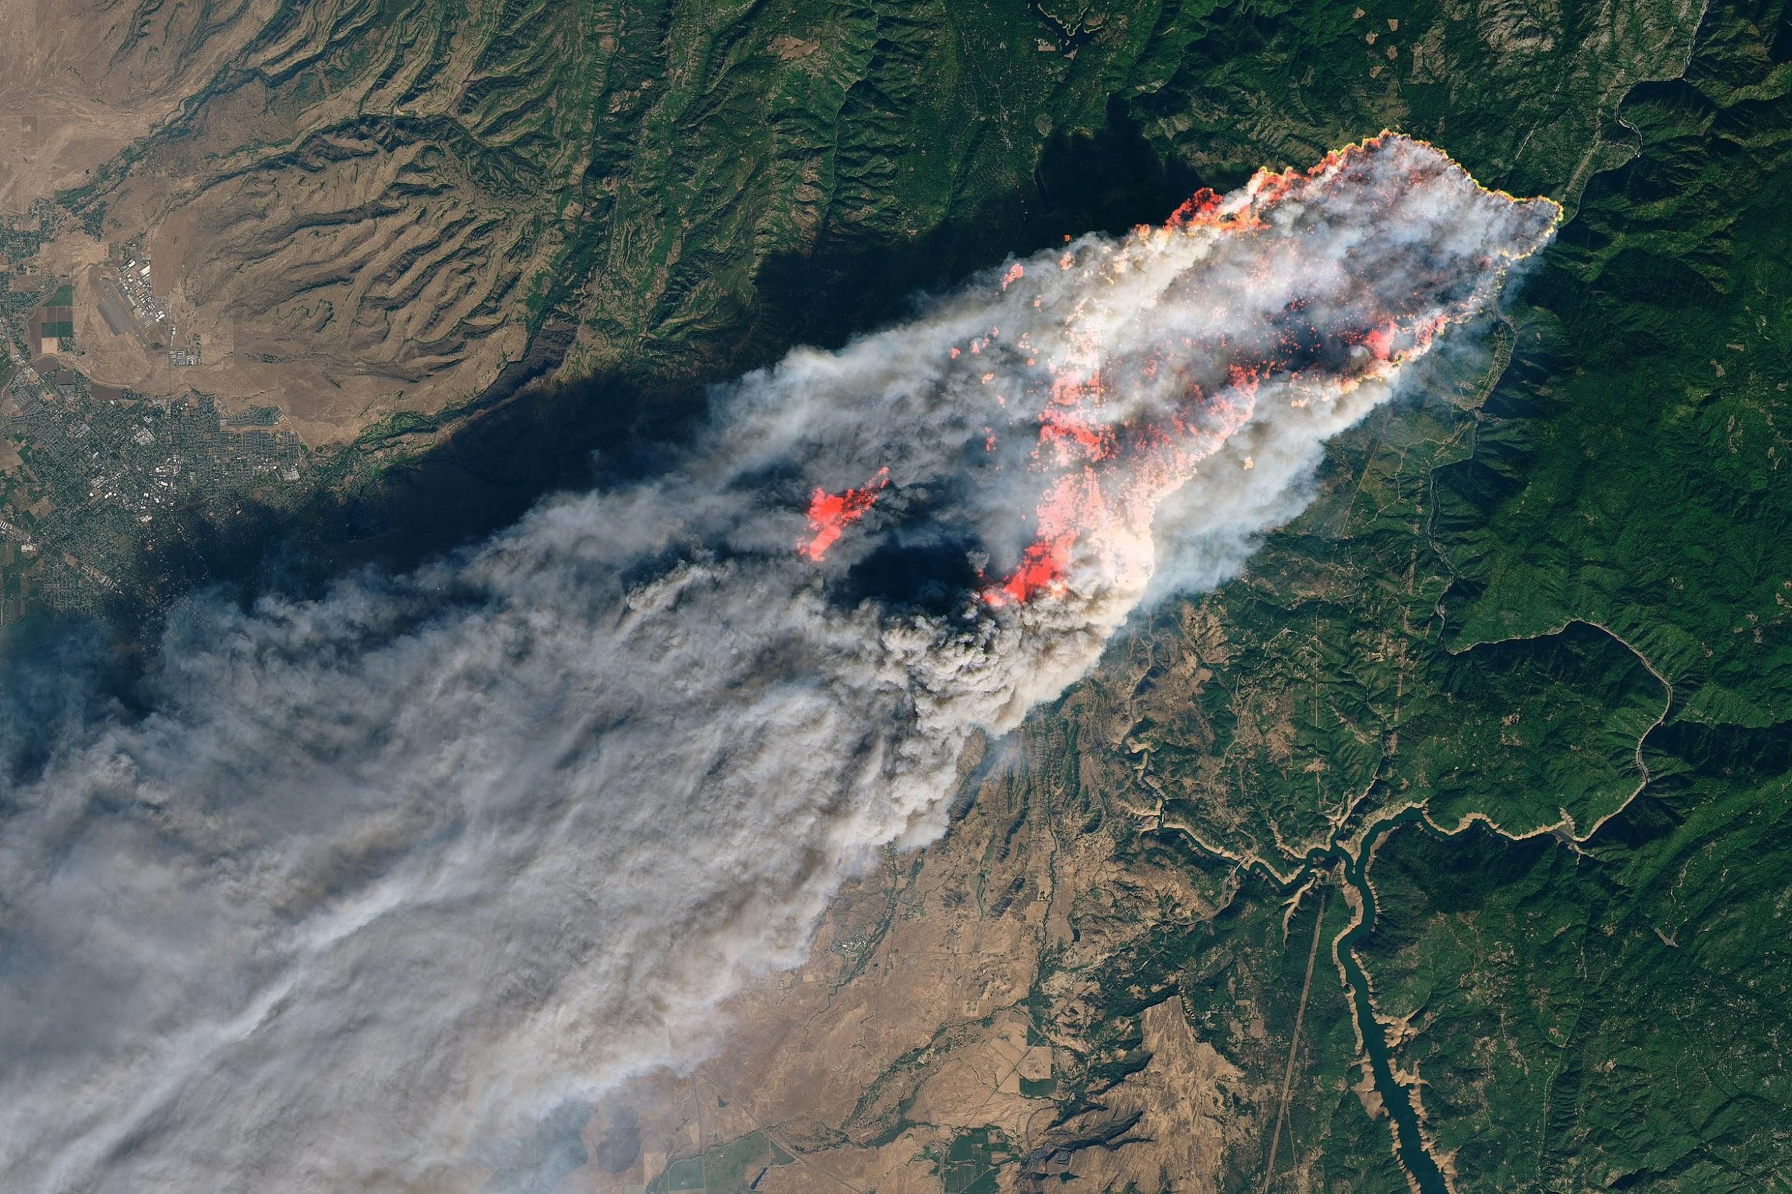

***Figure 1.2*** *A satellite image of the Camp Fire, courtesy of NASA.*

Even though fires have become more destructive, they are by no means a new problem for the state of California or neighboring regions. In the past entities tasked with the monitoring of fire conditions have relied on a combination of lookout towers strategically placed for maximum visibility and aircraft reconnaissance [9]. These methods have the drawbacks of having to compensate a human to monitor the region in question, and in the case of aircraft have the added expenses of fuel and a larger toll on the environment. This also includes the risk of human error leading to a catastrophic outcome that would otherwise be avoidable.

Autonomous designs have also been attempted before. Our team also took note of several competing designs discovered during our research process. Two specific designs piqued the interest of our group, each with radically different interpretations. The first is a design developed by a company called Vigilys, located in southern California. It utilizes spectral resonance imaging (SRI) as a detection method and stores power generated by a solar array on supercapacitors [21]. The second design we discovered was developed by a company called Insight Robotics. It uses a method for fire detection that is much more reminiscent of the one devised by our team, but their website provided sparse detail as to how the company generates power for these devices [11]. We will work collaboratively as a team to improve on what we believe are shortcomings in both the existing designs to create an objectively superior product with better marketability.

With the frequency and severity of wildfires on the rise as a result of global climate change, their impacts on surrounding communities have worsened steadily over the past several years. Many of the most damaging fires originated in rural and sparsely populated regions, allowing them to grow to unmanageable sizes before emergency personnel were able to identify them and respond to the situation. By devising a mechanism to quickly detect and accurately locate worrying fires soon after ignition, Smokey the Slug Detection System (SSDS) can expedite the response process by wirelessly communicating alerts to emergency crews.This would allow them to more effectively contain developing fires, thereby mitigating their destructive potential.

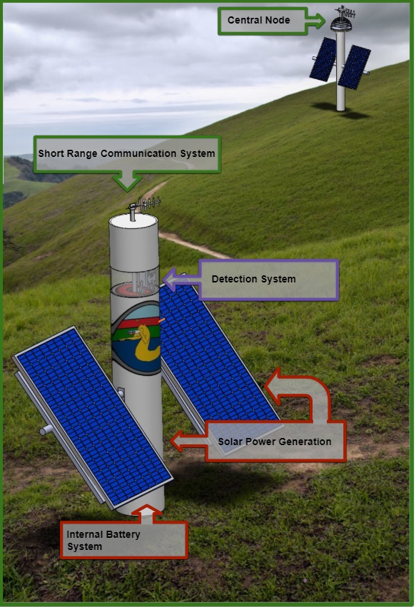

***Figure 1.3*** *A computer rendering of the concept design for Smokey the Slug Detection System.*

## 1.2 Stakeholder Analysis

Severe wildfires are clearly a significant problem that have had indiscriminately negative effects on entire communities, regardless of socioeconomic status. Additionally, there are entire segments of the national, state and local economies dedicated to managing environmental factors and assisting the emergency response process should it become necessary. The potential property damage threat of a major fire also worries insurers, who are undoubtedly interested in reducing their financial commitments to their clients in the form of insurance claims.

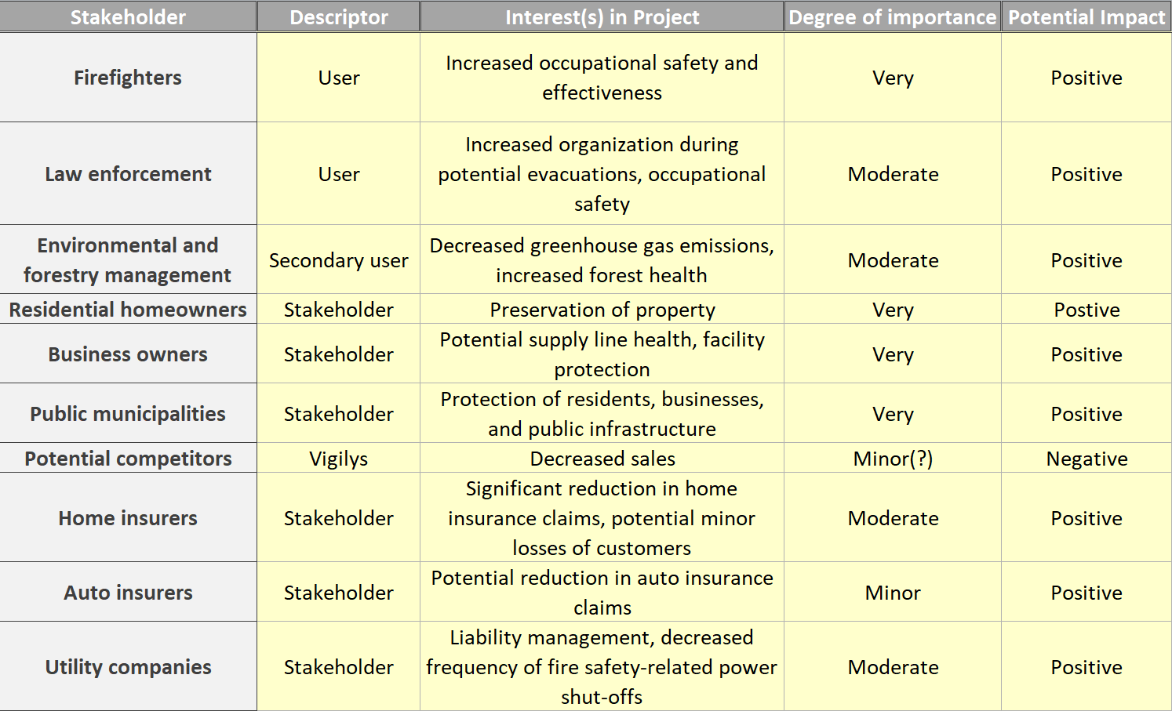

***Figure 1.4*** *Stakeholder analysis matrix.*

### 1.2.1 Firefighters

Firefighters are the most direct stakeholder in this project, as early fire detection means firefighters can deal with a fire before it becomes dangerous. Ideally we want our network of probes communicating directly with a local fire department.

### 1.2.2 Law Enforcement

This detection system would allow law enforcement to organize earlier evacuations in areas close to the ignition of the fire.

### 1.2.3 Forestry Management

Some fires are good for forest health, but catastrophic wildfires destroy forest ecosystems. Forest management would want our product to reduce catastrophic wildfires in order to maintain a healthier forest.

### 1.2.4 Homeowners & Business Owners

Our product would benefit homeowners and business owners by giving them earlier, more accurate information that could be used to evacuate safely with more of their property. Additionally, the early detection of wildfires would reduce the overall danger of an out of control wildfire spreading to inhabited areas.

### 1.2.5 Public Municipalities

Municipalities would be interested in this design for its use in protecting public infrastructure and issuing evacuations.

### 1.2.6 Potential Competitors and Sponsors

The only system currently like this was designed by a company called Vigilys. If our product is able to out compete theirs, they would be negatively impacted.

### 1.2.7 Home Insurers & Auto Insurers

Insurance companies would greatly benefit from the reduction of catastrophic fires due to our project. Fewer homes and cars burning leads to fewer insurance claims.

### 1.2.8 Utility Companies

Utility companies would be interested in our product for protecting their infrastructure. Utilities would also benefit from reduced power shut-offs due to wildfires. Moreover, several wildfires have been started by power lines; a system that could detect those ignitions could help reduce the liability of power companies.

## 1.3 Definition of design Constraints and Challenges

The various stakeholders of our project can be categorized into two broad classifications: users and beneficiaries. Expected users include firefighters, police and other law enforcement, and forestry management entities. These different first responders, along with beneficiary community members such as home and business owners, public municipalities, and various insurers stand to directly benefit from the implementation of our project. The desired deliverables of the beneficiaries are straightforward: they want to feel a sense of personal safety and security for their property investments. As the financially responsible parties, local home and business owners will want these reassurances in exchange for a reasonable system price tag.

In order to achieve peace of mind in fire prone communities, it will be paramount that our product reliably detect fires in a timely manner. Accomplishing this will undoubtedly shorten the emergency response process, which could save lives as well as prevent astronomic property damage. In the context of our detection mechanism, this boils down to two technical requirements. First, any probe we produce will have to have the capability to identify a fire at long range. A large effective range will grant emergency responders a head start on the response process, increasing the likelihood that nearby communities will require evacuation. This in turn corresponds to an improvement in public anxiety regarding fire risk. Secondly, our detector must be very resistant to false positive and false negative alarms. Inaccurate flame detection capability, either one that unnecessarily initiates an emergency response or one that misses a detection altogether, will be unacceptable to our clients and beneficiaries alike.

Once alerts are generated by the detection system, it is up to the communication system to relay these alerts to the appropriate party. This task presents some challenges and constraints due to the nature of the system. First and foremost, the communication of alerts must be wireless. A wired communication system is unreasonable and compromises the safety of the system. Secondly, the system must operate on unlicensed spectra to avoid the need to obtain a license which is a lengthy and expensive process. In addition to this, the wireless signals should be discernable at least twice as far as the detection system is capable of detecting to avoid bottlenecking the system. The system must not drop fire alerts being wirelessly communicated. Furthermore, the communication system must draw a low amount of power to avoid draining the solar power at night or in cloudy weather.

The problem of detecting and suppressing wildfires, specifically in remote areas with strong treelines, results in a set of engineering constraints and challenges specific to the design of a mechanical and power system. These constraints and challenges are generated by the location of the system, the cost of the system, and the power consumption needed to detect fires and wirelessly communicate alerts. The power consumption of managing the power system and actuate the mechanical loads of the system will also provide their own constraints and challenges.

The environment in which the system will be placed requires serious consideration of safety. Safety should be the top priority for a power system in an unmonitored, fire prone area. SSDS will obviously be placed in an environment worth protecting from catastrophe. Thus the power system must not be able to fail in a way that will cause damage to the surrounding environment by starting a wildfire.

Because of location, SSDS’s power system needs to be self-sustaining. This means the system will require a method of generating its own off-grid power. Tall treelines will make this more of a challenge. The forest canopy will make harvesting power from the sun or wind more difficult. For this reason, the power storage device must be high enough in capacity to run the system for an adequate amount of time without recharge. Efficiency of all components must be kept as high as possible to stretch the useable, available charge. Additionally, temperature fluctuations can be quite high in forest climates. The energy storage device must be able to operate, or at the very least, remain unharmed in these extreme conditions.

SSDS will be most successful if its cost is kept to a minimum. Thus the cost of every aspect of the power system should be kept to a minimum. The system must not be over-designed in terms of power needed. Over-designing the power generation and power storage systems will induce unnecessary cost that will carry over to the consumer. This will in turn make SSDS less marketable.

The power system will need to be able power its own management system. This relates back the safety constraints put in place by the area it will be monitoring. Since there must be uninterrupted charge monitoring, there must exist a critically low power mode for the system to enter when continuous regular operation would result in the power management system going offline.

The remaining constraints come from the needs of the detection, communication and mechanical systems. The detection system’s power needs will be determined by the method of detection and frequency of surveillance. The communication system’s power needs will be determined by the range of transmission as well as the data that will be transmitted. The power system will also need to supply the power for any mechanical systems the probe may incorporate.

# Chapter 2: System Overview

## 2.1 Solution Introduction

Through the design and implementation of four distinct subsystems: detection, communications, power and mechanical, this project will deliver a self-sustaining autonomous fire detection network to help reduce the impact of future wildfires. Our final product will be a system that can continuously and accurately scan the environment, day and night, to detect the presence of significant fires using image processing techniques on both visible light and infrared images. When fires are detected, the alerts will be sent through the communications system to the appropriate emergency personnel. The system will be self-sustaining, utilizing LTO batteries to store energy generated by solar panels.

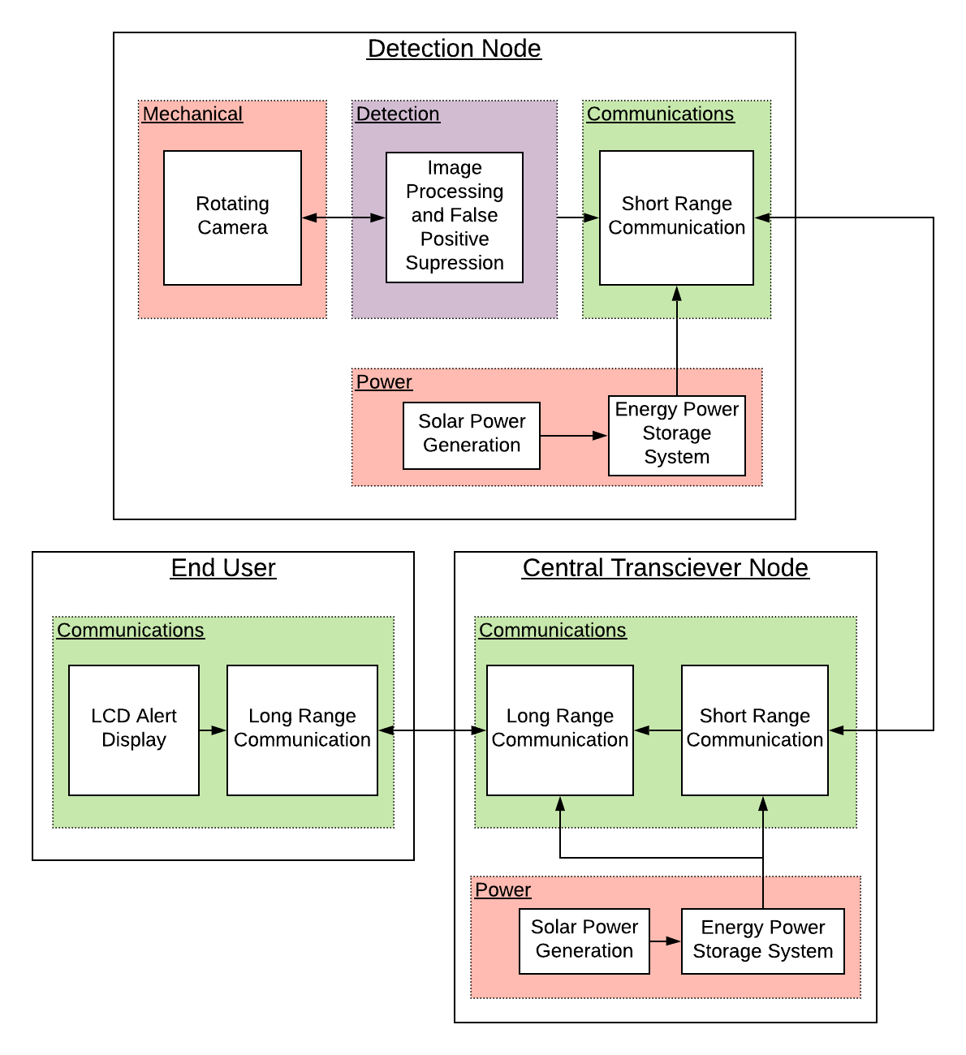

***Figure 2.1:*** *Top level system block diagram.*

The system as a whole is comprised of two types of nodes: a detection node that detects the wildfires, and a repeater node that relays alarms over a long range to alert emergency personnel. Each node must be continuously powered and self-sustaining, as it will be surveying continuously in a sparsely populated area. To remove dependence on existing electrical infrastructure, the system will be powered by a photovoltaic array. The energy produced by this arrangement is then stored in a battery that provides the rest of the hardware in each node with the appropriate power.

Looking at the nodes separately, the detection node involves all four subsystems. This particular node will be capturing images, processing them on site and sending alerts to the repeater node if it detects a fire. Image capturing involves the mechanical and detection systems. These two systems cooperatively rotate a camera 360 degrees, capturing images every 60 degrees to be processed. The detection system then processes the images and runs it through a false positive suppression check to determine if a fire is detected. If a fire is detected, an alert is then sent by the communications system to the repeater node.

The repeater node’s function is to relay alerts received to the appropriate emergency personnel. The communications system is the main system operating in this node, utilizing short range communication to receive the alerts from the detection nodes, and long range communication to send those alerts to emergency personnel.

## 2.2 Detection System

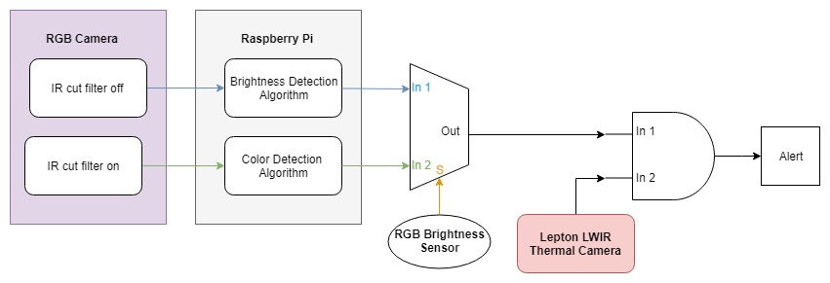

***Figure 2.2:*** *Block diagram of the detection subsystem hardware.*

Common sense dictates the design specifications of the detection subsystem. Any device produced by this team will have to rival the detection capabilities of existing systems. As such, it will need to be capable of detecting the presence of a burning wildfire at a distance of at least a mile to match Vigilys. Reliable detection at this range will make the cost-benefit tradeoff manageable to any public municipalities or private individuals wishing to operate our system. Our detection system will also need to be insulated against the occurrence of false positive detections. It cannot be tolerated if the devices calls emergency services out for false alarms. This will result in unnecessary expenditures and might potentially divert resources from a legitimate emergency.

The centerpiece of the detection subsystem is the image processing wildfire detection mechanism. Fires emit enough electromagnetic energy to easily differentiate them from the surrounding environment. Since no other naturally occurring phenomenon in a forest has the brightness signature of a wildfire, the primary algorithm produced for this design makes use of a brightness threshold to exclude pixels in an image that cannot be part of a fire. The image is converted to grayscale according to the magnitude of each pixel’s RGB components and subsequently binarized according to a prescribed threshold. The remaining pixels are sorted into objects by looking at adjacent pixel connections and filtered according to size and shape. Should the ambient lighting be too bright for the reliable execution of this algorithm, a digital brightness sensor will multiplex between it and a color saturation algorithm that provides better daytime functionality.

A secondary algorithm operates in high ambient brightness levels by surveying color saturation present in the RGB image. To the human eye, flames emit certain colors, notably red, orange and yellow. By tracking how saturated the captured images are with these colors, it provides another method for detecting the presence of a wildfire. In contrast to the colors of the surrounding vegetation, colors of a flame are better differentiated. By setting a threshold to check the level of “redness” in the image, the process segments the fire region, removing other objects that do not satisfy the threshold. As the color threshold defines the fire pixels in the region of interest, these pixels generate a resulting binary image that is sorted and processed similarly to the brightness thresholding algorithm to verify the presence of a flame. All images containing probable fire signatures from either the brightness or color thresholding algorithm will be stored in memory for comparison during the false positive suppression process.

Images are sampled from the surrounding environment using an RGB visible light camera, after which data from the camera output is transferred to the Raspberry Pi Zero W (RPi), our chosen image processing platform, via a ribbon cable. The RPi processes the sampled images according to our brightness thresholding algorithm developed using the Python OpenCV module. To increase the robusticity of the detection apparatus, brightness anomalies are flagged and reevaluated. This is achieved using a slightly altered brightness and color algorithm after a brief delay in an effort to reject potential false positive detections. Any anomalies that go unsuppressed will subsequently be assessed for temperature signatures using a longwave infrared (LWIR) thermal camera as a final confirmation before an alarm is triggered.

Directional orientation of the aforementioned sensory equipment is accomplished through a software controlled stepper motor. This is the primary point of integration between the mechanical and detection subsystems. The interface between the stepper motor and the detection process is overseen and driven by a sequential logic finite state machine running on our RPi. The input signals of this state machine are transferred between the RPi and an Arduino Uno, often shortened to Uno, that keeps using digital I/O pins.

The RPi is a single board computer which contains a SOC or ‘system on chip.’ The system on chip contains all of the components required for the processor to operate. A removable SD card is utilized for booting software and storing data. Because the RPi is simply a small computer, it has the capability to process digital images when paired with the proper software. This allows the platform to perform autonomous image processing, a focal point of the top level system. This capability, however, comes at the expense of a comparatively large power draw. The RPi board is manufactured in a variety of models, including the A/A+, B/B+ and Zero. Of these models, the detection subteam opted to pursue a design that incorporated the Zero. The Zero is rated at half the power consumption of the alternative models. All models of RPi have the capability of taking in photo data from a camera attachment via a ribbon cable port.

OpenCV methods provide many powerful tools for image processing and computer vision. These high level tools allow complex algorithms to be designed without mastery of the underlying mathematical techniques. Using this method, the detection subteam generated a series of algorithms designed specifically to identify specific and unique characteristics of a wildfire. Additionally, OpenCV is implemented as a Python package; this allowed our finished algorithms to be easily exported for execution on the RPi. This functionality is compatible for most commonly used image processing functions. The Python code is included in the Git repository named Smokey-the-Slug.

All brightness anomalies present in a given image will be detected by the brightness thresholding algorithm. That said, there are a variety of other sources of electromagnetic energy that can potentially pass through the threshold. Some of these sources might include reflections of sunlight off reflective surfaces such as water or a rock. The algorithm can also be triggered by intentional flames. In some cases, these sources might deceive the brightness threshold algorithm into misidentifying them as a wildfire. Therefore an extra step is required to confirm a fire’s existence prior to triggering an alarm. Each sample using the RPi IR-cut camera will contain six images. Because of the camera’s field of view, this is the number of images that corresponds to a 360° surveillance. If any images contain an anomaly, said location will be revisited after a short delay. Because wildfires flicker and grow in a dynamic manner, if the second sample of the anomaly returns a significantly altered signature the algorithm can confidently conclude that the signature in question is in fact an out of control fire. False positives, on the other hand, could disappear entirely, move slightly with the angle of incidence of sunlight or even become smaller. After examining two samples, the algorithm will have enough information to determine if an anomaly is a fire.

Another identifying feature of fires that the detection subsystem exploits is their temperature signatures. Temperature anomalies are detectable using instrumentation that is sensitive to electromagnetic energy in the midwave infrared spectrum, which is not visible to the human eye. With infrared sensors or thermal cameras monitoring the environment, detection probes can detect subjects emitting wavelengths of electromagnetic energy within the desired range. The infrared energy emitted by objects at high temperature is a consequence of blackbody radiation. Any object with a temperature above absolute zero will emit this form of energy due to absorption of incident electromagnetic energy. The expected observable electromagnetic emission spectrum ranges from roughly 8 microns to about 14 microns. This falls into the long wave infrared spectrum, which is much lower energy than the short (1-3 microns) and midwave (3-5 microns) bands commonly emitted by a hot fire. Therefore, detecting at shorter wavelengths will not show objects with temperatures comparable to a human, but will capture the energy of a large flame. Pairing the functionality of the temperature sensing system with the operation of the brightness thresholding and false positive rejection algorithms will significantly reduce the frequency of false alarms broadcast by the collective system.

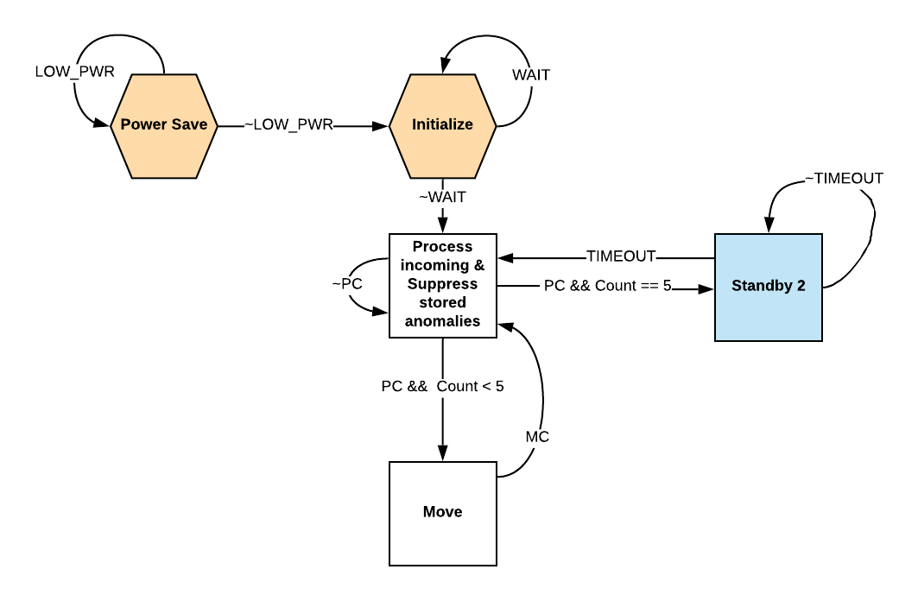

***Figure 2.3:*** *Abstraction of standard sampling finite state machine.*

Pictured in Figure 2.3 is the abstract state diagram that corresponds to the finite state machine operating on the RPi. It serves to cooperatively actuate the stepper motor and sample images with our RPi camera, while an accompanying Uno keeps track of the time of each step of the state machine through the use of an interrupt. Upon awakening from a critical power state, the machine will initialize all of its values as appropriate and loop there while the remaining hardware and software in the larger system configures.

When the system is properly initialized and ready to begin environmental surveillance it will immediately transition into a standard brightness sample. During this process the Arduino communicates with both the RPi and the stepper motor to accomplish the task of properly sampling the images for processing. When the final sample is collected, the machine begins its standby state and will loop there until the prescribed 5 minute delay for the sampling cycle lapses.

Immediately following the standby the state machine then cycles into another sampling action. This portion of the machine is dedicated to returning the stepper motor to its initial position as well as suppressing any potential false positive brightness anomalies as it traverses. As the machine cycles back through the structure, it will resample each image in order to either suppress flagged anomalies or scan for the presence of new ones. If the result of the algorithm suppresses the false positive, the motor will continue its return to its initial position. At any time if a potential false positive is determined to be a fire, the machine defaults to an alarm state and will initiate the process of notifying the responsible emergency agencies. Each sampling cycle is punctuated by a five minute standby delay unless the battery management system mandates that it should sample at a lower frequency of 12 minutes to reduce power consumption.

## 2.3 Communications System

The overarching goal of the communications system is to be able to reliably bridge communications between the detection nodes in the field and the end user in an efficient manner. To do so the communications system was designed with a few key features in mind.

The first of these considerations was range; this was determined in terms of the maximum detection range given and doubled taking into consideration that the detection nodes would not necessarily have to overlap in terms of sight to effectively detect a fire. The second important consideration was minimizing the power usage. A low power draw is absolutely essential in preventing the communications system from using more power than the sustainable power system could provide as well as minimizing the power requirements of the system in general so that lower wattage rated panels could be used. Due to the power constraints and the nature of the message content being sent and received, the data rate of the transmitter was minimized to allow for a lower power consumption.

It was also determined that a network of nodes that could be configured in a way to cover a large area would be optimal in a system like this. The addition of more nodes to the communications system requires at a minimum a pseudo ad-hoc network that allows for a message sent from one node to be re-transmitted throughout the network to the end of the repeater node sequence. The message is then transmitted to emergency personnel at the end user of the system. Due to the detection nodes transmitting to repeater nodes and then propagating through them to the end user, the system retains a level of redundancy.

To achieve a low power consumption as well as an acceptable transmission distance for detector nodes, the Semtech SX1276 LoRa spread spectrum transceiver was used. The repeater nodes will contain a single SX1276 operating on the 915Mhz band with a GPS chip. The SX1276 operates at 915Mhz, a license free band according to the FCC. A high level block diagram of the mentioned hardware can be found in Figure 2.4.

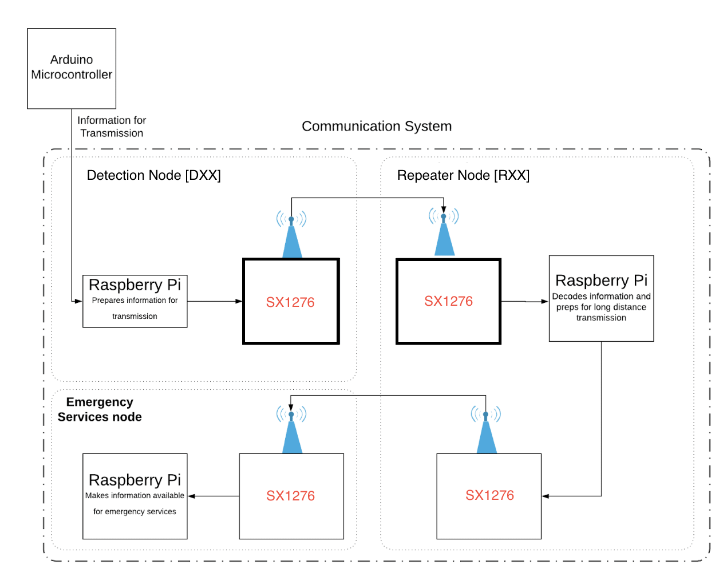

***Figure 2.4:****Block diagram of communications signal flow*

Figure 2.4 also demonstrates that there are three main components to the communication system: the detector node, the repeater node, and the emergency services/end-user node. Following the flow of the diagram, the information that is to be transmitted is generated at the detector node by the detection system. Once called, the communications software on the detection node will automatically assemble the message read in from a text file and the message will get passed over the SPI bus from the RPi to the SX1276. At this point the SX1276 would be configured for TX mode, then transmit the signal wirelessly.

Once the signal is transmitted it travels through the repeater nodes to the end user. This signal is then received at the end user by emergency services, and subsequently passed to the RPi where it is stored in a history file, processed, and presented to the user via an LCD display.

## 2.4 Power System

To effectively detect forest fires and communicate the danger to emergency personnel, the system will need a safe, reliable and stable power system. The challenge arises from the harsh climates and remote locations in which the probe networks will reside. A system which addresses these concerns in an effective way is shown in Figure 2.5.

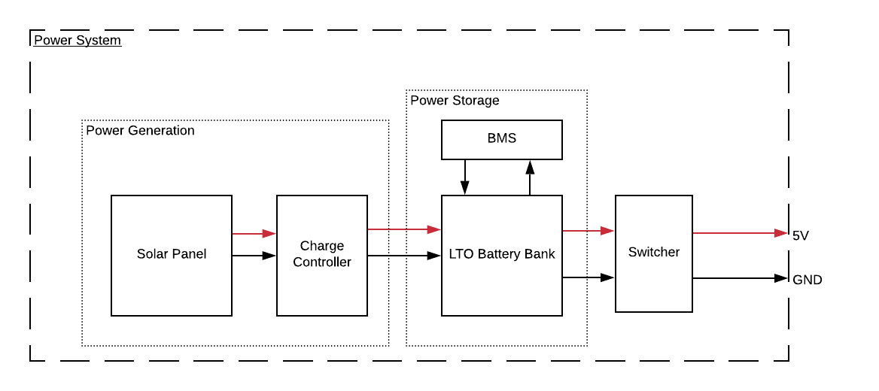

***Figure 2.5:*** *Top level power system block diagram.*

The power system is made up of three major parts, the first of which is power generation. The probe must be self-sustaining as it will be placed in a rural area and should not be confined to locations with access to an electrical grid. Photovoltaic solar panels will allow for freedom in probe location as well as self-sustaining power. With no moving parts, solar panels are also less prone to the mechanical failure and potential interference with wildlife that are often detrimental to wind or hydro power generation mechanisms. Thus solar panels are used as the solution for power generation in this design.

The second portion of the power system is power storage. The intermittency of solar power demands a power storage system if the probes are to remain active overnight and on cloudy days. The capacity of the power storage system should be large enough to sustain the probe between periods of low sun exposure. This means at least during the night and preferably up to two days, even with poor sun exposure. A critical component of the overall solution is autonomous detection. To maximize the autonomy of the probe, any type of human dependent upkeep must be kept to a minimum. Thus the power storage system must last as long as possible before needing a replacement. The long life span ensures that the probes will operate autonomously for as long as possible before needing human interference.

A lithium titanate oxide (LTO) battery pack was selected as the energy storage system for its long cycle-life, ability to quickly charge, wide temperature range of operation and intrinsic safety features. LTO chemistry is known as one of the safest lithium-ion variations and seldom experiences thermal runaway. Our team is confident the LTO chemistry will meet all of the specifications aforementioned. Safety is the most important consideration in the design of the probe’s power system. It must be certain that the battery pack will never have the chance to have a thermal runaway situation. The fire-prone areas in which the probe will be placed combined with a thermal runaway situation could potentially produce a forest fire, rather than detect one.

A customized battery management system (BMS) provides an extra layer of safety. Whether charging, discharging or at rest, the BMS will manage the cells to keep them operating in the safest and healthiest conditions possible. If the BMS senses any error or fault, it will disconnect the battery from the system preventing damage to the pack or the system itself, thereby eliminating any environmental risk.

The BMS will also be continuously checking the state of charge (SoC) of the battery pack and will determine the functionality of the system as a whole based on the SoC. The system has three modes of operation: a normal mode, lower power mode and critical power mode. The need for power saving modes comes from the intermittency of solar power generation. If the pack cannot be charged for an extended period of time, then the pack needs to adjust its duty cycle to extend its lifetime. Additionally, it would be unsafe to let the LTO pack be unmonitored. Thus in the case of extremely low charge, the detection and communication systems shutdown, the battery pack is disconnected from the load and all remaining charge is used to run the BMS. The BMS is very low power and will be able to operate until the pack reaches a charge high enough to exit critical low power mode, return to low duty cycle, and eventually to normal operation.

The last major part of the power system is power delivery. Delivery is accomplished by a means of a switch mode DC/DC buck converter circuit. The converter creates the 5V and 6V rails supplying the rest of the system. We are utilizing a switcher because it is an efficient way of converting the nominal 12V pack voltage to the supply voltages needed for the components of the rest of the system. Buck switching converters are slightly more efficient than boost and buck-boost converters. Thus it is beneficial to have a higher pack voltage and convert it to a lower voltage as needed.

## 

## 2.5 Mechanical Components

There are three nodes that make of SSDS and they all have their own mechanical specifications. Two nodes, the detection and repeater nodes, are placed out in the open in rural areas for fire detection and system communication. The end-user is the interface between the system and emergency personnel and other users.

The mechanical system of the detection node has two roles, the first is to provide a durable housing for all components of the probe. The probe must be robust enough to endure all weather conditions present in a forest environment, while offering a self-sustaining power system to provide years of adequate system function. To ensure the protection of the environment, safety considerations will heavily influence the mechanical design to avoid harming wildlife and minimizing pollution. Additionally, the mechanical design will ensure protection to all on system components by providing an enclosure system. This achieved this through the use of a five foot tall, 12in diameter PVC that holds all components on platforms within it. The solar panels are mounted to the sides of the PVC and the yagi is mounted on top.

The second role of the mechanical system of the detection node is to realize the moving parts of the probe. The system will maximize its radial field of view, rotating 360° to minimize the number of probes needed to monitor an area. To accomplish this, a stepper motor turns the camera that is used to capture images for the image processing detection mechanism. A stepper motor is needed specifically so we can accurately keep track of the position that the camera is in during a specific image capture in order to get an accurate location of any fires that are detected.

The repeater nodes has similar mechanical needs to the detection node. The key difference in the mechanical requirements for this node is that it does not require any moving parts. The repeater nodes a singularly used by communications to relay messages about detected fires and diagnostics of the system to the end user over long distances. Like the detection node, this node must be robust enough to endure all weather conditions present in a forest environment and must be self-sustaining to provide adequate system functionality for years. This is achieved through the a design that offers a minimalistic weatherproof housing. The housing is six feet tall and positions the antennas in the most effective location. Additionally, it offers sturdy mounting for all internal components and solar panels.

Finally, the end-user must be able to provide an easy to use interface for users that clearly display messages about the detection of fires and diagnostics of the system. This is implemented through a 3D printed, compact and user-friendly design that allows the LCD to clearly display messages. It also offers an audible alarm to alert emergency personnel of fires. Its compact 5.5in x 3.5in x 2in design allows for the end-user to be powered by a wall outlet. Finally, a Yagi antenna is used by the end-user to maximize the effective range of communications.

# 

# Chapter 3: Detection Subsystem

## 3.1 Subsystem Overview

The cornerstone of our proposed design is a functional flame detection mechanism. As laid out earlier, our ideal product will quickly and accurately detect fires autonomously while persisting in a variety of environmental conditions. This is obviously a complex engineering challenge with a number of variables to take into consideration. A quick, accurate, autonomous and persistent device is a highly subjective concept, so different engineers are bound to interpret solutions in dramatically different ways. In order to develop a working detector we boiled these terms down into a series of discrete and objective design constraints. All of these resulting specifications have been addressed in some manner in our final prototype.

Members of our detection subteam saw two ways to ensure satisfactory identification speeds. First and foremost, increasing the effective detection range of our design will allow our products to give more advanced of a warning when a large fire threatens populated areas. This in turn gives firefighters more time to mobilize and contain the blaze before it can threaten nearby communities. It also affords residents more time to gather their belongings should an evacuation become necessary. With this in mind, detection radius of our devices was prioritized as the development of our design progressed. Rapid flame detection also implies that our detector needs to be capable of detecting fires with minimal delay after ignition. In terms of engineering design this simply means that our detector needs to observe the surrounding environment either continuously or have a sampling frequency that is sufficiently high so that any fire that does start in its surveyed area can be identified before it can grow to worrying size. This feature is central to the success of our design, and as such our team made several design choices in an effort to reduce this delay.

Detection accuracy is fundamental to the success of our project. Our final design is obviously useless if it fails in our stated goal of detecting burning fires within its effective range. The same can be said if it triggers an excessive amount of false alarms. Not only might this incur unnecessary expenses from the unneeded deployment of emergency services, in a worst case scenario such a situation might divert resources from a genuine emergency. Many countermeasures were implemented in our final design to provide increased detection sensitivity and resistance to variable lighting and weather conditions. False positive safeguarding was also of great concern throughout the design process.

Blind spots in the surveillance areas of our probes also pose the risk of missed fire detections. Potential causes of this includes dense vegetation cover, as well as topographical obstacles in the local vicinity of the probe sites. To oppose this issue, our design team planned to couple calculated probe placement with several design features intended to increase the area of our detection coverage.

Two of the most common methods of identifying wildfires currently in use are surveillance aircraft or strategically placed networks of manned watchtowers 9]. In order to reduce the fiscal commitment of these operations and eliminate the risk of human error, our design team decided that it was important to make our detectors operate in an autonomous manner. This implies that all mechanical processes must be automated through mechatronics, and driven by the sequential logic of finite state machines. It also means that flame detection has to be accomplished algorithmically, without the involvement of a technician. Significant portions of the finalized prototype were dedicated to realizing this capability.

To properly serve their intended purpose, the probes that we produce will need to operate year-round, rain or shine, day and night. Aside from the self-evident need for a weatherproof housing to protect the delicate electronics inside each probe, they will also be operating in remote areas, where the lack of an electrical grid complicates the design process. As a result, the detection system itself would need a small enough power draw to allow it to be sustainably powered. This choice carried with it the added benefit of being less taxing on the environment.

With all of the aforementioned specifications outlined, we were able to proceed in the design process more effectively. All design choices were evaluated with these specifications in mind, which granted us the ability to make design tradeoffs with the confidence that it would result in a more effective detection device.

## 3.2 Detection Background

The engineering challenges associated with the task of accurately detecting fires at long range with minimal false positives are immense. The open-ended nature of the problem at hand requires a sophisticated solution in order to be competitive in any market. The stakes associated with failure to detect an emerging fire also complicate things, as it means that the performance of our design will be held to the highest standard. Given the amount of different qualities that can be taken advantage of for the purposes of identifying burning fires, potential solutions could have many conceivable designs. Coupling this with the sheer variety of hardware platforms that can be utilized in such designs means that the number of different possible designs is theoretically limitless.

### 3.2.1 Fire Characteristics

In order to more effectively detect fires, it is important to have a strong conceptual understanding of the physical phenomena associated with them. Having a complete understanding of the qualities that make fires stand out from the surrounding background will ease the difficulty of selecting hardware later in the design process, as well as the development of complementary software that ensures the hardware functions as intended. Members of our team responsible for the development of the detection mechanism made the choice early on to capitalize on several identifying characteristics of wildfires, resulting in a more accurate detection device with increased resistance to missed and false positive identifications alike.

One of the most apparent physical qualities of a flame that makes it stand out from the environment that surrounds it is its brightness. Most natural objects simply reflect light from external sources such as the sun. The chemical reaction of combustion, however, generates heat that triggers the emission of electromagnetic energy that can be seen as visible light [32]. With this in mind, any flame can be categorized into two distinct groups based on the amount of light that they give off. These are called either luminous or non-luminous flames [37]. Luminous flames typically exhibit a red-orange hue due to a lack of oxygen availability for the chemical reaction taking place [37]. This is common for fires fueled by wood and other vegetation, evidenced by the excess carbon from the combustion of hydrocarbons in the wood being released in the form of black soot [37]. On the other hand, non-luminous flames have surplus oxygen, giving them a much fainter blue color such as that of a laboratory burner. The presence of additional oxygen also means that non-luminous flames burn at a comparatively higher temperature than their luminous counterparts [37]. The fact that wildfires are generally luminous flames allows for the harnessing of this quality as part of our fire detection system. With selection of the proper hardware, it will be fairly straightforward to detect the brightness of a fire against a darker backdrop.

Another obvious feature of wildfires that can be used in the detection process is the coloration of their flames. On a chemical level, electrons stay in their ground states close to their associated nuclei at low energy levels [39]. When exposed to energy from an external source, such as from the heat of a nearby combustion reaction reaction characteristic of all flames, they can be elevated to higher energy orbitals temporarily. When this energy eventually gets dissipated, the electrons recede to their original orbitals. As a result, a photon of electromagnetic energy gets emitted with an associated energy in direct proportion to the amount of energy originally absorbed by the electron [39]. This energy is often referred to as the atom’s bandgap energy. Elements can be identified by their bandgap emissions, which are distinct from element to element due to the types of orbitals present in the atomic structures [39]. This concept manifests itself when different elements get exposed to the heat of a flame. For instance, copper will result in a green colored flame while an element like strontium yields flames with violet coloration [39].

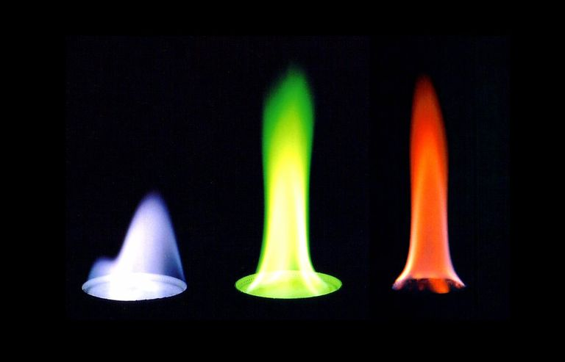

***Figure 3.1:*** *A controlled lab flame test demonstrating the spectroscopic properties of three elemental compounds. The color produced by the heat of each flame is determined by the movement of electrons between orbitals in the atomic structure of each.*

Due to an abundance of carbon present in the hydrocarbons burning in a wildfire, their flames have an orange coloration that is stereotypically associated with fire [39]. This particular color scheme stands out sufficiently from the background colors of mostly green vegetation and brown earth to be used to identify fires in remote areas.

The last, but certainly not least identifying characteristic that can be used to efficiently detect fires is their heat signature. By the same process by which combustion of different elements and compounds produces different colors of visible light, they also produce large amounts of infrared radiation. The intensity and frequency of the electromagnetic emissions of a fire are determined by the Stefan-Boltzmann law and Wien’s displacement law, respectively [40]. Both of these are illustrated in Figures 3.2 and 3.3.

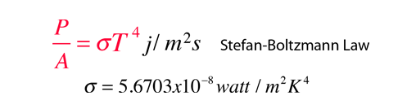

***Figure 3.2:*** *A mathematical illustration of the Stefan-Boltzmann law. The intensity of the radiating emissions increases according to a quartic polynomial of the temperature of the material.*

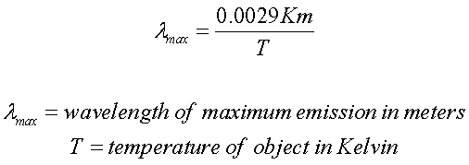

***Figure 3.3:*** *A mathematical illustration of Wien’s displacement law. As the temperature of the heated object or substance increases, there will be a corresponding decrease in the wavelength of the radiation emitted. This also implies that hotter objects have more energy, which tracks with classical thermodynamic principles.*

The Stefan-Boltzmann law dictates the strength of infrared emissions based on the temperature of the substance at hand. Given the fact that large scale wildfires routinely exceed temperatures of 800°C, it follows that they embody a significant source of thermal radiation [40]. Couple this with large surface areas typical of wildfires, and it is a reasonable conclusion that such fires will emit intense infrared radiation that can easily be detected by a camera that can image in the infrared spectrum. The exact frequency of the emitted radiation is modeled according to the aforementioned Wien’s displacement law, which states that the frequency of the fire’s emissions is inversely proportional to the temperature at which it resides [40]. These two facts tell us that any object hot enough to emit visible light will also emit infrared light, which humans perceive as heat [40]. In short, sampling the environment around our probes for unusual infrared signatures will decrease the likelihood of false positive detections by backstopping our detection mechanisms that operate in the visible light spectrum.

Imaging in the infrared spectrum also extends the effective range of our detection probes. All infrared rays have a larger wavelength than the visible spectrum, and thus lower associated energy [40]. Despite having a lower photon energy, radiation with a larger wavelength propagates more efficiently due to the principles of diffraction [41].

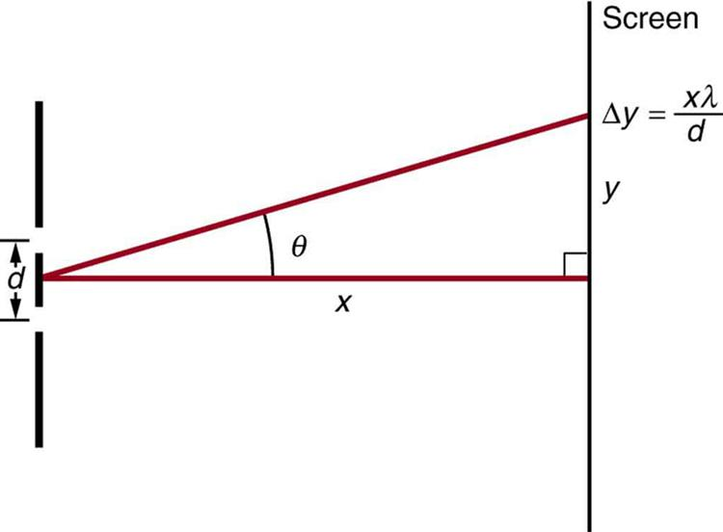

***Figure 3.4:*** *An illustration of the double slit experiment that proved the existence of electromagnetic diffraction. Due to wavelike properties, photons of light can be “bent” around obstructions in their path. As the wavelength of the light increases the diffraction effect also increases in magnitude with linear dependence on the wavelength, λ.*

Figure 3.4 demonstrates how higher wavelengths of light are more susceptible to the impacts of diffraction. In spite of the fact that photons with higher wavelengths carry more energy, diffraction of such radiation is much more pronounced [41]. The result is increased atmospheric losses for radiation in the visible light spectrum, which has a larger wavelength in comparison to the infrared spectrum. Taking this into account, the addition of infrared detection capability to our prototype design will not only increase the accuracy of our detector by limiting false positives, but will also increase the range at which those fires can be identified.

### 3.2.2 Candidate Detection Designs

A number of different methods are currently in existence that can reliably detect fires under different circumstances. Each of these designs had to be carefully evaluated for efficacy before embarking on the design process. Each potential design strikes a balance between detection constraints of range, accuracy, cost and power consumption. Not only did this tradeoff impact the way in which the detection mechanism was designed, but it also had implications that would impact the ways in which the other functional subsystems developed over the course of the project.

One design proposed early in the development of our flame detector was a network of thermistor devices capable of converting ambient temperature into an analog voltage signal. Thermistors are straightforward devices that are exceedingly cheap and easy to work with. They also draw a small enough amount of power that powering them through sustainable methods would not be difficult. Theoretically, placing a number of these devices in remote areas could trigger alerts to emergency personnel if a fire got close enough to trigger a temperature spike near them.

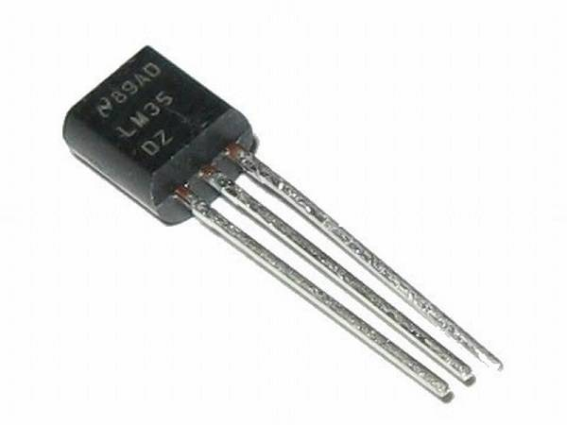

***Figure 3.5:*** *Photograph of an LM35 thermistor, a common component manufactured by Texas Instruments.*

The benefits of this design were extremely inviting, but it also carried with it some disqualifying limitations. For example, the range capability of this candidate design is severely lacking. Thermistors are only capable of measuring the temperature of their immediate surroundings. They are ineffective when it comes to measuring temperature at ranges in excess of a few centimeters. As a result, the number of thermistors that would be required to complete the construction of such a design is simply not practical to implement.

Another fairly common way of identifying a flame is through the process of chemical spectroscopic resonance imaging, commonly abbreviated as SRI. Flame detection in this manner functions by observing a designated area for the electromagnetic rays emitted when electrons return to their ground states after excitation from an external energy source. Using this method allows for the detection of the combustion of carbon and oxygen that are emblematic of a large wildfire [1]. Because a combustion reaction is required to trigger this detection mechanism, it has an extremely low rate of false positive alarms, which our detection subteam found attractive about this methodology.

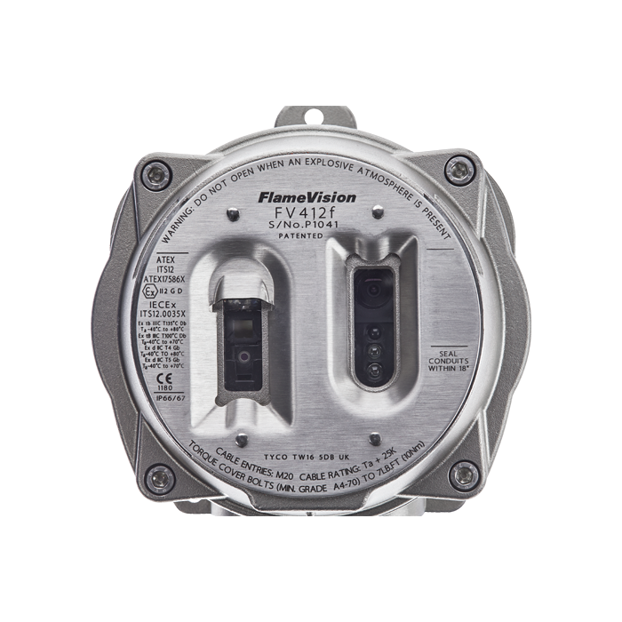

***Figure 3.6:*** *An example of an SRI flame detector developed by a company called FlameVision.*

SRI is an effective method for flame detection that has already been considerably developed. It is commonly used in applications like the safety monitoring of gas flaring on offshore oil rigs [1]. That said, the equipment required for this type of flame identification is quite expensive and has a limited effective range [1]. The conjunction of these two disadvantages render SRI inapplicable for our purposes.

The final possible design that our team assessed for incorporation into our own detector design is image or video processing. Algorithms used to identify data within a pixelated image have revolutionized the methods of flame detection. These methods afford the benefit of increased effectiveness at long range because it can only be limited by visual obstruction and atmospheric loss, in theory.

As explained to us by a UCSC, Marc Reinig, a camera captures whatever light strikes its pixelated sensor, so any light that is able to propagate from its source to the camera lens will be depicted in the image. This meant that we did not require the purchase of a sophisticated and expensive camera to implement this design. It also meant that the zoom setting on the camera we ended up choosing could be fixed to a satisfactory magnification that could capture of the light emitted by a fire that is separated from our detector by a large distance. The combination of affordability and the range capability is ultimately what prompted our design team to pursue this final method. In addition to these substantial benefits, this type of design also carries with it the possibility for future upgrades to our finished system as technologies advance and new imaging techniques emerge. Current image processing software and hardware are also widely available and well documented, clearly making this technique the best for our team to pursue.

## 3.3 Hardware Overview

The detection system operates by sampling the surrounding area using two cameras and a brightness sensor. The brightness sensor measures the ambient brightness of the surrounding environment. The brightness measurement is used to toggle an IR cut filter on an RGB RPi camera. The RGB camera will capture visible light in all light levels and will capture shortwave IR (SWIR) in low light levels below 250 lux. The other camera is a FLIR Lepton camera that is used to capture LWIR images.

The resulting images from all cameras will be processed by several image processing algorithms on a RPi. The RGB images with SWIR cutoff will be processed using a color thresholding algorithm to detect the presence of a fire’s characteristic red coloration. The image that captured SWIR will be processed using a brightness thresholding algorithm to detect the bright light from a fire in a low light level environment. The LWIR image is processed using a modified brightness thresholding algorithm to detect the more intense LWIR given off by wildfires. When both algorithms detect a fire and confirm that the anomalies are not false positives, the detection will result in an alarm to the end user. Figure 3.7 shows this process visually.



**Figure 3.7**: *Depending on the ambient brightness level in the environment, the system will mux between two detection algorithms to process images from the RGB camera. The processed image from the RGB camera will be combined with the thermal camera output to determine an alert.*

### 3.3.1 RGB Camera Module for Raspberry Pi

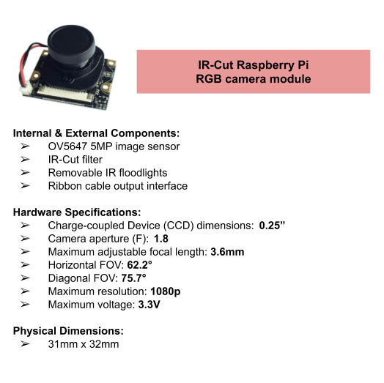

***Figure 3.8:*** *Hardware characteristics of an IR-Cut Raspberry Pi RGB camera module.*

Key features that can be used to identify a flame are how bright it burns and the colors of light it emits. In order to capture these features, a camera sensitive to both the infrared and the visible wavelengths was selected. We chose a near infrared-sensitive camera with a motorized infrared cut filter that operates on the Raspberry Pi and outputs RGB images. This camera is special because it is able to remove the filter to allow infrared light to reach the camera’s sensors or keep the filter on to cut out infrared light. While the filter is on, it is operating in “Normal Mode” where it filters out infrared wavelengths allowing only the wavelengths in the visible spectrum, 380nm to 740nm, to pass through. When the filter is off, it is considered to be in “Night Mode” where the camera becomes sensitive to infrared wavelengths of about 740nm to 1000nm, which is just outside of the visible spectrum for humans. The IR sensitivity gives the camera the ideal settings to still capture clear images at night [38].

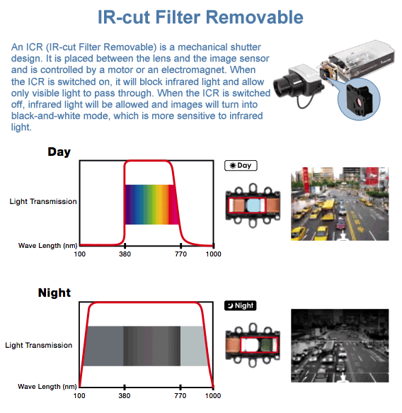

***Figure 3.9:*** *Spectral response of RPi camera with and without IR-cut filter removed.*

Being able to switch the IR filter on and off allows the camera to operate during either night or day to optimize the clarity of images to detect brightness and color anomalies. During day time, the filter will stay on to cut out any infrared light from reaching the camera’s sensors. This would allow the camera to produce colored images as human eyes would see them. If the filter was off and infrared light was let through, it would produce images with distorted colors. In most cases, unfiltered images had a reddish distortion to colors of the objects, making certain colors appear different than what the human eye saw. Thus, the system implements the filter to stay on during the day to look for objects that are red or orange since these colors are the most prominent in a wildfire. The wavelengths of these colors also fall within the range of 590nm to 740nm, almost reaching the near infrared spectrum.

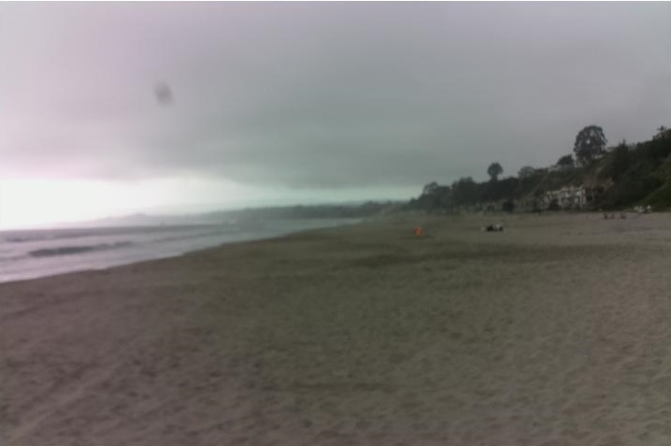

***Figure 3.10:*** *Image captured during “Normal Mode”.*

Once the camera captures these color anomalies it will inform the system to process these images and verify if there was a fire or not. “Normal Mode” will continue to operate and look for color anomalies, but as day transitions to night, the overall ambient light level will decrease. By detecting the light intensity with a ambient light sensor, the detection system can instruct the camera to switch operation to “Night Mode.”

During night time, the detection system would switch the IR filter off so that it becomes more sensitive to infrared radiation to capture a bright object more easily. Due to the low light environment, colors of objects are more difficult to see during the night, so removing the filter will increase the spectrum of light available to the camera to detect bright objects better. The resulting unfiltered IR images during the night will show the bright object saturating the image with white pixels in contrast to the black background, ultimately creating a binary black and white image. As a fire burns hotter in comparison to its surroundings at night than during the day, it will grow brighter and will be indicated by the white pixels in the image.



***Figure 3.11:*** *Image captured during “Night Mode”.*

Increasing the IR sensitivity causes the camera to not only detect brightness anomalies from fires but from any other bright objects that can saturate a region in the image with white pixels. This noise from non-fire objects is due to the camera being sensitive to only the near infrared spectrum, allowing any reflective or other bright lights to appear in the nighttime images as well. This makes the detection system susceptible to false positives but image processing will be implemented to suppress the false positives and verify the presence of a flame. As “Night Mode” continues to operate, it will simultaneously measure the ambient light level to instruct the system to switch to daytime operations.

In addition to nighttime operation, the RPi camera has as set of infrared LED lights that can be implemented to provide IR lighting in low light levels. The IR LEDs have a built-in sensor that can detect the ambient light intensity and adjust the amount of infrared light accordingly. Since the detection system is looking for fire signatures, it does not need the scene to be illuminated by the LEDs and has been removed from the camera module. Furthermore, the camera module with the LEDs on requires a high power consumption rated at 5V and 2A where a power adapter is recommended to power both the RPi and camera. Without a stable power supply or if a low power current adapter is used, the RPi may crash or underperform. Therefore, the detection system implemented the RPi camera module without the IR LEDs to reduce power consumption and the risk of corrupting the RPi.

When the infrared LEDs are removed, the IR cut filter can be operated manually with the GPIO pin shown in Figure 3.12. The GPIO pin is an input that can either be set high or low. When the pin is high, the cut filter captures IR light in the image, but when the GPIO pin is set low the IR light is excluded.

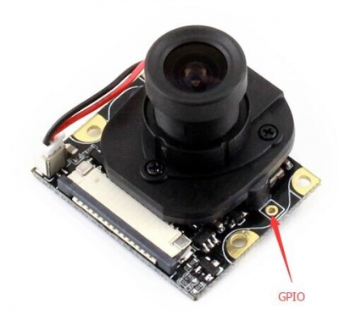

***Figure 3.12:*** *This is the RGB camera with infrared LEDs disconnected. The red arrow points to the GPIO control for the IR cut filter.*

The RPi camera module utilizes a ribbon cable to communicate its images to the RPi where image processing happens. To ensure that the detection system does not have any missed detections or blind spots, it will be rotating the cameras 360°. As the camera rotates, the position of the ribbon cable will have to be properly positioned to prevent the ribbon cable from twisting or bending in a way that will corrupt the information passed between the camera module and RPi. To reduce the risk of damaging the ribbon cable and ensure the two devices communicate efficiently, HDMI to ribbon cable port adapters were utilized to provide more freedom for the camera to rotate.

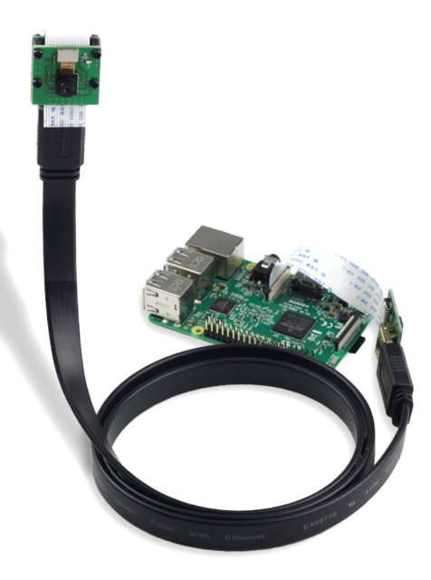

***Figure 3.13:*** *HDMI extension from camera to RPi using ribbon port adapters.*

### 3.3.2 - ISL29125 Ambient RGB Brightness Sensor

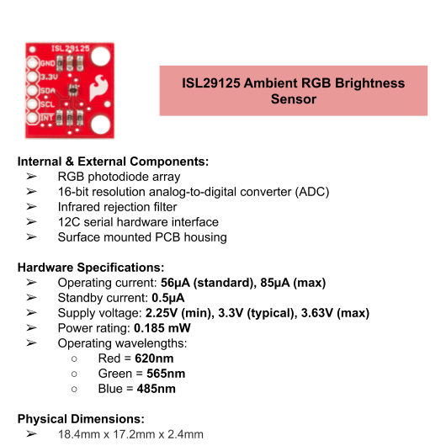

***Figure 3.14:*** *A hardware description of the design specifications for the ISL29125 ambient RGB brightness sensor*

The ISL29125 utilizes a compact photodiode array to measure the ambient brightness of three different colors of light in the visible spectrum: red, green and blue. The intensities of each color are converted into digital values of 16-bit or 12-bit resolution depending on the desired measurement range. The sensor can be configured to have a maximum reading of either 300 or 10,000 lux, with the wider range requiring greater resolution. Commands and sensor data are transmitted by way of an I2C serial interface with a master device. When mounted directionally on our camera array, it provides information as to how bright the surrounding environment will appear in the images captured by our RGB camera module.

Our algorithmic flame detector operates in two distinct modes within the visible spectrum. Overnight and during periods of dim lighting, large flames emit such intense light in comparison to the surrounding environment that the best way to detect them in such a situation is through the application of brightness thresholding. During daylight hours, additional light pollution from solar rays render this method of flame detection ineffective. However, the coloration exhibited by the flames can be exploited for detection purposes during this time. This is accomplished through observation of color saturation within an image.

By sampling the brightness of each sector around the probe as the images are captured and computing the corresponding magnitude of the combined components, the algorithm that gets applied to each can be dynamically selected. Not only does this help grant our device’s autonomous capability, by switching algorithms to adapt to changing environmental conditions many false positive sources can be mitigated. This also serves to maximize the effective range of our prototype detector. The sensor itself also draws such a small amount of power that the benefits it provides greatly overshadow the burden it places on our device’s power system.

### 3.3.3 FLIR Lepton 2.5 Longwave Infrared Thermal Camera

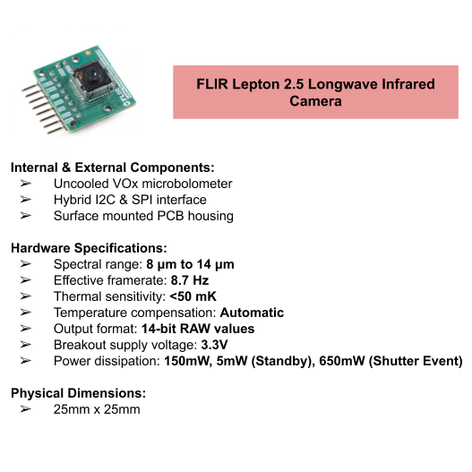

***Figure 3.15:*** *An overview of the FLIR Lepton 2.5 LWIR thermal imaging platform.*

The Lepton 2.5 thermal camera gives our detector the ability to survey the surrounding environment for anomalous temperature signatures. It does this by using an uncooled microbolometer to measure the infrared radiation being emitted by objects within its field of view. It is classified as a longwave infrared device that has an effective range between 8 microns and 14 microns.

Although midwave infrared cameras are more ideal for thermal imaging applications, the Lepton offers a passable substitute at significant cost savings to our team. This also carries the benefit of increased range, as the longer wavelength of the longwave IR emissions allow them to propagate over longer distances [40]. As such, wildfires are easily detected at long range using this methodology. The increase in effective range from the application of the Lepton thermal camera yields a corresponding decrease in the lead time for a successful detection. Additionally, sampling for fires in both the visible and infrared spectra decreases the likelihood of false positive detections. In order for our system to trigger an alert to emergency personnel it must detect a fire in both spectra, thereby increasing the robusticity of our detection mechanism. Furthermore infrared rays propagate well through fog and smoke, which would obscure visible light. This ensures that variable weather will not negatively impact our ability to detect fires to an appreciable degree.

The Lepton camera module is also quite compact with a satisfactory power dissipation rating. Its structure is smaller than the diameter of a dime, and is exceptionally light. These features make it easy to rotate as part of our camera array, increasing our coverage area for our probe. The reasonably low power rating for the capability the Lepton provides also make it ideal to be powered by our system’s solar array.

### 3.3.4 3D Printed PLA Camera Housing



***Figure 3.15:*** *An overview of the design specifications for the 3D printed camera housing manufactured by our team.*

The RPi IR-cut camera module, Lepton LWIR thermal camera and ambient light sensor are assembled together in the camera housing shown in Figure 3.15. The housing was designed and constructed by a tab-and-slot method to allow ease of setup and maintenance. The front panel of the camera housing holds the camera modules and sensor by simply screwing the devices on to secure their positioning. The IR-cut camera is positioned at the top of the front panel to optimize its field of view for capturing images. Positioning the IR-cut camera towards the top of the housing also provides more space for the HDMI-ribbon cable adapters to allow for smoother camera rotation.

Positioned below the IR-cut camera is the ambient light sensor. The light sensor module sits on the outside of the front panel, facing the same direction as the camera, to ensure exposure to the ambient light level. The light sensor was placed to face the same line of sight as the camera to detect the brightness levels captured by the camera. In other words, as day transitions to night, the camera will output darker images, so having the light sensor see what the camera sees will help determine the change in operating mode for the camera. This positioning of the light sensor optimizes algorithmic functionality more so than placing the light sensor on the top platform of the camera housing. With the sensor on top of the housing, it would have a different line of sight in respect to the camera and detect different light levels than the camera sees. For instance, the sensor may detect higher light levels when the sun is on one side of the housing while the camera side of the housing may detect lower light levels. In turn, the sensor will instruct the camera to continue operating in “Normal Mode” when it should be operating in “Night Mode” instead or vice-versa. Therefore, the ambient light sensor is highly directional and positioning it with respect to the camera optimizes camera functions throughout the day.

Lastly, the LWIR thermal camera is placed below the ambient light sensor towards the bottom of the front panel of the camera housing, lining up with the lens from the IR-cut camera. Due to the positioning of the header pins on the thermal camera board, placing the thermal camera towards the base of the housing was optimal for connecting wires from the module to the RPi. With the thermal camera in the same line of sight as the IR-cut camera, it will contribute to validating the presence of a fire in the cameras’ field of view.

Furthermore, the overall camera housing sits on top of a gear that provides rotation for the camera modules and sensor. On each side of the housing are a pair of stands that provides additional movement. The stands are screwed into the side panels of the housing, allowing rotation about the horizontal axis. This rotation provides a way of adjusting the angle of view for the camera. If the detection system were placed on top a hill, the camera housing can be tilted downwards and secured to provide optimal field of view.

### 3.3.5 3D Printed PETG Drive & Load Gears

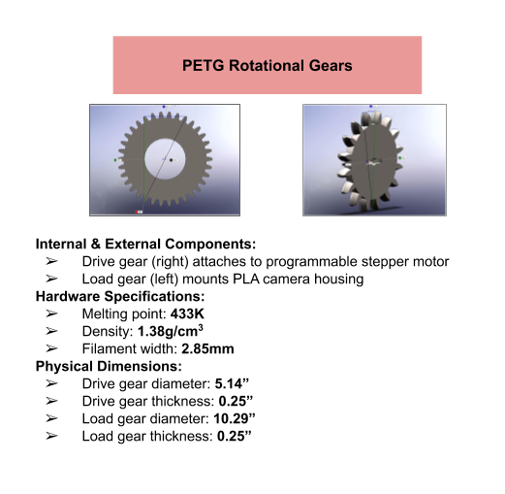

***Figure 3.16:*** *An examination of the hardware specifications for both the drive and load gears of the mechanical system designed to rotate our camera array and its incorporated hardware.*

Spur gears were chosen for their ability to have a large gear diameter. The gears needed to be large enough to rotate the camera housing 360° degrees. Additionally, the gear driven needed to have a large inner diameter for the wiring harness. By creating a large inner diameter, the wiring harness could be capable of reaching the camera modules and the communication devices from the RPi.

As seen in Figure 3.16 the 10.29” driven gear will have 36 teeth as the 5.14” driver gear will have 18 teeth, meaning this gear system will have a 2:1 ratio. This makes for a smooth gear simulation within Solidworks. The spur gears were chosen to be a quarter inch thick with 100 percent infill. This allowed the gears to be as durable and robust as possible to rotate the camera rig through many years of operation.

Spur gears were chosen over bevel gears because larger bevel gears result in a more complicated simulation. Although bevel gears are designed to be perpendicular to one another, bevel gears proved to be uneasy to work with once it reaches anything over 1-3 inches in diameter. Additionally, due to the bevel gear architecture the placement of a ball bearing under the driven bevel gear would not be possible.

Devising a mechanical design to have the driver gear be perpendicular to the driven gear allowed the driven gear to be centered within the PVC. This would make for a consistent field of view comparatively to if the two gears were parallel to one another. For spur gears to be able to spin properly perpendicular to one another, the driver gear will need a 70° chamfer between each teeth, leaving the driven gear the same without change. This would allow the driver gear teeth to be flush with the driven gear perpendicular to one another. Through simulation, having the right angled gear with a chamfer of 70° confirmed that the gears would sit flush with one another through multiple rotation cycles.

### 3.3.6 NEMA23 Programmable Stepper Motor

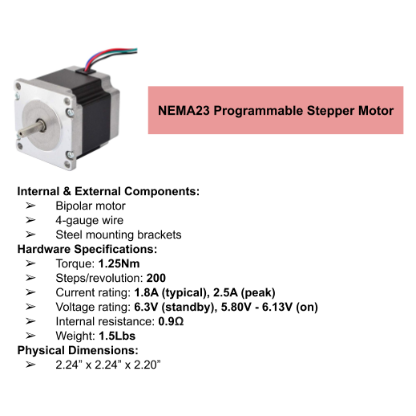

***Figure 3.17:*** *An overview of the programmable stepper motor implemented by our system’s mechanical design.*

The NEMA23 was chosen for its ability to handle the load of the driver gear to rotate the camera housing 360° degrees in a consistent manner. The NEMA23 stepper motor, is a DC electric motor that divides a full rotation into a number of equal steps. The NEMA23 position can be commanded to move and hold at one of these steps without any position sensor for feedback, as long as the motor is carefully sized to the application in respect to torque and speed. The move/hold application would be used on the detection process of the design, having the stepper motor stop and capture image is one of the core reasons the NEMA23 was chosen.

The NEMA23 is a bipolar stepper motor, that needs an H-bridge to drive it. The chosen H-bridge is a L298N H-Bridge which has a maximum current rating of 3A. The L298N H-bridge was chosen for its low power rating and easy integration with the Uno. The NEMA23 has an experimentally obtained current and voltage rating shown in Figure 3.17. This indicates that the NEMA23 stepper motor and the L298N H-bridge work well with one another.

Having previously tested the NEMA17 with a torque of 45Ncm(63.7oz.in), the stepper motor was unable to handle the load of the driver gear. The NEMA23 is nearly 2.5 times as strong as the NEMA17, offering 1.26Nm(178.5oz.in) holding torque. Additionally, the physical dimensions of the NEMA23 showed that the stepper motor would fit properly into the rotating rig.

### 3.3.7 Raspberry Pi Microcontroller

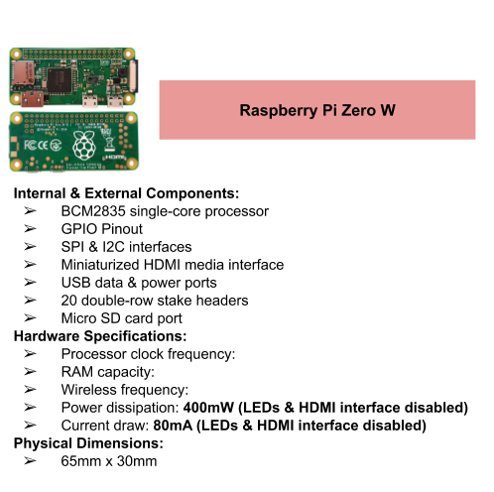

***Figure 3.18:*** *The Raspberry Pi Zero W is used in this design for its low power consumption, processing capabilities, and peripheral connections such as SPI, I2C and ribbon cable interface.*

The RPi Zero W (RPi) was chosen for its processing ability, low power consumption and its ability to connect multiple peripheral devices. The RPi Zero W has a single core 1GHz processor, the same processing capability as the RPi B/B+ and RPi A/A+ modules. All RPi modules require the same 5V rating, but the Zero W only requires 80mA with HDMI and LED turned off [18]. Only the A+ modules offer similar low power characteristics, but the A+ only has 256MB of RAM compared to the Zero’s 512MB of RAM, making the Zero W more ideal for image processing. The Zero W also offers a camera port as well as SPI and I2C capability, allowing the connection of two cameras, a brightness sensor, and a transceiver module [42]. The RPi acts as a master device for all of the peripheral hardware discussed in this Chapter with the exception of the stepper motor. The RPi also acts as the master device for the transceiver module is discussed in Chapter 4. Similar image processing microcontrollers do not have a convenient camera ribbon cable port. Boards in the Teensy family used by the Forever Flight project, a drone based wildfire detection system, would not work for our design because they do not have a ribbon cable port, sufficient processing power or sufficient RAM. However, they would have more stable memory to protect against unexpected power fluctuations. RPi’s can become corrupt after shutting down unexpectedly while Teensy boards will maintain stable memory.

## 3.4 Software Description

The algorithms on the RPi were implemented using Python 3 and OpenCV. Python 3 was chosen because it implements powerful image processing while being very versatile and forgiving for working with file manipulation. Additionally, Python has numerous packages available to accomplish any task. Python is ideal for prototyping, but a commercial design should use C to maximize processing speed. All Python packages were installed using the “sudo apt-get” command.

The OpenCV 3.4.3 Python package is used for its image processing methods. The OpenCV package allows images to be read in as arrays for processing and offers many different methods to manipulate these arrays. The specific methods and the function of the algorithms are described in upcoming sections. The MATLAB image processing toolbox gives a similar list of functions to the OpenCV methods, but some MATLAB functions are not able to be converted to C code to be executed on the RPi.

### 3.4.1 Sampling Finite State Machine

## 

***Figure 3.19:*** *This is a block diagram describing that operation of the operation of the RPi.*

A state machine is used to control the execution of the image processing algorithms and when the cameras will capture images. The Uno controls the stepper motor and powers auxiliary devices. The Uno is discussed in further detail in later chapters. The RPi is used to run image processing algorithms and operate the transceiver modules discussed in Chapter 4. The RPi and Uno communicate the state of the stepper to coordinate capturing images when the cameras are not moving. This communication is accomplished by setting GPIO pins high or low.

The cameras survey a full 360° every 5 minutes during regular operation. During times of low power, the sampling frequency is increased to 12 minutes and suspended in critical power mode. This 5 minute time was chosen to limit the maximum theoretical detection time to 15 minutes. For example, if a fire starts right after a cycle ends, 5 minutes will pass before the next cycle. If the probe misses the fire on the first cycle, it will take another 5 minutes to begin a second cycle. A fire detected on the second cycle will be confirmed to not be a false positive after another additional 5 minutes.

The RPi has a single output to the Uno. This output uses BCM 16 to let the Uno know when images have been captured and the RPi is ready to move to the next position. The pin is set high when the RPi is ready to move. The RPi accepts two inputs from the Uno. One input, BCM 20, lets the RPi know when the stepper has stopped moving and is ready for the RPi to take pictures and process images. The pin is high when the RPi should take pictures. The second input, BCM 21, is used as a diagnostic pin from the Uno to the RPi. This pin is high when the battery encounters issues. This diagnostic information can then be relayed to the end user.

The RPi focuses on running non-blocking code, but blocking code is required for transmitting or receiving RF signals. Times for transmitting and receiving are chosen when the RPi is waiting for a positive edge from the Uno indicating that the cameras can capture images. Since the Uno will wait for the RPi to acknowledge that images were successfully processed, there will be no chance for the RPi to miss a time sensitive signal. Additionally, messages are only transmitted after all sectors have been surveyed. This reduces the possibility of numerous messages from one cycle from clogging communications channels.

The functionality for transmitting and receiving images has been implemented with a C executable and text files. The C executable’s functionality is described in Chapter 4. Messages that are received by the node are stored in text file if they require action from the state machine. Otherwise, received messages will be dealt with inside the C executable. Messages that need to be transmitted by the state machine are stored in a different text file for the C executable to access when called. The transmit text file is cleared after calling the C executable to transmit all messages.

The RPi also toggles between the color saturation thresholding and the brightness thresholding algorithms. This control also includes operating the mechanical cut filter on the RGB camera to change its IR sensitivity. When lux levels are above 250, the RPi sets BCM 26 low to block IR light and will process the image with the color saturation thresholding algorithm. When lux levels are below 250, the RPi sets BCM 26 high to allow IR light through and will process the image with the brightness thresholding algorithm. The next false positive check will also use the same cut filter setting and algorithm to confirm or reject any anomalies.

### 3.4.2 Supporting Software

The RPi uses the Raspbian Stretch operating system. This is the recommended operating system from the manufacturer, Adafruit. The full Raspbian operating system was not used because it implements features such as a graphic user interface desktop that is not necessary for the design.

The cameras are operated using a Python package and C executable. The picamera Python package is used to operate the RGB camera. The picamera package allows control over image resolution, shutter time, and post processing effects such as brightness and contrast although none of these were used. The LeptonModule git repository provides C executables to capture images from the FLIR Lepton camera.

The OS module is used to call C executables such as the transceiver module and LeptonModule executables. This is accomplished by using the OS package to run bash commands from a Python script. Another option would be the subprocess package, but the subprocess package has output requirements on the output from executable that are not present in the OS package.

The SMbus package is used to push commands to the RGB brightness sensor’s registers over the I2C interface. There are separate SMbus methods for reading and writing to each register.

The RPi package is used to operate the GPIO pin on the RPi. The Python scripts use the GPIO pins in BCM mode.

The time, math, and numpy packages are used to expand the basic functionality of Python by giving it the ability to set timers and run more high level math functions such as calculating the distance between anomalies in an image. The numpy package also allows Python access to most data types and additional control over arrays.

Python scripts are executed on start up by adding a bash command to rc.local. This bash command executes as the RPi is starting up so an ampersand is added after the command to let the RPi continue booting while the state machine is continuously running.

### 3.4.3 Brightness Thresholding Algorithm

The thresholding algorithm is used to process images from the RGB camera at low light levels. At low light levels a potential wildfire will be the brightest source of light in a remote area. The algorithm looks for groups of connected pixels with the highest values in a grayscale image array. The threshold and maximum connected pixels have been determined experimentally through field testing. More field testing would refine those numbers to create a more accurate system. Additionally a machine learning algorithm could be used to calculate the ideal values given a large set of images from field testing.

The images are converted to grayscale by averaging the red, blue, and green values with equal weight. This differs from the usual grayscale conversion that weighs green highest and blue lowest. This is done because human eyes do not view each color as the same brightness. However, since a fire does not have this weighting, the typical grayscale conversion is replaced with an unweighted average.

Images are then thresholded to create a binary image with the Python threshold method. Any pixel with a value below the threshold has its value set to zero and any pixels with a value above the threshold is set to the maximum value of 255. The threshold has been experimentally calculated to be 230. This leaves a binary image with only nonzero pixels that have the brightness characteristics of a fire.

The binary image is then run through a blur filter to connect pixels into groups. Connected pixels are defined by having another pixel in the adjacent 8 pixels with a nonzero value. This is accomplished with the Python connectedComponentsWithStats method.

The connected pixel groups are then sorted based on size into groups that could potentially be fires. Groups of pixels that are too big are discarded as not being fires. The maximum size has been experimentally determined to be 10000 pixels. Any remaining groups are flagged as possible fires and are recorded for the false positive algorithm to check on the next pass.



***Figure 3.20:*** *This image was captured by the RGB camera in light levels below 150 lux. The bright spot in the middle is a beach fire at 500ft.*

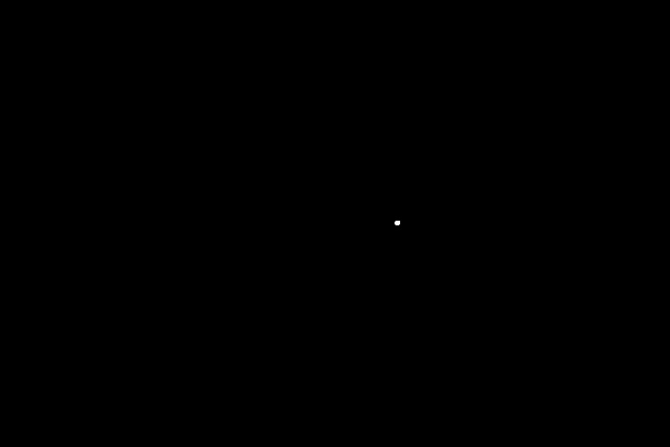

***Figure 3.21:*** *This image is the result of the brightness thresholding algorithm on Figure 3.20. The only remaining pixels are those from the fire.*

### 3.4.4 Color Saturation Thresholding Algorithm

The color saturation algorithm is used to process images from the RPi camera operating in “Normal Mode” during daylight hours. With more light during day time, there are bound to be other bright objects or reflective objects that may trigger the brightness thresholding algorithm. Since more colors are apparent during the day, taking a survey of the surrounding environment to look for groupings of red or orange pixels in the RGB images will likely indicate the presence of a flame in contrast with the background color of mostly green and brown vegetation and earth.

The algorithm takes the RGB image and thresholds the pixels to differentiate the pixels in a fire region from any similar colors captured from non-fire objects. The original RGB image is separated into its red(R), green(G), and blue(B) color channels and then converted to a new image using the YCbCr color space. The YCbCr color space represents the brightness (Y) of the image and its color information (Cb and Cr). The Y, luminance, channel of the new image is essentially a grayscale conversion of the original image since it focuses on the brightness of the pixels. The Cb, chrominance-blue, channel provides color information within the blue and yellow spectrum while the Cr, chrominance-red, channel provides color information in the red and green spectrum. Using these three channels, the RGB image will be segmented into its brightest and reddest region.

With each color channel extracted as vectors, the values in these vectors will provide the information used for thresholding. The first check to find the fire region was by identifying the pixels where the Y values were greater than the Cr values. The algorithm would then check where the Cb values were less than the Cr values since there are more red in a fire than there are blue. Lastly, the process checks where the Cr values are greater than the lowest Cr value present in the fire region. With the Matlab image processing toolbox, it helped identify the color thresholds for the Cr channel. For any pixel that holds true to these three checks, it will produce the segmented image of the fire region, removing other parts of the image that are not above the threshold.



***Figure 3.22:*** *Original RGB image of a small beach fire taken during the day at 200ft away. RPi camera is operating in “Normal Mode”.*

***Figure 3.23a*** ***Figure 3.23b***

***Figure 3.23:*** *Figure 3.23a is the direct processed image after thresholding the RGB image from Figure 3.22 in the YCbCr color space. Figure 3.23b is a zoomed in version of 3.24a to show the segmented fire pixels.*

With the segmented image, it is separated into its three RGB channels and are used for the next level of color thresholding. Since a flame appears mostly red in color, the red channel will have the largest pixel values while the blue channel has the lowest values. By checking the pixels where the red values and green values are greater than the blue values, and where the blue values are less than the lowest red value, it will segment the image and convert it to a binary, black and white, image. Where the pixels hold true to the thresholds, that pixel value will be maximized to a white pixel, containing a value of one or 255. For pixels that do not hold true to the threshold, their values are converted to a black pixel, which is a value of 0.

***Figure 3.24a*** ***Figure 3.24b***

***Figure 3.24:*** *Figure 3.24a is the binary image resulting from Figure 3.23a after thresholding the RGB channels. Figure 3.24b is a zoomed in version of Figure 3.24a to show the bright pixels clearer.*

Once the color saturation of the flame is processed with color thresholding, it will result in a binary image of the fire region, which is a simpler format for further processing. The connected pixels from the binary image are sorted by area, so any group of connected pixels with too large of an area are determined not to be potential fires.

### 3.4.5 Thermal Thresholding

Images from the FLIR Lepton are used to capture the profile of a fire in the LWIR spectrum. These images are processed similarly to those taken by the RGB camera in low light levels. However, the output of the FLIR Lepton is very different than that of the RGB camera.

A single image is extracted from the video stream using code from the LeptonModule git repository. The Lepton sends images in packets that contain a rows worth of pixels. The executable listens on the SPI channel until it receives 60 packets of pixel data. The pixel data is saved as a PGM file with 3 lines of header information followed by 60 lines of pixel data. The header information contains the type of PGM, resolution and maximum value.

The PGM file output from the FLIR Lepton is not viewable by humans, so a conversion algorithm is necessary to view images for analysis and debugging. Each pixel value is extracted and scaled to be between 0-255 and copied into an array. The OpenCV package is then used to save the array as a JPG image for human viewing. There is an online tool to convert PGM files to JPG images, but it was only limited to 10 images per day. Therefore, it is recommended that a conversion algorithm is used for field testing and data analysis.

The code from LeptonModule subtracts the minimum pixel value from every pixel in the image so at least one pixel has a value of zero in the image. This scaling functionality was removed in this design to obtain the absolute values output by the Lepton. With values scaled the object with the most IR intensity in the image will always appear to be white. This could lead excessive false positive in a cold environment.

The thresholding algorithm in Section 3.4.3 has been repurposed for the IR images from the FLIR Lepton. The only changes made were in the values used for the threshold and maximum connected pixels. The threshold value is 8400 and the maximum connected pixel value was 25. Additionally, the PGM images do not need to be converted to grayscale values, as the PGM file has grayscale pixel values.

**

***Figure 3.25:*** *This image was captured by the FLIR Lepton from 1000ft. The bright spot in the middle is from a 1ft ${}^{3}$ beach fire. The pixel values have been scaled for human understanding, actual maximum values from the fire are closer to 8500.*

**

***Figure 3.26:*** *This image is the result of the brightness thresholding algorithm on Figure 3.25. The only remaining pixel is that from the fire. The pixel may appear to be more than one in a cross pattern, but that is only an effect from jpg formatting.*

### 3.4.6 False positive suppression algorithm

A false positive suppression algorithm is used to counteract the numerous false positives possible in this design. A couple false positive examples are if a person shines a flashlight into the cameras or the sun shines on the probe. The flashlight is both hot and bright likely triggering a fire alert. Additionally, the sun and its reflection are both hot and bright and could be red in a sunrise or sunset. The false positive algorithm will look at the longer term behavior of a fire to decide if an anomaly is indeed a fire. A fire will grow, but will not completely change location between surveillance cycles. Therefore, the false positive algorithm will compare images of the same sector in adjacent samples, confirming that an anomaly is a fire if it remains in the same area and if it has grown. After testing false positives detected either moved far enough to be rejected or varied by less than 10%. The false positive algorithm will only compare anomalies that come from the same type of algorithm.

The false positive algorithm uses information from the Python connectedComponentsWithStats method to find the center of each set of connected pixels. If the second picture of the sector has an anomaly within the radius of the first anomaly and the second anomaly is bigger than the first by at least 10% then the false positive suppression algorithm will confirm that anomaly as a fire and initiate the process of alerting emergency services.

# Chapter 4: Communication Subsystem

# 

## 4.1 Introduction

The need for a reliable and robust communications network on this system is paramount. Once alerts are generated by the detection team, it is up to the communications subsystem to relay them to the proper authorities. As previously mentioned, this subsystem has the following requirements: wireless, low power, operating on unlicensed spectra, capable of relaying messages twice as far as the fire detection range, and doing so reliably.

The need for a wireless system is the most apparent constraint. The alternative is a wired communication system and this design would be impractical and also introduce hazards. Due to the nature and purpose of this system, the probes will be placed in the wilderness and therefore be subject to wildlife and the elements. Additionally having a wired system would not only be more expensive but also more dangerous. It would present the possibility of the relatively exposed cables becoming structurally damaged which would not only compromise the integrity of the system as a whole but also present the possibility of the system itself starting a fire which in of itself is quintessentially the antipodal of our intended goal. However there are also a few advantages that come with a wired system such as higher rate of data transfer and whilst in operation, a much higher rate of successful transmission. However with all this in consideration the wireless implementation of the communications system was deemed necessary at the sacrifice of the aforementioned higher speed and reliability.

Furthermore, this subsystem needs to consume as little power as possible. The power source of this system will be capable of operating without the need for human intervention only if each subsystem strives to use the lowest amount of power possible. Since the system is designed to be autonomous this is a necessary constraint for every system. Following this constraint is the desire for this subsystem to operate on unlicensed spectra. There are two main reasons for this. The first reason ties back to the need for a low power system. Obtaining a license to operate on certain spectra would allow the system to output more power wirelessly and therefore extend the effective communication range however this would conflict with the desire for a low power system. The second reason is more economical as these licenses require time and money to obtain, both of which are valuable resources.

The final constraints of the subsystem are it’s range and its reliability. To avoid a bottlenecking of the detections range, the wireless range needs to be twice that of the detection range. This is due to the detection probes being placed with twice the distance of their detection range between them and still having no blind spots due to their 360 degree field of view. Lastly and of utmost importance is the reliability of transmission. Once alerts are sent wirelessly, there needs to be mechanisms in place to ensure that messages aren’t lost and are received without or with minimum corruption.

With these identified design constraints, a plan was devised to translate them to engineering specifications and to implement them with both hardware and software.

## 4.2 Strategy for Implementation

Before selecting hardware and writing software to implement the system, a method to detail the design constraints in terms of engineering specifications was created. The wireless and unlicensed spectrum requirements are straightforward and are in and of themselves viewed as engineering specifications limiting the final hardware choices. However, the desired range, reliability, and low power requirement are less straightforward. To detail the desired range from a distance as an engineering specification, a link budget was determined to be the proper tool. Further, in terms of reliability from a constraint point of view to an actual specification was defined as the ability of the system to transmit alerts and ensure that they are received with little to no corruption. To accomplish this, a set of protocols was determined to be necessary and thus implemented in software. Lastly, the low power requirement was discussed with the power team whom once able to identify the realistic capacity of their system detailed the power specification of the communication system.

## 4.3 Link Budget Analysis

Using Radio Mobile, an amateur radio software used for electromagnetic propagation analysis, a link budget study was completed. This software allows the user to select two locations, input certain specifications of transmission, and analyze path loss of signals due to free space, urban obstruction, forestry loss, and statistical loss. With this software, a simulation of a link between the parking lot along Coolidge Drive at UCSC and an open field in Pogonip was completed. These locations were selected because they are accessible to the team, could be used to actually field test the hardware, and represent a distance further than what the detection node should be able to achieve. Once the locations were selected, the remaining variables to be inputed were the antenna heights, frequency, transmit power, antenna gains, and receiver sensitivity. However, after using the software, it was noticed that the receiver sensitivity didn’t affect the pathloss. As such, this parameter was chosen arbitrarily. The antenna heights were selected to be 1.5 meters off the ground since this height is roughly what the system height will be. Several different frequencies were tested within the unlicensed spectra to observe how they affect path loss and the transmit power was set to 10 dBm as a reference. The antenna gains were set to 5 dBi as this is the average gain of a standard rubber ducky antenna. The figure below shows the output of radio mobile with the described parameters.

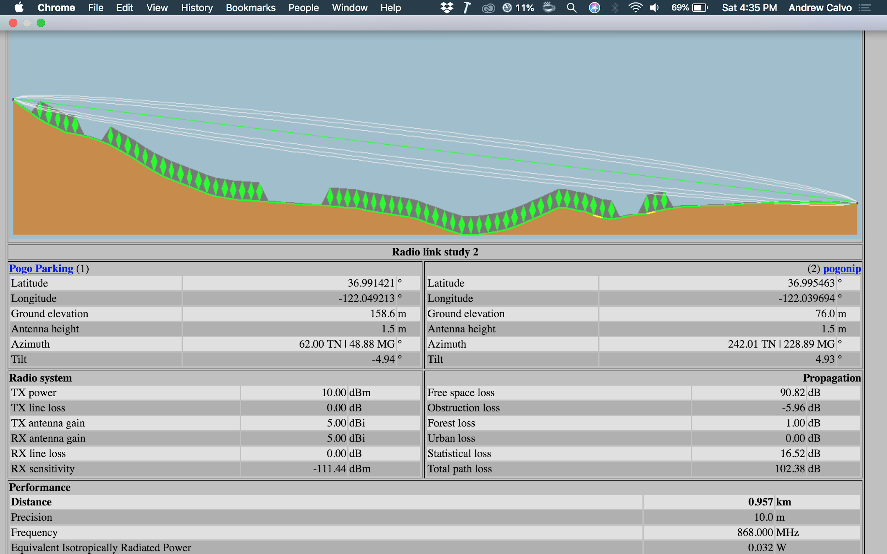

***Figure******4.1:*** *Radio Mobile propagation analysis*

From Figure 4.1, it can be seen that the path loss with the given parameters is 102.38 dB. When the simulation was ran with all the same parameters except for the frequency being set to 433 MHz, the path loss decreased to about 98.67 dB. These two theoretical quantities give the expected path loss at their respective frequencies at a distance 50 meters shy of a kilometer. With these values, a transceiver could now be selected that has a difference in transmit power and receiver sensitivity greater than those pathlosses.

## 4.4 System Topology

### 4.4.1 Overview

In terms of the topology, the communications system consists of three distinctively unique types of nodes and a flexible network protocol to handle and relay the stream of information coming from the detection team. The three types of nodes are the detection nodes, the repeater nodes, and the end user nodes. These nodes function in cohesion to deliver messages from the detection system to the end user and vice versa. They all operate on a basic network protocol that dictates what to do when a message is received and what should happen to acknowledge the reception of a given message.

### 4.4.2 Detection Nodes

The detection nodes formerly classed as short range communications were equipped with low power TI CC1101 transceivers later swapped for longer range Semtech SX1276 LoRa spread spectrum transceivers. These transceivers are used with the RPi sharing the SPI pins MISO, MOSI, and SCLK with the detection team and controlled with BCM pin 25 as its chip enable.

### 4.4.3 Range Extenders

In the case of the range extenders the same Semtech SX1276 was used however in this case due to the lack of presence from the detection and power teams the entire 40 pin header was available for use and so a module containing a SX1276 and GPS chip by Dragino was used. The basic idea was that with this package connections would be robust, reliable, and easy to match. Additionally with the inclusion of a GPS module the time could be synced on each device with true time to ensure that messages would have accurate absolute timestamps instead of locally accurate timestamps.

### 4.4.4 End User

The design of the fire detection system includes an end-user interface that notifies the proper fire control personnel of any alerts, including a fire or battery system error. The interface provides information but does not take in any inputs. It is housed in a 3-D printed box using polylactic acid(PLA) with the dimensions of: 5.5” x 3.5” x 2.2”. Within the housing, a RPi, LoRa transceiver with the SX1276 chip, and a printed circuit board that controls an audible buzzer are present. A 16x2 LCD screen using the Hitachi HD44780 driver is secured on the top center portion of the box. In addition, an 8-element Yagi antenna, not shown in the diagram below, is connected to the transceiver and mountable to a mechanically stable location.

## 4.5 Selection of Hardware

### 4.5.1 Overview of Core Components

The communications system consists of three distinct areas of hardware namely the short range communications, the long range communications, and the end user. Strictly speaking the short range communications have been scrapped in favor of long range to be discussed below. Originally all communications hardware (hardware excluding the end user display assembly) was chosen primarily to be as long range and low power as possible due to the then perceived power limitations. After comparing a roster of viable SOC’s the RPi was chosen and proposed to the team due to its inclusion of the standard camera cable for the cameras and it’s low power consumption compared to its alternatives. Additionally this board was chosen and proposed due to its large number of GPIO pins and inclusion of all three primary communications UART, SPI, and I2C for versatility of peripherals.

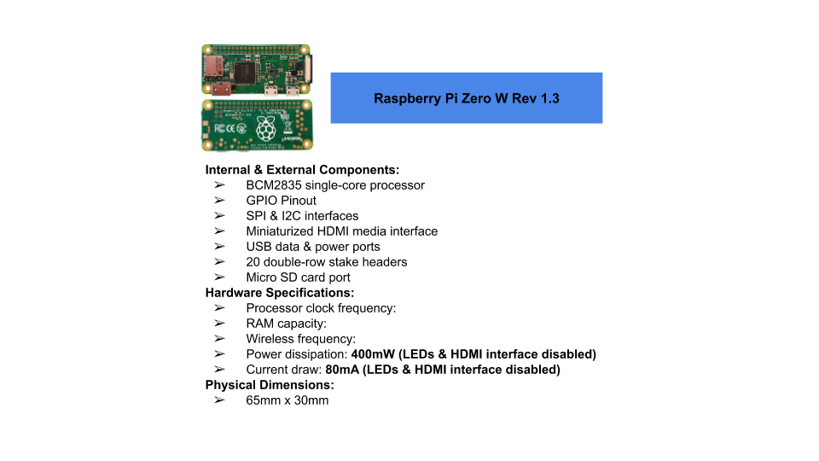

***Figure******4.2:*** *SOC used on SSDS*

### 4.5.2 Short Range Communications

Originally the short range communications were to be handled by a TI CC1101 chip for its ability to be adaptable with the volatile requirements of the team and it’s satisfaction of the engineering specifications. Compared to other TI chips such as the CC1120 and CC1150, the CC1101 had maximum range while still maintaining the flexibility to greatly increase range with the addition of the natively supported CC1190 range extender. In this case however since the CC1190 board didn’t have a readily available expansion board eventually the chips were purchased and a reference design was used for the expansion board. This however was superseded by the Semtech SX1276 LoRa spread spectrum chip due to the lack of available manpower in finishing the long range. However it is important to note that the CC1101 has several distinct advantages over the SX1276. Primarily these advantages lie in obstruction of the Fresnel zone in which the SX1276 is highly temperamental to obstructions and requires nearly a perfect line of sight between modules whereas the CC1101 using G-FSK at 433 MHz was comparatively much more reliable with obstructions the tradeoff being shorter range but rectified with the CC1190 range extender. The next primary advantage of the CC1101 was its ability to perform an automated CRC-16 check which would have all but eliminated the need for a corruption checking protocol.

### 4.5.3 Long Range Communications

The long range communications system was originally intended to be handled by a NB-IoT transceiver however was superseded by LoRa. Specifically speaking the LoRa module that ended up being the primary communications chip was the SX1276 by Semtech. The candidacy of LoRa and NB-IoT was primarily a function of low power however the deciding factor of LoRa over NB-IoT was the availability of chips for purchase as when the project first required the two the only source of NB-IoT chips were from a norwegian company and were priced much less viable then existing LoRa tech. Two implementations of the SX1276 were used; the first in its base chip from with expansion board and the second as part of an expansion board that also included onboard GPS. The former was chosen for its small size and availability when compared to NB-IoT at the time. The latter was chosen partly because the 40 pin header of the RPi was available for use and so the Dragino LoRa board was chosen for its ease of implementation through simply connecting its own 40 pin bank to the 40 pin header of the RPi. The Dragino LoRa board was also chosen for its inclusion of an onboard GPS chip capable of receiving time.

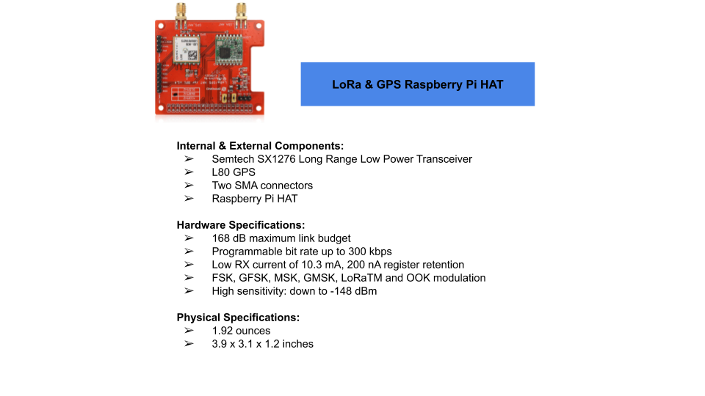

***Figure 4.3:*** *LoRa Transceiver used on SSDS*

### 4.5.4 End User Display

The end user node contains an alarm, LCD screen, LoRa transceiver, and RPi. The alarm consists of a PCB that includes an LM311 comparator chip by Texas Instruments, a PKB24SPCH3601-B0 piezoelectric buzzer by Murata, and three 0805 surface mount resistors. The piezoelectric buzzer was chosen for its small size of 1-inch diameter as well as its adequate audible volume. The sound pressure level according to its datasheet is 90dB at 12Vdc. The operating voltage ranges from 3.0 to 15.0Vdc. The schematic for the circuit is shown below:

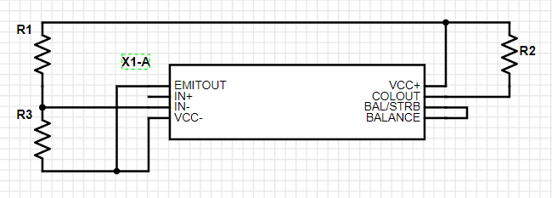

***Figure 4.4:*** *Schematic of alarm circuit*

The LM311 chip is represented by X1-A and has 8 pins. The values of R1, R2, and R3 are 200 kΩ, 20 kΩ, and 20 kΩ, respectively. The purpose of the comparator is to compare two input signals, IN+ and IN-. If the voltage at IN+ is greater than the voltage at IN-, the COLOUT pin will output a signal that is equivalent to VCC, feeding into the piezoelectric buzzer. If IN- is greater than IN+, the output at COLOUT is zero.

R1 and R3 serve as a voltage divider network. The voltage Vref at IN- can be calculated by using equation 4.1:

$\frac{VCC⋅R3}{R1 + R3} = Vref$ (4.1)

This gives Vref a value of 0.5V when VCC is set to 5.5V, which would increase if VCC were increased. Any time the GPIO pin connected to IN+ is high, the voltage provided will be greater than 0.5V and an output of 5.5V will be sensed at pin COLOUT to feed into the positive end of the piezoelectric buzzer. The negative terminal connects to ground to complete the circuit.

A 5.5V source is connected from the RPi to VCC+ while VCC- is grounded. IN+ is connected to a GPIO pin on the RPi; when the GPIO pin is set high, the IN+ pin senses that and compares the voltage to IN-. The voltage at IN+ will be greater, resulting in COLOUT to supply VCC+ to the buzzer. The voltage input to the buzzer produces a high pitched ring that is loud enough to alert anyone within a 30 foot radius.

### 4.5.5 Antenna

In order to increase the range of all wireless communications, 8-element Yagi-Uda antennas were designed and built: one mounted on the detection node and one on the end-user node. The antennas are used to provide high directional gain, a key factor in the maximum range that separate nodes can reliably communicate. An illustration of the antenna is shown below in Figure 4.5:

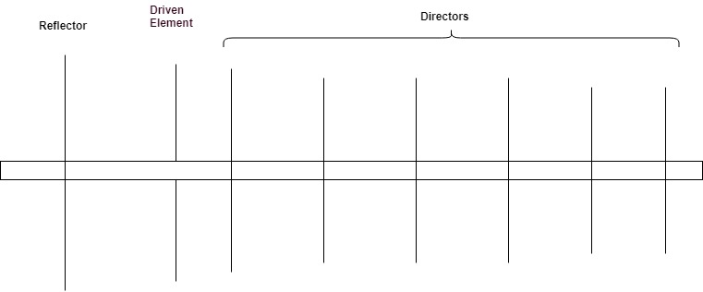

***Figure 4.5:*** *Yagi antenna illustration*

It is constructed with PVC and copper wire. RG-58 coaxial cable and SMA connectors join the driven element of the antenna to the LoRa transceivers. The boom, which is the rod that the 8 elements are connected to perpendicularly, has a total length of 30 inches. The antennas are responsible for transmitting and receiving the electromagnetic waves that contain crucial information and messages regarding fires or battery system errors.

The most common directional antenna, the Yagi, was proposed and then simulated in software to determine if it would increase the transmission range to the desired value. The physical dimensions were optimized for 868 MHz, which is the frequency that the LoRa operates. A Yagi calculator provided the dimensions, shown below, for an antenna for that frequency up to 10 elements:

|  |  |  |
| --- | --- | --- |
| **Element** | **Length (mm)** | **Distance from previous element (mm)** |
| Reflector | 168.4 | 0 |
| Driven Element (Dipole) | 162.7 | 69.0 |
| Director 1 | 151.8 | 25.9 |
| Director 2 | 150.2 | 62.2 |
| Director 3 | 148.7 | 74.3 |
| Director 4 | 147.3 | 86.3 |
| Director 5 | 146.1 | 96.7 |
| Director 6 | 144.9 | 103.6 |
| Director 7 | 143.8 | 108.8 |
| Director 8 | 142.7 | 114.0 |

***Table 4.1:*** *Yagi dimensions*

In 4nec2, a free program for creating antennas and observing their characteristics, the Yagi was modeled along with the quarter-wave whip and rubber ducky antennas. The driven element was modeled as a half-wavelength dipole. Adding more directors to a Yagi improved the gain in one direction and narrowed its beamwidth. Simulations started off with a 3-element antenna and the number incremented by one until the total element count reached 10. The conclusion was that a Yagi possessed much greater gain than the quarter-wave whip and the rubber ducky. The 8-element Yagi simulation produced desirable results, providing a gain of 17.7 dBi with vertical polarization at 2 meters above perfect ground. The simulation profile is shown below:

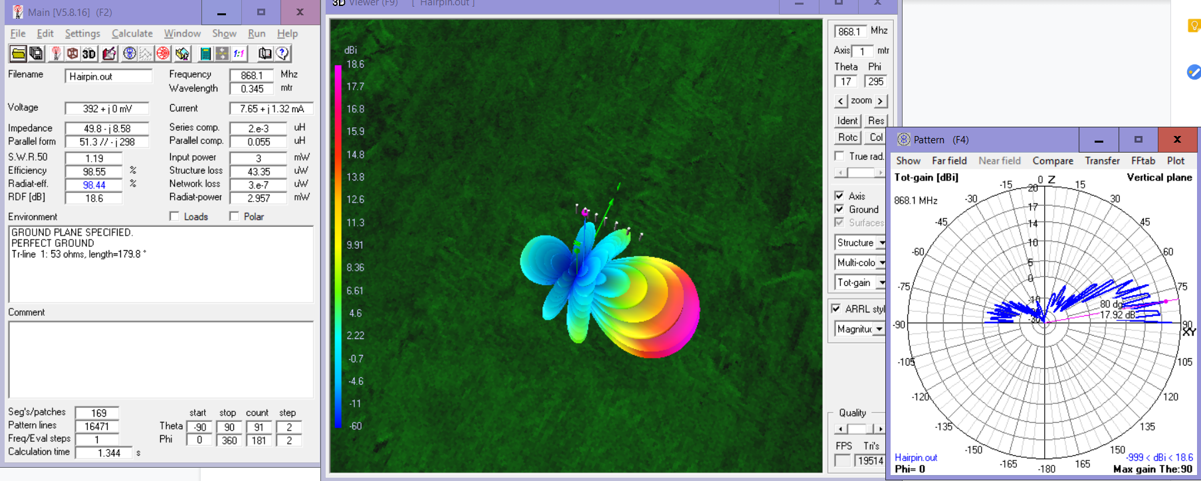

***Figure 4.6:*** *Simulation of 8-element Yagi*

The radiation pattern of the antenna is displayed along with its gain color coded. The input power in the model is 3 mW and the antenna possesses a feed impedance of 49.8 - 8.58j Ohms. The effective beamwidth is 28 degrees above the boom’s axis, requiring the antenna to be pointed directly at another transmitting or receiving antenna to achieve maximum gain.

The 8-element Yagi was selected for its gain improvement over the quarter-wavelength whip antenna’s simulated gain of 2.14 dBi. Choosing a design with fewer elements would lower the gain without significantly widening the beamwidth for a more lenient mounting position. Increasing the number of elements to nine would lengthen the boom by an extra four inches but would provide only 1 dBi of gain, yielding an undesirable tradeoff. The 8-element design offered a compromise on size and gain as well as physical stability of the antenna; statistically, adding more elements would increase the chance of damage or malfunction on one element. Minimizing the number of elements while still reaching 3 km transmission range was important for lowering the probability of an element sustaining damage.

The improved gain from the Yagi was compared with the range and RSSI data gathered from field tests results, resulting in an estimation that the 8-element antenna would provide the desired 1.5 km additional range. Construction of the prototype antenna comprises of 1-inch diameter PVC pipe with a length of 30 inches, #14 AWG bare copper wire, masking tape, and 3 feet of 50 ohm impedance RG-58 coaxial cable with an SMA male connector on one end. The wire is cut to the specified lengths according to the chart above, up to Director 6, to obtain a total of 8 elements.

The driven element wire is separated exactly in half with each piece having a length of 81.35 mm. The open end of the RG-58 coaxial cable is soldered onto the ends of the dipole with the center conductor connected to one arm and the outer braided shield connected to the other arm. In this configuration, the balanced dipole is directly connected to the unbalanced transmission line. The currents on one dipole arm may not be exactly equal to the current on the other arm, which would decrease the antenna efficiency. A quarter-wavelength folded balun using the same RG-58 cable is utilized to resolve this issue. A diagram of the balun is shown below:

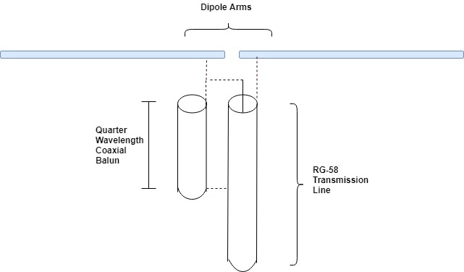

***Figure 4.7:*** *Folded Balun*

A portion of RG-58 cable with a length of a quarter-wavelength (8.63 cm) is connected to the system. One end of the balun’s outer conductor is soldered to the dipole arm that is connected to the transmission line’s center conductor. The other end of the outer conductor is soldered to the transmission line’s braided conductor. The inner conductor of the quarter-wavelength piece is left unconnected and floating. The current below the balun is balanced and the antenna radiates properly.

Using masking tape, all elements are adhered to the PVC pipe at the previously specified distances with their center points lined up. Determining the feed impedance was performed experimentally with a vector network analyzer (VNA) to confirm the simulated impedance value. The result was 46.5 - 14.3j ohms; the antenna possessed a capacitive reactance in its impedance that needed to be removed for maximum performance. An inductor coil using 24 AWG shielded wire was created and soldered between the dipole arms to transform the antenna impedance to 48.9 ohms, reaching an impedance close to the desired value of 50 ohms.

## 4.6 Software Discussion

### 4.6.1 Overview

Software forms the backbone of the communications system and defines everything from the network protocol to message assembly, disassembly and interfacing with the end user.

### 4.6.2 The Network Protocol

The network protocol used on the detection, repeater, end user nodes handle incoming and outgoing traffic to ensure communications between the various nodes. At its core the network protocol consists of error checking, message acknowledgement, and a propagation standard. Error checking is accomplished in the following manner. When a message needs to be sent by any node, the message is transmitted until an acknowledge signal is received. Furthermore, acknowledge signals are only sent when more than one identical copy of the message is received at the destination. This ensures that only non corrupted messages will be acknowledged because statistically, the odds of a message being received more than once and identically corrupted are extremely low. Using this method of error checking through verification by identically received messages and acknowledge signals, transmitted signals can be ensured to be not corrupted and delivered. The only remaining problem is the propagation of signals through the system. Due to the possibility of the system consisting of many nodes, a portion of each message sent is dedicated to propagation information which are the following: source, intermediate destination, intermediate source, and final destination.

The network protocol assumes that the detection nodes, the repeater nodes, and end user nodes are orientated in such a way that the detection nodes are in range of each incremental repeater node however not necessarily in range of one another. The repeater nodes must be orientated in a way that each successive node is within range of the previous repeater should there be multiple and the final repeater node be in range of the end user node. The network can be adjusted for multiple repeaters both at the same ranges to ensure redundancy or simply extending toward the end user. There can also be multiple end users on the network and in fact with the current implementation of the network the end user can be present at any point in the pipeline; the protocol is flexible enough to “end” the line of transmission at any node that identifies itself as an end user.

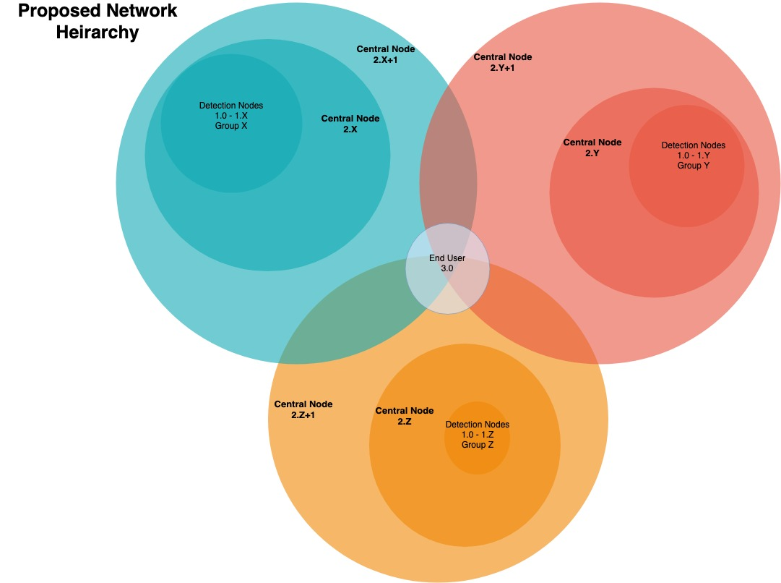

***Figure 4.8:***  *Visual representation of system hierarchy*

This primarily means that since the central nodes will send messages with the intermediate destination being the next expected node prior to the end user but having a final destination field of the end user that the message will propagate along the repeater nodes however many there are and if an end user is encountered then the message will formally be received and should it not be transmitted by the final central node then it will continue on until the last one where the due to the lack of existence of a further repeater node be ejected. The basis of this network protocol relies thus on the existence of a first line of repeater nodes designated R00 however does not rely on a hard coded number of repeater nodes. Additionally it is expected that the end user be in range of any given repeater node regardless of the node numbering.

When any given node receives a message it will store the message assuming that it is not a duplicate of an existing message kept in the communications history file. Should it be a duplicate however the appropriate action will be taken either delete and an acknowledgement sent or simply forwarded with no history kept and acknowledgement sent in terms of the repeater nodes. This process would continue until the final acknowledgement is sent by the end user to the last repeater node that forwarded a message.

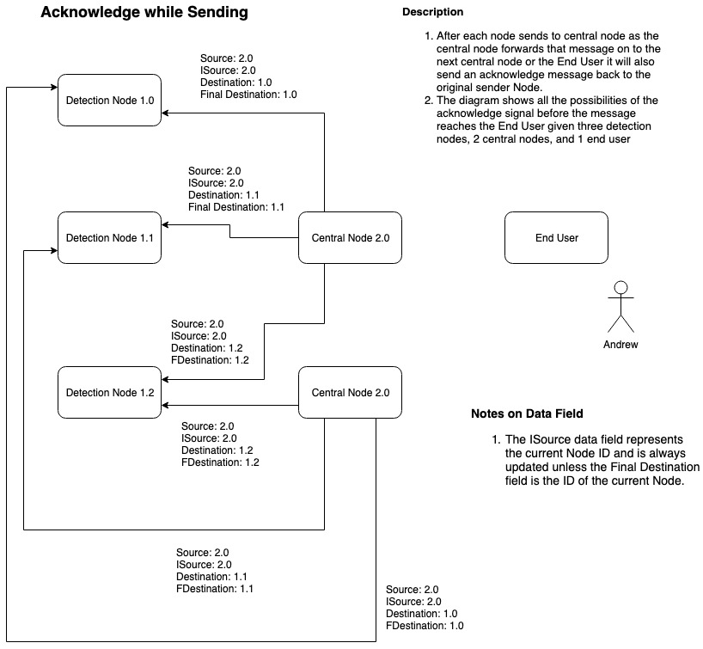

***Figure 4.9:*** *Flow chart of message propagation from end user to detection nodes*

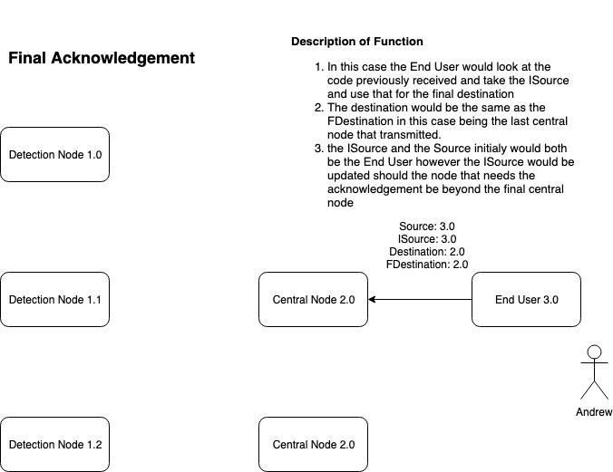

***Figure 4.10:*** *Flow chart of message acknowledgement propagation*

The return process made by the end user consists of an acknowledgement message to the most recent repeater node as defined by the message received by the end user.

### 4.6.3 Detection Nodes

The detection nodes incorporate the basic network protocol agreed upon as well as a few extra features tailored to the detection nodes. The first constraint was that the RPi was single threaded and could only handle one task at a time. This meant that since the detection state machine was always running and in a different programming language on the RPi, the communications software written would most logically have to take form of an executable. In this case the final communications software was done in C whereas the entirety of the detection state machine was written in Python.

The detection side software also includes additional features added due to constraints such as storage of messages in a C file system and transmission of messages read from the same style of file system. These were used such that the detection state machine could simply call the C executable and pass arguments for TX or RX mode where RX mode would set the mode and a time duration to stay in that mode and TX would simply transmit a given message as defined by the network protocol. In either case the executable would look for a set of given files agreed upon between the communications team and the detection team. In the event that any one or multiple of the files didn’t exist the executable would prompt the user of the absence and create the file so that on the next execution the files would be present. This was done for the sake of robustness in consideration that an autonomous system would need to be able to handle cases like these especially given the constraint that it could possibly be deployed in a secluded area devoid of engineers to conveniently rectify such simple issues.

Additionally the detection nodes feature the ability to distinguish between messages that are deemed old and need to be discarded as well as duplicates of the current message. This was implemented as part of the network protocol as there is only a finite amount of storage before it would take a significant amount of time to parse through and check each message in the file system for validity. It was determined with the detection team that a reasonable amount of time before the scrapping of any given message would be anything past 10 minutes old. This particular check is done every time a message is received to ensure that at minimum the check is performed every time the executable is called by the detection state machine.

The executable can be called by passing <TX> for TX mode and <RX> <long time> for RX mode with specified time in terms of a c long. In the case of TX mode as mentioned before the software will automatically create any missing files should they not be present however it will be left blank for detection to fill. In the case of RX mode the software will perform two distinct operations in each case a message is received and registered through the FIFO. The first will be to delete the receive file which the detection team will use to reference messages and populate it with the messages in the current cycle. The second function will be to add to the communications history file which will be used as a message reference to check for duplicates. Ideally with no corrupted messages all messages will have a counterpart and will be acknowledged then deleted. However unfortunately there will be cases of corrupt messages in which case the worst case scenario will be a pileup of such messages which is why past a certain time difference those messages will be thrown away regardless of status.

### 4.6.4 Repeaters

The range extenders use a variation of the software found on the end user nodes. It would simply take every message it receives, update the intermediate source of it and forward it to the “next” node.

### 4.6.5 End User

The end user node implements the agreed upon network protocols using two linked lists and a finite state machine. This state machine controls the LoRa Transceiver and it’s state transition diagram is shown in figure 4.9. The linked lists store messages sequentially; one list is for messages that have not been acknowledged and the other list stores a history of messages that have been acknowledged. The first list stores unique messages within it and waits for duplicate messages to arrive as part of the network protocol. Once a duplicate message is received, the node within the linked list containing the message is deleted and a acknowledge signal is sent. The need for two lists arose from the possibility that acknowledge signals sent from the end user may be dropped. If this were to happen, the genesis of the signal being acknowledged would keep transmitting since it never received a acknowledgment. To circumvent more duplicate messages being sent, the second list stores a history of messages that have had their acknowledge signals sent. When a message is received, this second linked list is check to see if the message being received is actually unique or a result of a dropped acknowledge signal. If the identical message is found within this linked list, the acknowledge signal is retransmitted.

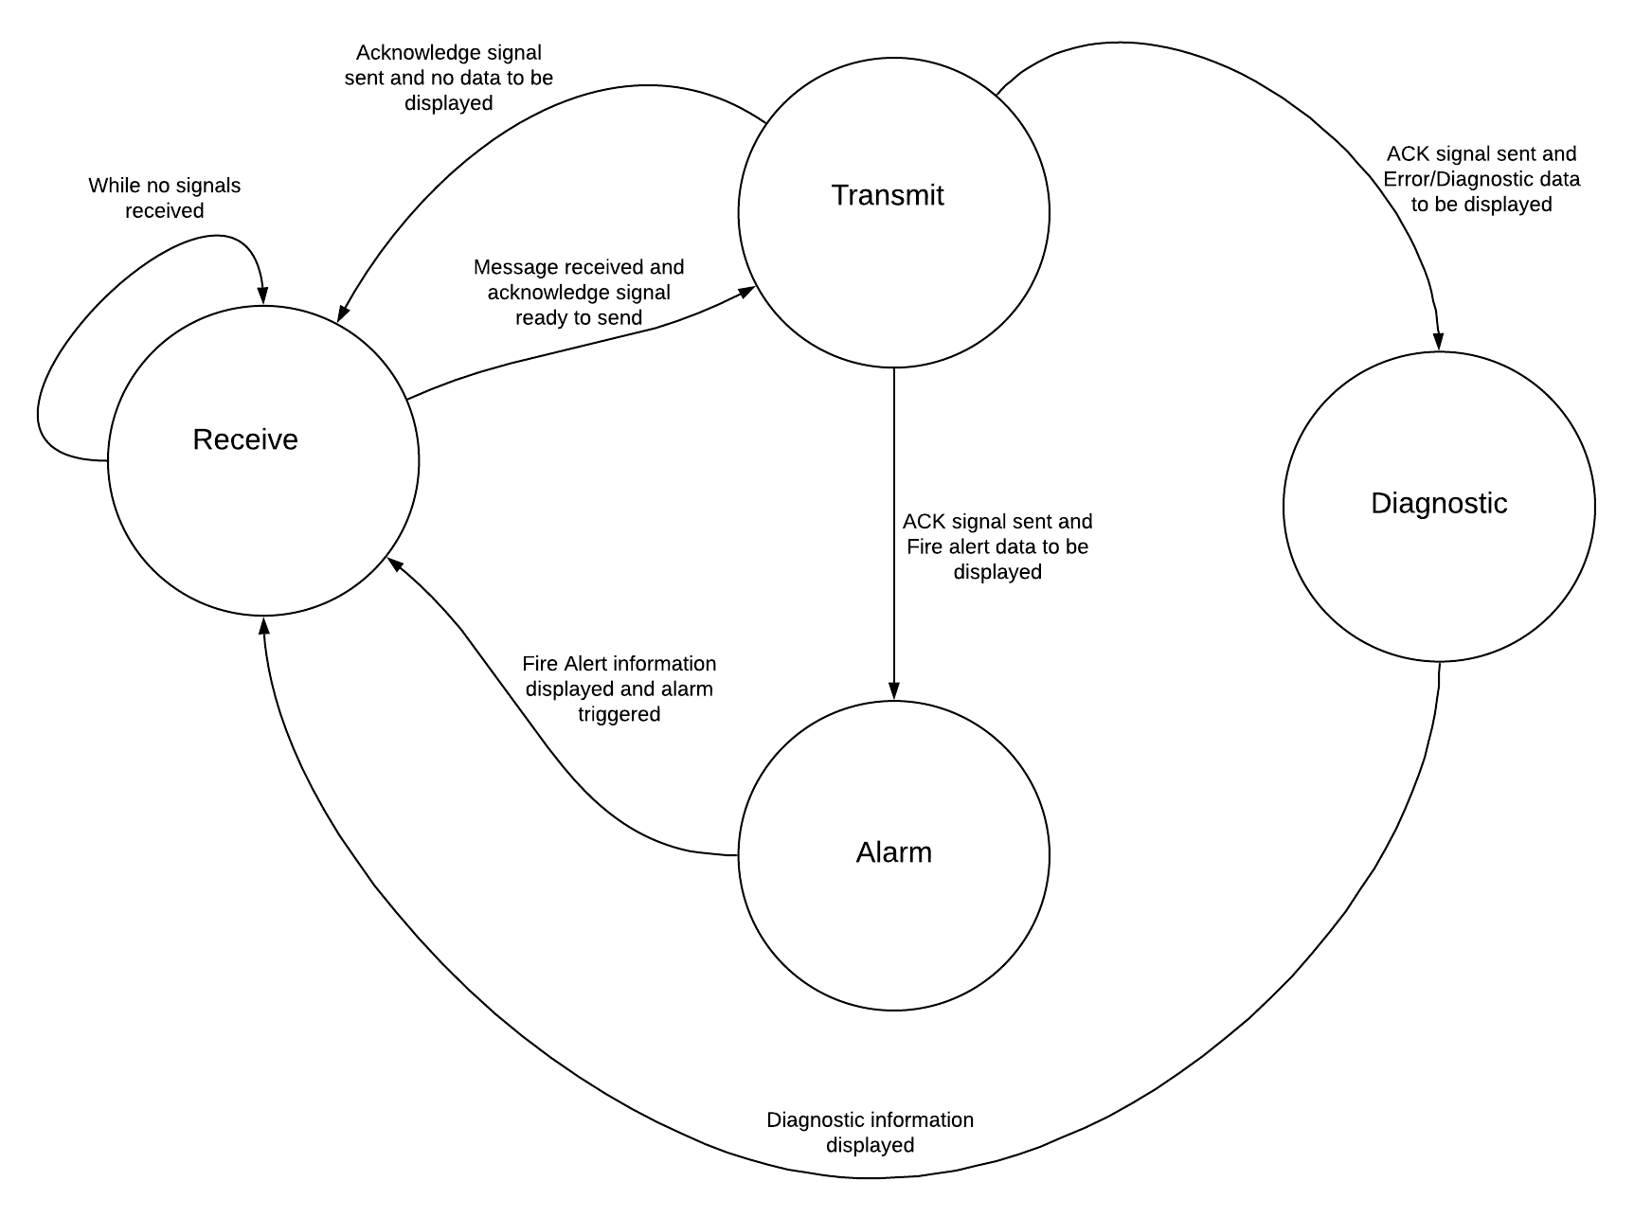

***Figure 4.11:*** *Finite state machine transition diagram for end user*

Once a message is deemed uncorrupted, it is displayed on the LCD screen using the open source wiringPi library.

### 4.6.6 LCD Display

A 16 x 2 LCD display from uxcell was chosen for the user interface display. The dimensions are 3.7 x 1.2 x 2.4 inches in terms of L x W x H. The screen is shown below:

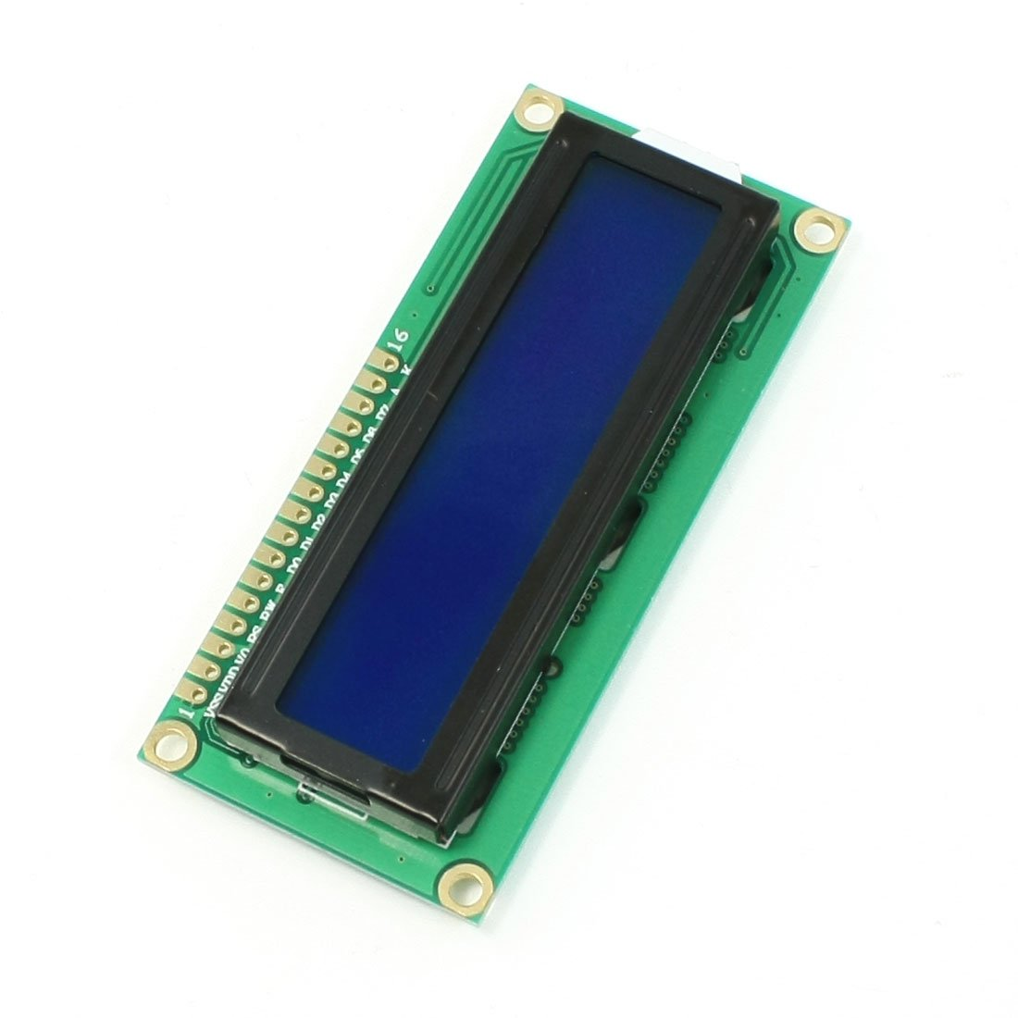

***Figure 4.12:*** *LCD Display*

The screen offers a clear interface for the user to view messages from the system. It fulfills the requirement of being compact and minimalistic. It runs off of the Hitachi HD44780 driver, making it compatible to be programmed with C and the WiringPi library. Since the LoRa transceiver connected to the Raspberry Pi Zero is also programmed using WiringPi, integration with the end-user state machine is simplified when using this LCD.

The user is provided information about detected fires and battery management system (BMS) errors through text-based messages from the LCD screen mounted on the top of the end-user system. The display prints out messages that describe any potential issues. There are 16 pins on the LCD, not all of which are used. The pins from the LCD connect to the pins from the RPi for proper communication between the two devices. This is accomplished by soldering #24 AWG wire between the pins instead of relying on jumper wires for connections. The pin list is given in the table below:

|  |  |
| --- | --- |
| **LCD** | **RPi** |
| VSS (1) | 6 |
| VDD (2) | 2 |
| V0 (3) | 6 |
| RS (4) | 37 |
| RW (5) | 6 |
| E (6) | 35 |
| D4 (11) | 33 |
| D5 (12) | 31 |
| D6 (13) | 29 |
| D7 (14) | 40 |
| A (15) | 2 |
| K (16) | 6 |

***Table 4.2:*** *Pin connections for LCD to RPi*

Pins V0 (3) and A(15) from the LCD each have a 2kΩ resistor in series between them and their respective pins on the RPi. These resistors control the backlight brightness (A) and contrast control (V0) on the screen.

On the RPi, Raspbian is installed as the operating system. The LCD library within the WiringPi library is used to program the LCD to display text messages properly. For ease of integration with the rest of the system, C is used as the programming language for the software that runs on the RPi to control the LCD. For a fire message, the message format is given by:

FIRE! PROBE #

QUAD #

The # after “PROBE” represents the predefined unit number of the probe that detects a fire and sends an alert. Similarly, the value of # after “QUAD” ranges from 1 to 4 and represents the direction of the fire relative to the probe. The quadrants are predefined and fixed; the direction that the camera is facing after rotation does not change the quadrant number in any way.

If an error is detected regarding the battery by the BMS on a probe, the respective probe sends out a message that will be displayed on the LCD in the format:

BATT ERR UNIT #

(NON)CRITICAL

The # is based on the probe number and the “NON” portion will be added based on the necessity of maintenance on the battery system, which will be determined by the BMS.

# Chapter 5: Power Subsystem

## 5.1 Introduction

To effectively detect wildfires and communicate the danger to emergency personnel, the power system of SSDS needs to be safe, reliable and stable. The challenge arises from the harsh climates and remote locations in which the probe networks will reside. The probes must be self-sustaining as they will be placed in rural areas and should not be confined to locations with access to an electrical grid. Therefore, the system must always provide its own continuous power, mandating a need for a power generation and storage system. To maintain the autonomy of probes, any type of human dependent upkeep must be minimized. Thus the power generation and storage systems must last as long as possible before needing maintenance or replacement. The long life span ensures that the probes will operate autonomously for as long as possible before needing human interference. An ability to quickly charge our storage is also ideal as it would allow for the quick storage of generated power. Safety is the most important consideration in the design of the probe’s power system. We must prevent the possibility of thermal-runaway. The fire-prone areas in which the probe will be placed combined with a thermal runaway situation could potentially produce a wildfire. Finally, an understanding of the power consumption of SSDS as a whole is needed to build an adequate power system that can reliably, safely and continuously power SSDS.

## 5.2 Power Budget

Due to the autonomous nature of the SSDS, its power system must provide sufficient and reliable power to all other systems within the probes. To gather a comprehensive understanding of the power use of the system, a power budget is created. The power budget is needed to measure the total power consumption of each individual component and the system as a whole. This is used to build the power system, including the construction of the battery pack, selection of power generation and design of voltage rails.

The power budget is broken down in three different states: Typical, Low and Critical. These states are based on the three operational modes that SSDS has. These operational modes are further discussed in Section 5.5. Power Modes of Operation, but as the name suggests, the states alter the operation of the system. As you can see in Figures 5.1 through Figure 5.3, all components related to the power system will always be powered, no matter the state. In Typical and Low power, the transceivers are always powered as each node must be constantly listening for messages from other nodes. In Typical Mode, the batteries have enough charge to safely sample for fires every 5 minutes. This means that the stepper motor kicks on for 3.06s, the time it takes for it to make a full sampling movement, every five minutes to move the cameras. The RPi goes into Data Acquisition mode where it captures images of the environment. It then moves into Data Processing to process these images. This duty cycle is reflected in Figure 5.1in the Time Active columns. When the SoC of SSDS drops below 40%,the system enters Low Power mode, the power budget for which is shown in Figure 5.2.In Low Power mode, the sampling frequency drops to 12 minutes, which is again reflected in the Time Active column. Finally, in Critical mode, Figure 5.3, all components except those used in the maintenance of the batteries are powered down. This dramatically drops the power consumption to 1.71Ah compared to the nearly 16Ah usage that the system has in Typical and Low power modes. Critical power mode occurs with an SoC of 20% or if there is a battery fault detected. SoC determination and battery fault detection are discussed in detail throughout this chapter.

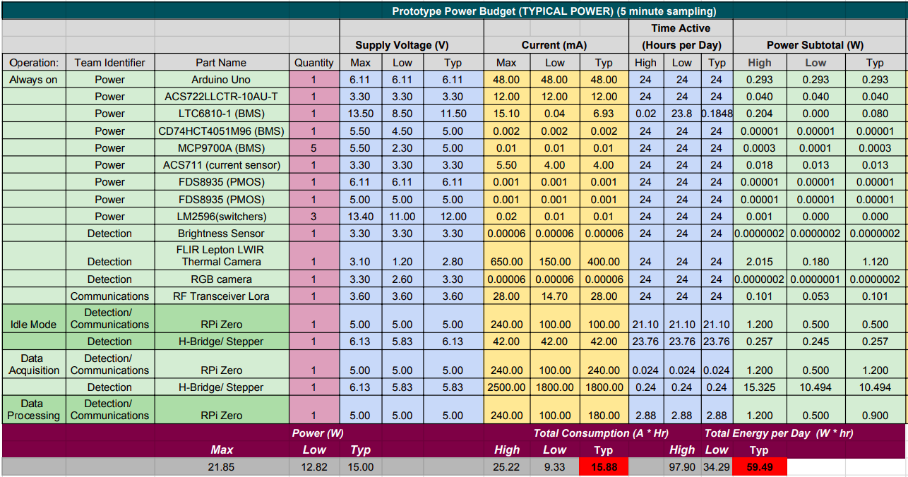

***Figure 5.1:*** *Power budget of typical operation of SSDS. In this mode of operation, SSDS used 15.88Ah and 59.49Wh a day.*

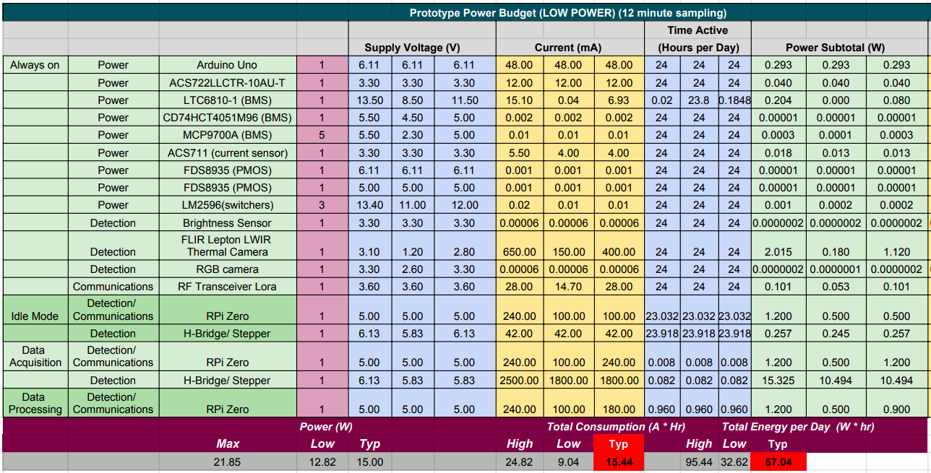

***Figure 5.2:*** *Power budget of low power operation of SSDS. This results in a 3% decrease in energy consumption from typical operation, dropping the usage down to 57.04Wh.*

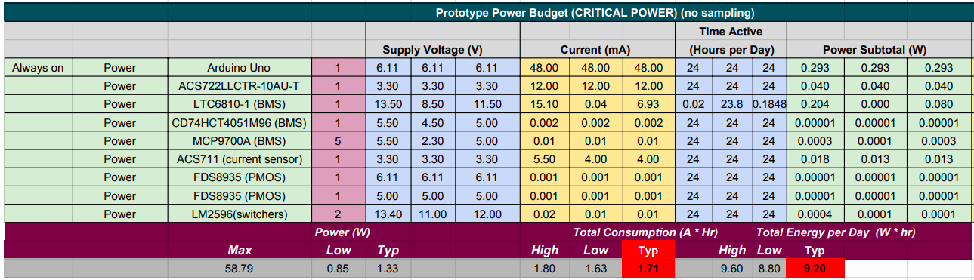

***Figure 5.3:****Power budget of critical operation of SSDS. This dramatically drops the energy consumption of the system compared to typical operation down by about 85% to 9.02Wh from 59.49Wh.*

These three power budgets are central to the design of the SSDS power system. Solutions to energy storage and generation depend heavily on the the power usage of the system, while power delivery is informed by the voltage and current needs of each component. There are a few areas where power consumption can be drastically reduced. These are discussed in Chapter 8on continuation work.

## 5.3 System Overview

### 5.3.1 Selection of Photovoltaics

To achieve the self-sustaining feature of SSDS, the probes generate their own power through the use of solar panels. The reason solar panels were chosen as the means of power generation is because they are the most feasible for the application. Wind turbines are not feasible as they depend heavily on whether a location is particularly windy. Additionally, to sustain the probes they would need to be much larger than the solar panel system. All other forms of self-sustaining power such as, geothermal and hydropower are not worth considering as they make the system more complex, more expensive and more dependent on location.

|  |  |  |  |  |  |  |  |  |  |  |
| --- | --- | --- | --- | --- | --- | --- | --- | --- | --- | --- |
| **Design Solar Panels** | **Cost** | **Size** | **Service Life** | **Charge Profile (V/time)** | **Location** | **Efficiency** | **Low Light Performance** | **Diffused Light Performance** | **Heat Tolerance** | **Total** |
| **Weighting** | 3x | 3x | 3x | 2x | 1x | 3x | 1x | 2x | 2x |  |
| **Monocrystalline** | -- | ++ | +++ | +++ | + | + | + | 0 | + | 22 |
| **Polycrystalline** | - | + | +++ | ++ | 0 | 0 | 0 | ++ | 0 | 17 |
| **Thin Film** | ++ | -- | + | -- | - | -- | - | -- | 0 | -11 |

***Figure 5.4:*** *Solar Panel Design Matrix.*

There are three main types of solar panels that we considered for this project. As shown in Figure 5.4, the most important criteria when making our decision on which panels to use are their cost, size and service life. SSDS, when implemented, is made up of multiple probes, so purchasing expensive equipment for each is not ideal. Looking solely at this aspect, thin film solar panels seem like a good choice. However, thin film panels were only considered because they were inexpensive. After completing the matrix in Figure 5.4, it's been concluded that thin film solar panels are infeasible for use in SSDS due to their extremely low efficiency per area. We would need to use huge thin film panels to get close to power output of the crystalline panels. Completing the rest of the matrix, both of the crystalline panels sufficiently meet our criteria, with monocrystalline edging out polycrystalline, as they are the most efficient type of solar panels available per area. However, because they are less expensive, polycrystalline panels are used for SSDS.

### 5.3.2 Selection of Lithium Titanate Oxide Battery

Regardless of sun exposure, the probe must be able to perform surveillance cycles as frequently as possible both day and night. If this condition is not met then the chance of missing a fire or catching a fire too late is increased. The probe relies on the sun for energy generation, and the intermittency of solar energy requires the probe to have an energy storage system. The method used for storing energy must have a long life span, a wide-temperature range of operation, an acceptable capacity and an intrinsic level of safety. These aforementioned parameters are important and should be well defined.

* **Life span:** There are two ways of specifying an energy storage device’s life span
  + **Cycle-life:** A cycle refers to the process of completely charging/discharging an energy storage device. The total number of cycles an energy storage device can support before its capacity is too severely damaged to continue healthy operation is called its cycle-life.
  + **Overall age:** This refers to the total number of years an energy storage device can be expected to stay useful.
* **Temperature range of operation:** This is the range of temperatures over which the energy storage device can safely and effectively operate.
* **Capacity:** This refers to the total amount of energy an energy storage device can store.
* **Intrinsic Safety:** Not all energy storage devices are equally stable and resilient to abuse. Chemistry, packaging and manufacturing process are just a few of the many factors that can impact the intrinsic safety of an energy storage device. Intrinsic safety refers to a battery cell’s intrinsic ability not to fail in a way that could cause damage to the surrounding area

The lifespan should be maximized as we want each node to last as long as possible before needing replacement. This improves the usefulness, overall price and marketability of the system. The temperature range of operation is important because areas that may need fire monitoring in summer may be freezing in winter and the cells should not fail because of the ambient temperature of the area. Capacity is of course important because it will allow the system to stay active longer when solar panels are not generating power. Intrinsic safety is important because a failure in a cell could cause damage or even fire to the surrounding area.

In addition to these important design parameters, cost, weight and size are also parameters worth keeping in mind. Keeping costs down must be a priority for any system to maximize its market potential. Weight and size also play a role in marketability in addition to keeping the project feasible.

The battery is the obvious choice for a storage system that needs to meet these requirements. Lithium ion type batteries are the highest performing and highest density rechargeable batteries on the market. Many types of lithium ion battery types would meet the basic needs of this project. Thus, lithium ion was selected to be the family of battery chemistry researched for this project. In addition to these cells performing well in life span, temperature range, capacity and intrinsic safety, the ability to place cells in series and parallel allows for total control of the voltage and capacity of the battery pack. This allows for the pack to be more easily designed to fit the exact specifications outlined in the power budget mentioned in Section 5.2.

Under certain circumstances super-capacitors may also be an energy storage solution. If the general power needs of the system are low enough and the system operates in bursts then supercapacitors may be the right for the application. Supercapacitors have a longer cycle-life compared to batteries, often take up less space and can charge and discharge more rapidly than most batteries. The cost is that they have very low energy capacity and add complexity to the design of the energy storage management system. SSDS has energy usage requirements, as seen in the power budget of Figure 5.1 and Figure 5.2, that make supercaps alone inadequate. They simply do not have the energy density to maintain the system during the night. It was initially thought that a supercapacitor-battery hybrid pack would be the best solution as it would have the energy storage capacity of the batteries when needed and the charge/discharge rate and incredible micro-cycling capability of the supercapacitors when needed. The combination of the two would also make the pack last longer in terms of cycle-life. However, the added life-time that the supercapacitors would provide is unnecessary. Batteries alone would produce an acceptable lifetime. This reasoning comes from the expected lifetime of other components and the recommended frequency of maintenance.

The choice of battery chemistry for SSDS is the Lithium-Titanate Oxide (LTO) chemistry. A report of popular lithium battery chemistry variations was conducted by the Boston Consulting Group [49]. The results of the comparison are shown in Figure 5.5. Performance refers to the cell’s ability to operate safely in extreme hot and cold temperatures. Cost is the economic cost of the cell. Specific energy is the energy capacity of the cell and specific power is the cell’s ability to provide high currents. Safety and life span have been previously defined.

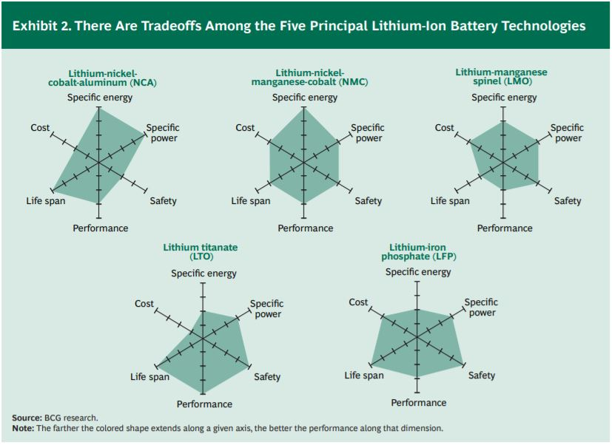

***Figure 5.5*** *A comparison of common lithium battery chemistry variations in six different categories[49]*

Safety, performance and lifespan are of the greatest priority for SSDS. Specific energy is also important, but the ability to place cells in parallel to increase the overall energy capacity makes it a less serious design constraint. If the volume of the energy storage system needed to be significantly small, then specific energy would have been a more significant. However that is not the case for SSDS. A slightly increased volume due to extra cells is not a problem for this project.

As one can see from Figure 5.5, the LTO outperforms every other cell in terms of the performance criteria. LTO is also tied as best in the life span and safety criteria. Although a power system should not rely on the battery chemistry alone to keep the system safe, this is the job of a competent battery management system, the LTO cell is incredibly safe and provides that extra layer of safety if the battery management system is to fail. The cell is generally not prone to thermal runaway and does not fail as easily as other lithium chemistries in low and high temperatures. LTO chemistry has a cycle life and cycle characteristic that makes it excellent for solar applications in which the pack will constantly be charging and discharging with the random variations of available sunlight.

The LTO cell chosen and used for SSDS is the Toshiba SCiB 20Ah cell, shown in Figure 5.6. To safely design with and handle these cells, the documentation provided by Toshiba should be reviewed and understood. Any suggestions made by Toshiba should supersede the suggestions made in this report. These are high quality LTO cells that are used in many automotive application in the US and Japan [44]. The SCiB has a proposed cycle life of over 20,000 cycles. Specifically Toshiba claims that it retains 70% capacity after 20,000 cycles and about 80% after 17,000 cycles [44]. The lifespan of a battery cell is difficult to determine, but can usually be inferred by the manufacturer's warranty. From Toshiba’s warranty these cells can be inferred to last a minimum of 12 years [44]. Because the probes are fairly efficient the cycle life will outlast the lifespan meaning that the 12 year life span will end before 20,000 cycles are reached. A life span of 12 years is acceptable for SSDS [48]. The cells operate from 1.5V to 2.7V with a nominal voltage of 2.3V. These cells were configured into a battery pack that is optimal for the system.

The pack was designed to consist of five series cell and have a nominal pack voltage of 11.5V. The detection and communication system’s components run off of 5V. The mechanical system runs off of 6V. Any pack configuration could have been chosen and a buck, boost or buck boost converter could have been used to achieve the creation of this rail. However, buck converters are more efficient than boost or buck-boost converter [47]. Thus the pack voltage should be larger than 6V so that a buck converter can be used to created the rails needed by the rest of the system. This combined with the fact that the LTO compatible, ready-to-use charge controllers available demand a 12V nominal, 8V minimum, pack voltage provide the motivation for the 11.5V pack.

The daily used charge of the system as seen in the power budget of Figure 5.1 is approximately 16Ah. Thus a fully charged SCiB could in theory keep the system running for more than a 24 hours. An additional parallel string could be added to double the pack capacity but would double the cost as well. A 20Ah capacity could be stretched to last even longer with low power modes, where power usage is reduced to extend battery lifetime. This solution will be adequate for powering the system for the system’s continuous operation at a reasonable cost.

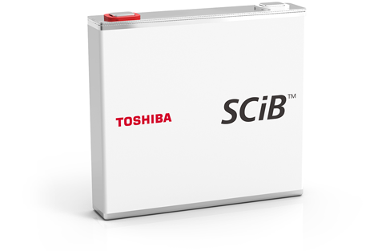

***Figure 5.6:*** *The physical package of the Toshiba SCiB 20Ah cell used in SSDS power storage system* [44].

### 5.3.3 Battery Management System

Performance and safety of lithium ion battery systems are maximized when a battery management system (BMS) is implemented. Through research BMS technology has been refined to the point where its function can now be explicitly defined:

1. Real-time monitoring of battery states. By measuring external characteristic parameters (such as the external voltage, current, cell temperature, etc.), with the appropriate algorithm, BMS could realize estimation and monitoring of battery internal parameters and states (such as the DC resistance, polarization voltage, maximum available capacity, SOC, etc.)
2. Efficient battery energy utilization. Provide a theoretical basis and data support to battery usage, maintenance and equalization.
3. Prevent over-charge or over-discharge of the battery.
4. Ensure user safety and extend battery life [47].

The components needed to perform the functionality described above include a master controller for information processing, voltage sensors, temperature sensors, current sensors as well as a balancing network and digitally controllable connection switches. A block diagram of the BMS used in SSDS can be seen in Figure 5.7. With these basic blocks, the functionality mentioned above can be carried out. A number of characteristics need to be monitored in “real-time” to successfully manage and determine states of the battery pack.

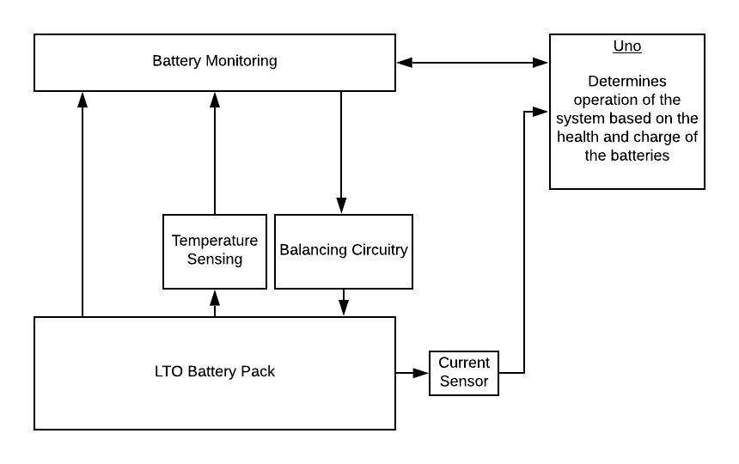

***Figure 5.7:*** *Block diagram of the BMS used in SSDS*

First, the need for voltage monitoring will be discussed. In the block diagram of Figure 5.7 one can see a voltage sensing block. All cells have a minimum and maximum voltage threshold. Discharging beyond the minimum threshold will damage the cell’s chemistry and in turn its ability to hold charge. Overcharging a cell and there is the potential for a thermal runaway. The voltage of every cell in the battery pack must be monitored to ensure that no single cell or the pack as a whole is overcharged or over-discharged.

Another need for voltage monitoring is cell balancing. Because the voltage of a cell is proportional to its charge, when any two cells have a voltage difference, they also have a charge difference.This charge difference is known as a cell imbalance. See Figure 5.8 which shows how cells in a series connected pack may not necessarily have the same charge. There are multiple reasons for cell imbalance including: internal resistance, self discharge, initial SOC and different operating conditions [47]. These parameters can vary from cell to cell leading to charge difference within a battery stack, or connection of batteries. If this imbalance is allowed to persist over time, the imbalance will grow with every charge as well as with degradation of the individual cells.

This imbalance is dangerous because it can cause individual cells to exceed their defined voltage thresholds. If one cell is charging quicker than the others and has reached its upper threshold, its continued charging must be halted while still allowing the other cells to catch up. If that is not done two things can happen. Either the cell would be overcharged causing a dangerous situation or the charging of all cell must be halted which would in turn lower the overall capacity of the battery pack to the capacity of the lowest charged cell. Figure 5.8 battery pack B which shows how the lower charged cells are over-discharged because the battery pack charge was not limited to the lowest capacity cell. Also notice Figure 5.8 battery pack C which shows how cells can be overcharged because the fully charged cells are allowed to continue charging along with the cell that are not yet fully charged. With each of the cell voltages known, the BMS can also compare cell voltages to determine if one or more cells has an imbalance. It can use this information to perform techniques known as cell balancing or cell equalization to rebalance the cells and prevent the unideal situations discussed. Figure 5.8 battery pack D shows a battery pack with a type of cell balancing. This keeps the higher charged cells from overcharging while the lower charged cells are allowed to continue charging.

There are two types of balancing, passive and active. Active balancing achieves equalization by transferring the charge in higher charged cells to the lesser charged cells. Although this method can be more energy efficient, it is a complicated process that introduces the need for additional parts, higher cost and increased unreliability [47]. There are also not many application-specific ICs (ASICc) available on the market which means that one would have to do much of the heavy lifting in terms of design on their own. In all active balancing is not practical for SSDS BMS.

Passive balancing achieves equalization by burning the excess charge in the a cell through a bypass resistance. When one or more cells are of higher charge than the other, the charge is continuously burned away until it sits at the same level of charge as the lowest charged cell. This is shown in Figure 5.8 battery pack D. The red squares represent active bypass resistors that are dissipating the extra charge that would over-charge the cells if the resistors were not there. Passive balancing is less energy efficient but cheaper, more reliable and simple [47]. There are many ASICs available on the market today that simplify the design of BMS by handling much of the hardware and firmware needed for passive balancing. One such chip that does this and works for LTO chemistry packs is the LTC6810-1 and is the chip used for the BMS of SSDS.

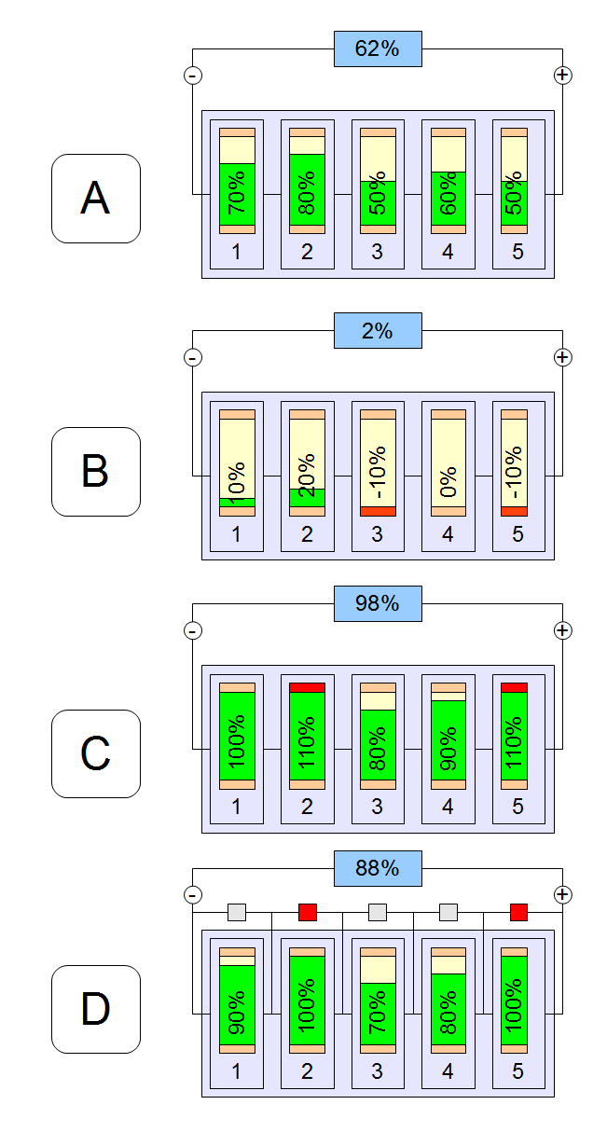

***Figure 5.8:*** *A visual to show the need for balancing in a series connected pack as well as an implementation of passive balancing*

Secondly, the temperature of each cell needs to be monitored. The need for temperature monitoring is straightforward: the cells have a safe range of temperature that they can operate over and any other temperature will cause damage to the cell and perhaps even the surrounding environment. The temperature sensors will inform the master controller if there is a temperature threshold breach. The master controller can then take necessary action to manage the thermal situation.

Lastly, the current in and out of the entire battery pack needs to be continuously monitored. This of course provide overcurrent protection for the pack. Another function of the current sensing is to perform state of charge (SoC) estimation. The SoC of the battery refers to the percentage of usable charge left in the battery cell or battery pack. This must be known by the master controller to inform the rest of the system how to operate. If the remaining charge was unknown, then the pack could die without informing the rest of the system. This could cause the devices the battery pack is powering to shut down incorrectly causing data corruption along with a number of other problems By knowledge of the SoC the amount of charge and discharge cycles can also be tracked informing the state of health (SoH) of the battery pack. SoH is a measure of how healthy the pack is in terms of how many years it can continue operating under the conditions in which it normally operates. More advanced BMSs use a combination of cell voltage measurements and pack current to perform a more accurate estimation of SoC and SoH.

A master controller is needed to control all of this operation as well as process the voltage, temperature and current data. This master controller is in charge of samping all data, processing that data and performing necessary actions informed by that data. Section 5.4 Hardware Description elaborates on the how to physically implement this BMS design with hardware and Section 5.5 Software Description elaborates on the software needed to operate the BMS successfully.

### 5.3.4 Switching Converter for Power Delivery

The main purpose of the power system of SSDS is to provide power to all components of the system. SSDS uses a 12V battery pack. This was mandated by the selection of the system’s charge controller, which will be discussed in Section 5.4 Hardware Description. However, most components used in the system are powered by a supply less than 12V, so we create voltage rails for them. The two microcontrollers, the Uno and RPi, can provide 3.3V rails to all smaller components that require them, like antennas, cameras, and sensors, but themselves need their own voltage supply. The stepper motor also needs a voltage supply. Both the stepper and Uno need higher than 5V and could be powered with up to 12V, but the more voltage supplied to the stepper motor, the higher the current draw. The stepper needed at least 1.5A to move the cameras and could draw up to 5A. As discussedin Chapter 3,the H-bridge used is rated for a peak current of 3A and a continuous current of 2A. It was observed that the current draw of the stepper motor is between 6V and 7V was acceptable, peaking at around 3A and continuously running around 2A. A 6V rail was therefore selected for the Uno and stepper motor, which allows for a peak current of 2.5A and continuous current of 1.8A. The RPi strictly requires a 5V rail, staying between 4.75V and 5.25V to avoid damaging the controller.

Accordingly, three power rails are used in SSDS: a 5V rail, 6V rail and 3.3V rail. The 3.3V rails are easily taken from the Uno and R pi as both of these boards provide 3.3V power pins. We create a 5V rail and 6V rail using buck switching regulators to step down the pack’s nominal 12V voltage.

### 5.3.5 System Level Solution

Because of the autonomous nature of SSDS and the fact that it is to be implemented in wilderness, its power system needs to be self-sustaining, safe and reliable. The motivation for SSDS is to detect, report and ultimately suppress fires that develop in remote, unmonitored areas. These remote areas will most likely not have access to power grids. Thus the need for a self-sustaining power system is clear. This system must be safe and provide SSDS as a whole with sufficient power to meet consumption detailed in the power budget. This power system must provide sufficient power to all other systems of SSDS.



***Figure 5.9:*** *High-level power system block diagram*

To accomplish this, a solar powered system design is broken down into three major parts: power generation, power storage, and power delivery. A block diagram of this system can be seen in Figure 5.9. Power generation is responsible for maintaining the autonomous nature of SSDS. Through the use of solar panels, our system is capable of independently powering itself in remote areas. Power storage ensures that generated power can be saved and used later, also contributing to the self-sustaining nature of SSDS. Power delivery provides all components of SSDS with the necessary voltage rails. Specifically the system uses solar panels to charge an LTO battery pack that can reliably and easily power SSDS regardless of weather conditions. A BMS maintains safe battery conditions and actively optimizes the operation of the system to extend battery life. Power is delivered to all components of SSDS through the use of buck converters. These three aspects of the power system allow SSDS to be self-sustaining, providing safe and reliable power to the system as a whole.

## 5.4 Hardware Description

### 5.4.1 Solar Panels and Charge Control

As discussed before, the self-sustaining nature of SSDS requires the use of solar panels, but the selection of the specific solar panels used for SSDS first relies on the power consumption of the system and the selection of a solar charge controller. As will be discussed in the following section, Lithium-Titanate Oxide (LTO) battery cells were selected for our system due to their safe and stable chemistry. This mandated that the solar charge controller selected for SSDS be capable of safely charging this chemistry. LTOs are a lesser used battery chemistry, so readily available solar charge controllers are not typically compatible with them. Most premade LTO compatible charge controllers are PWM controllers. Many of these controllers are rated for 12V and between 15 to 30A. The specific LTOs used in our system are rated to charge at a maximum of 160A, so this range of currents is safe for our batteries [44].With a 12V PWM controller, the solar panels must also be 12V. To narrow in on the needs of the system, refer to the power budget discussed in 5.2,to see that SSDS uses at most97.9Wh daily. On average, Santa Cruz receives about 5.4 hours of peak sunlight, therefore, the power needed to operate our system in Santa Cruz is 97.9Wh/5.4hours, which is 18.1W. Polycrystalline panels are about 15% efficient [53], so SSDS would need at least a 20W panel to run the system. This would only be enough to power the system, we also want to charge the batteries, so the ideal size of panels for SSDS is chosen as 25W.As mentioned before, most LTO charge controllers are rated for 12V. With a 25W solar panel, we would only need a charge controller rated at around 25W/12V, not considering the efficiency of the panels, which is about 2A.However, as mentioned before, the lowest current rating for an off-the-shelf LTO solar charge controller is 15A. This is overpowered for our current system, but we did not have time to design our own charge controller. Yet, our system must be able to monitor around the clock, regardless of weather conditions, so having larger panels than necessary ensures that the system will keep running over night as it is able to charge the batteries even on cloudy days when sunlight is not as intense. With this, the charge controller used in SSDS is the ZS-15AW, a 12V, 15A PWM solar charge controller by Zamp Solar, shown in Figure 5.10.

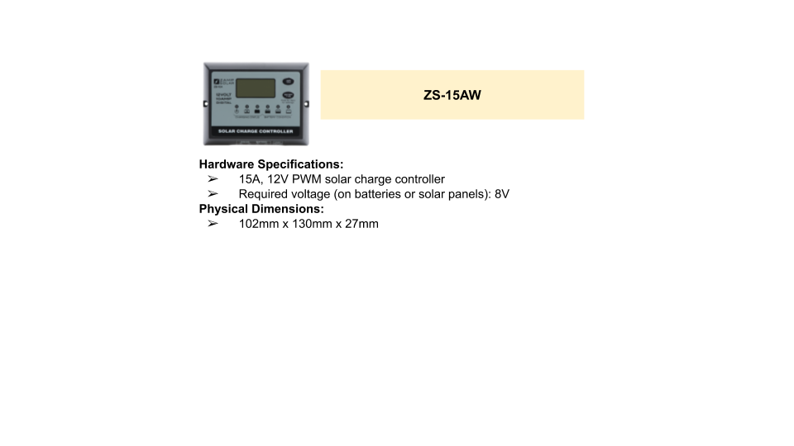

***Figure 5.10****: Solar charge controller used in SSDS*

The ZS-15AW is a PWM charge controller utilizes a typical 4-stage charging algorithm that can charge a pack as low as 3V up to a steady 13.4V. A diagram of its operation can be seen in Figure 5.11.

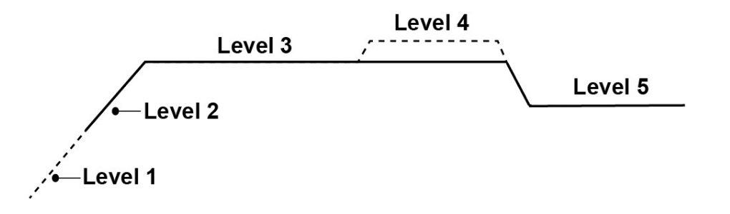

***Figure 5.11:*** *Diagram of charging algorithm of the charge controller from Zamp Solar user manual. (Level 4 is not for the LTO controller). Time is along the x axis and voltage along the y*

Level 1, shown in Figure 5.11, is a soft charge stage that will slowing ramp up the current to charge an over-discharged pack with a voltage as low as 3V. Level 2 shows the bulk charge stage where maximum current charging, 15A, is used until the battery voltage reaches the regulation voltage. In the absorption stage, Level 3, the controller holds the voltage constant to avoid overcharging and overheating. Finaling Level 5 shows the float stage where battery is fully recharged and the voltage is reduced to prevent damage to the cells. When the solar panels are not generating electricity, the charge controller prevents them from drawing power from the charged battery pack.

Because we are using a 15A charge controller and our batteries can safely charge at this level, we select panels that take full advantage of the charging capabilities of our charge controller. As will be discussed with mechanical design in Chapter 6,we use two panels for our system to help balance the probe. SSDS’s charge controller can charge the batteries with up to 15A, so our panels need to provide up to this current. Additionally, by using a 12V PWM controller, both the batteries and panels need to be 12V. Therefore there are two options for solar panel set up. The first is to use two 6V panels in series to get the 12V, as the voltage of panels in series add. These series panels each would have to provide 15A, so they would have to be around 90W panels (6V⋅15A), not accounting for efficiency of the panels yet. The second option is to use two parallel 12V panels that each provide 5A, as panels in parallel have the same voltage but their currents add. These panels would therefore also have to provide around 90W (7.5A⋅12V), again not accounting for efficiency yet. Most 6V panels are under 10W, so we chose to use two parallel 12V panels. For final panel selection, equation (5.1) is used. The panels selected are polycrystalline panels, which are about 15% efficient.

90W + 90W(0.15) = 103.5W (5.1)

With that, two 100W solar panels are used in SSDS, shown in Figure 5.12.

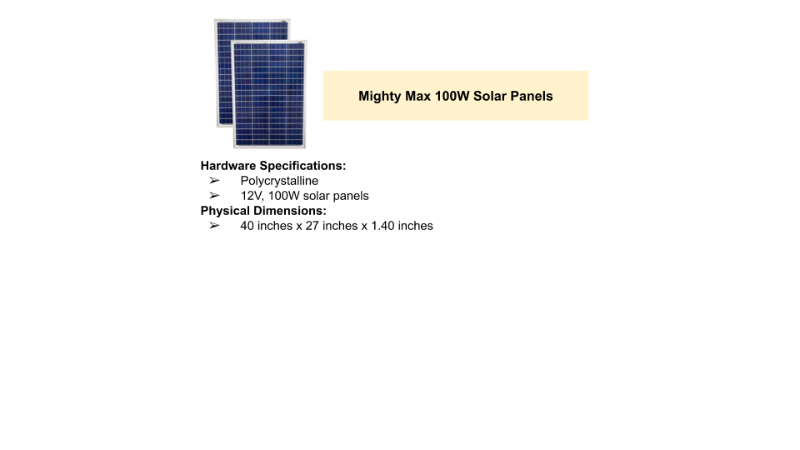

***Figure 5.12:*** *Solar panels used in SSDS*

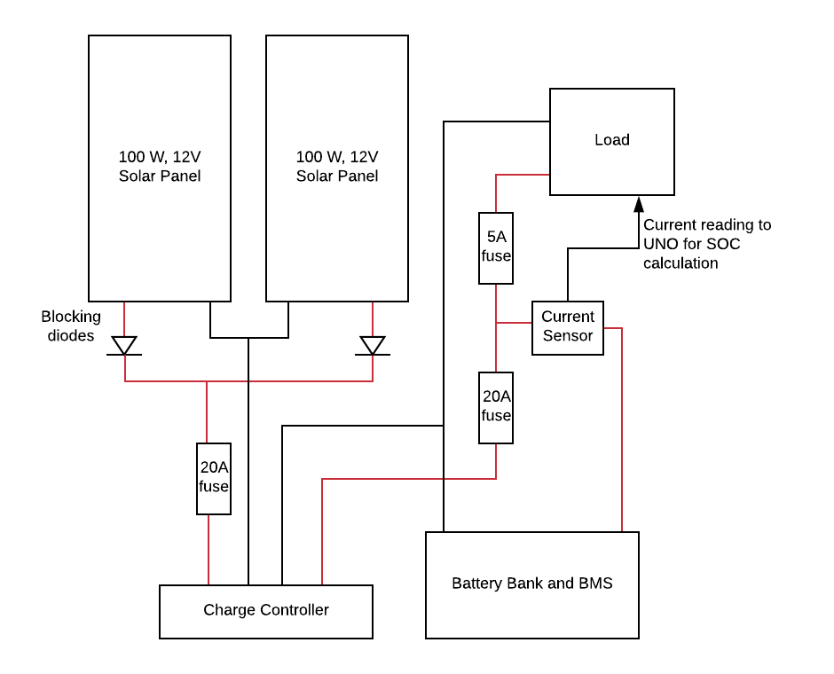

***Figure 5.13:*** *Diagram of the solar set up used in SSDS.*

The final considerations for the solar power generation design are the safety considerations. The final solar set up can be seen in Figure 5.13. With parallel panels, blocking diodes are needed after each panel to prevent them from charging each other if one is producing more power than the other. Two 15A MC4 in-line built in diodes are used for ease of set up, as the solar panels have MC4 connectors, shown in Figure 5.14. These diodes are simply plugged into the positive connection of each panel. A 15A maximum current is more than enough, as each panel could only produce at most 8A. The next safety feature is the fuses. There are three fuses shown in Figure 5.13 and an additional two fuses within the Load to protect the Uno and RPi. The 20A fuses before and after the charge controller are suggested in the user manual of the ZS-15AW controller that is being used.The 20A fuses used in SSDS are shown in Figure 5.15. On the solar panel side, the fuse is located as close to the controller as possible and on the battery side, the fuse is located as close to the battery as possible. Finally, a 5A fuse is placed before the load, which will draw at most 4A. The current sensor depicted in the diagram in Figure 5.13will be discussed in the following section on power storage while the content of the Load block will be discussed Section 5.4.3.4 Hall Effect Current Sensor Coulomb Counter.

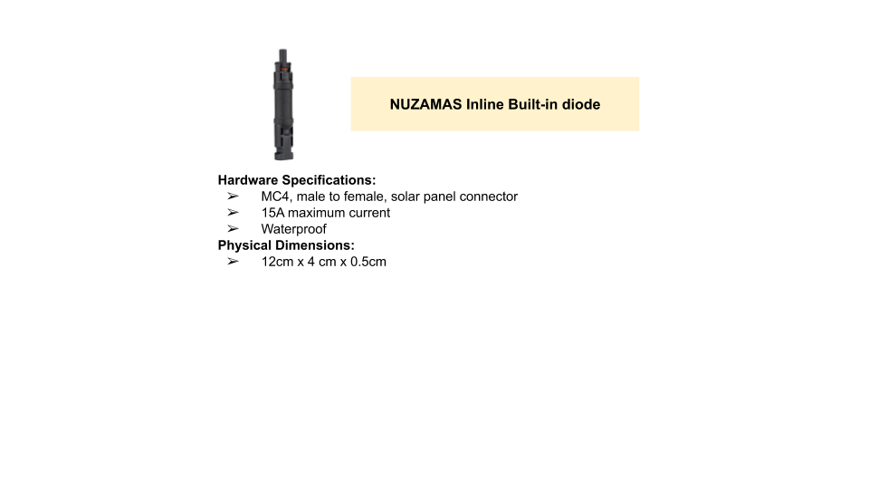

***Figure 5.14:*** *Blocking diodes used to protect solar panels in SSDS*

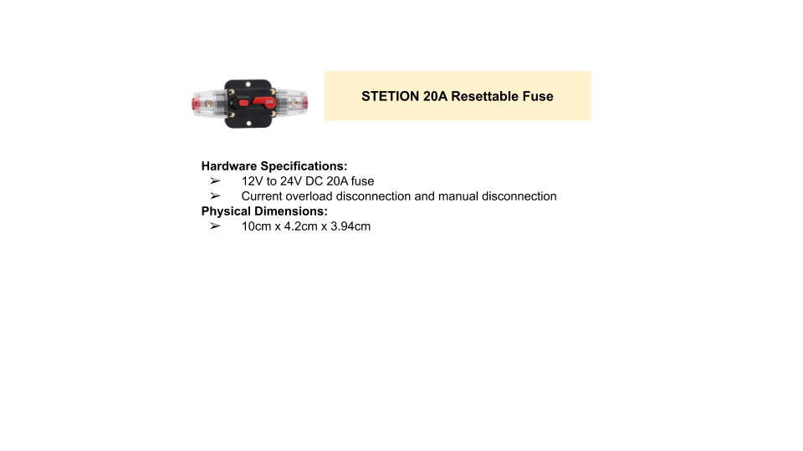

***Figure 5.15:*** *Fuse used to protect the batteries in SSDS.*

### 5.4.2 Battery Pack

The battery chosen for power storage is the Toshiba SCiB 20Ah LTO cell. This is a prismatic battery with a nominal voltage of 2.3V, a lower voltage limit of 1.5V and an upper voltage limit of 2.7V. The 20Ah capacity of this battery is sufficient to power the entire system for over a day with absolutely no solar generation. The cell can operate between -30°C and 55°C. Because of this temperature range, external heating and cooling system are unneeded. This greatly simplifies the design constraints of the battery pack. In addition to their response to ambient temperature, the cells are designed to handle 160A of current. Thus the cell will easily handle the maximum current of 15A that the battery pack will experience in the constant current phase of the charging cycle. This means that heating from charging and discharging are negligible.

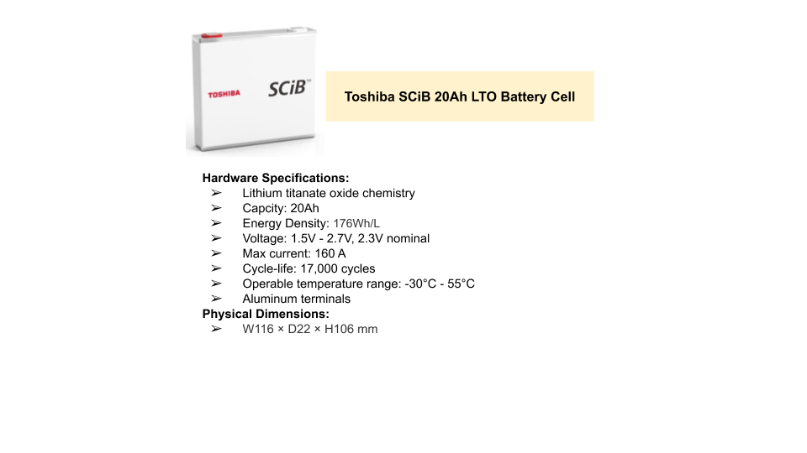

***Figure 5.16*** *Battery cell used in SSDS battery pack*

To have a 12V battery pack, five cells must be placed in series. This results in a 20Ah pack with a maximum voltage of 13.5V and a minimum voltage of 7.5V. However the cells should not be discharged to their lowest limit to ensure that they are never over-discharged. Additionally the charge controller requires at least 8V to work with the battery pack. Thus the cells are limited at 1.7V. The charge controller also does not allow for a voltage higher than 13.4V. Thus it will automatically stop charging the pack when that voltage is reached. This results in cell voltage limits of 1.7V and 2.68V and pack voltage limits of 8.5V and 13.4V.

The prototype pack can be seen in Figure 5.17. Five cells are placed side by side in alternating polarity so that connection from positive to negative terminal is simplified. Although heating is not expected to be an issue, the batteries are spaced 2cm apart to allow for passive cooling if needed. The terminals are made of aluminum and less than 5 mm thick. The heat capacity of aluminum makes soldering to the terminals imposible. The terminals are too thin to safely drill and tap a connection. Thus the only way of connecting to the terminals is by pressure or by laser/ultrasonic welding. The prototype in Figure 5.17 uses wing nuts that force an acrylic top to create pressure between the busbars and the terminals. Aluminum is used as the busbar material. Copper is not used because Galvanic corrosion will take place between the two metals. The prototype uses thin pieces of generic aluminum 6061 to connect the terminals. On the positive and negative terminals of the pack, a nut is drilled through an aluminum strip that is pressured to the terminal. On both points of connection 8AWG wire is crimped to a ring terminal that is connected to the nut. This provides a working prototype pack that meets the requirements of the system

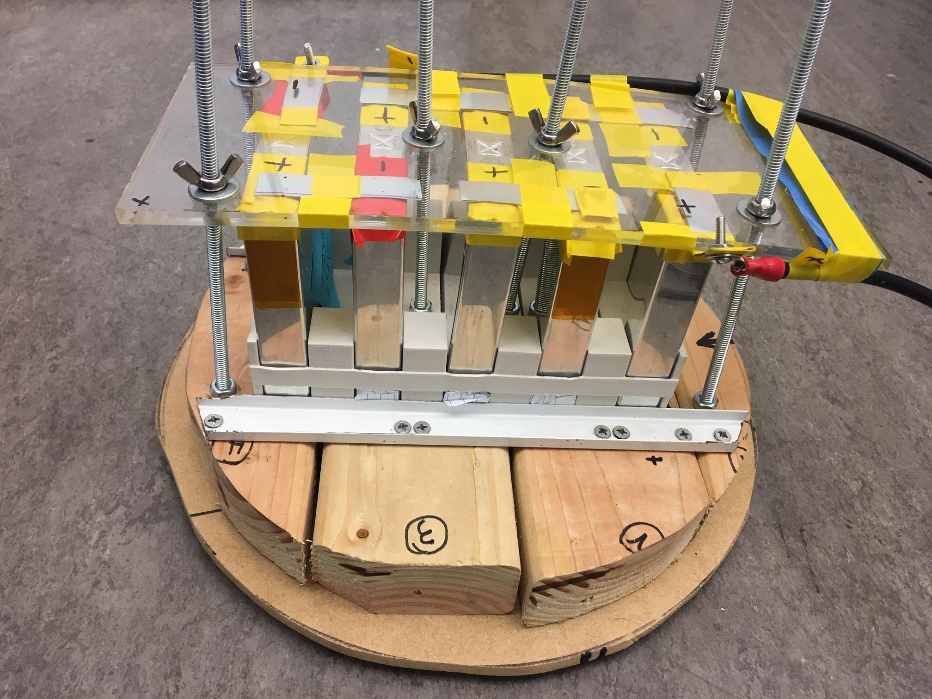

***Figure 5.17:*** *The prototype battery pack. Five Toshiba 20Ah LTO cells with aluminum bus bars pressure connecting the cells.*

### 5.4.3 BMS Hardware

The BMS consists of a master controller, cell voltage monitor, cell balancing circuit, temperature monitor and current sensor. For clarification these components in the battery power system of the SSDS probes are listed out.

1. Master Controller: Arduino Uno Microcontroller centered around ATmega328P
2. Cell Voltage Monitor: LTC6810-1 Six-Channel Battery Stack Monitor IC
3. Cell Balancing Circuit: LTC6810-1 Six-Channel Battery Stack Monitor IC
4. Temperature Monitor: MCP9700 Linear Thermistors
5. Current Sensor: ACS711 Hall Effect Current Sensor

These components together create a fully functioning BMS suitable for the 12V, 20Ah LTO battery pack used in SSDS.

#### 5.4.3.1 Uno Microcontroller

To implement an intelligent BMS that actively tracks the state of the batteries and optimizes the performance of SSDS, a microcontroller is needed. The Arduino Uno (Uno), shown in Figure 5.18, is selected as the power system’s microcontroller. This microcontroller is relatively low power, using about 0.25W, about 20% of the RPi’s 1.2W usage. Additionally, all members of the power subteam have experience working with the Uno. It provides all the functionality needed for our system, with 20 I/O pins, of which we used 16, and sufficient, scalable timers/counters, of which we used two.

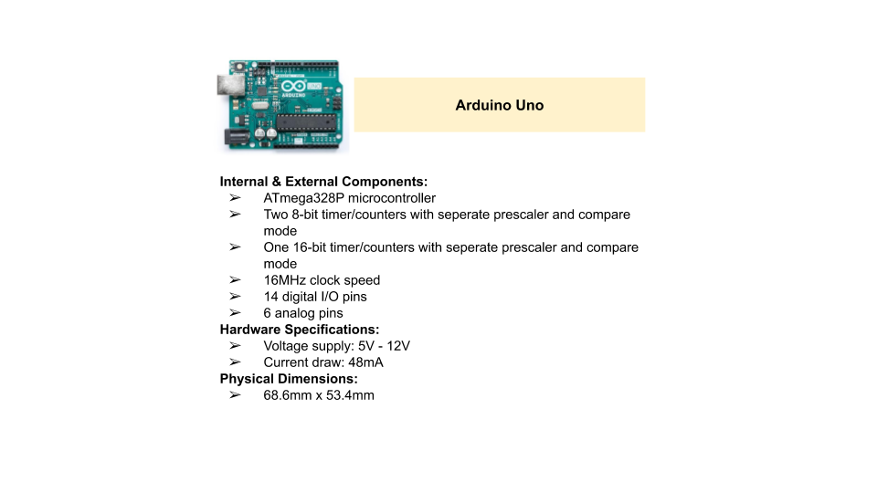

***Figure 5.18:*** *Microcontroller used as the master controller for the BMS and power system of SSDS.*

The Uno has two main roles in the SSDS. The first is to manage the batteries. The Uno runs a coulomb counting algorithm to keep an estimation of the battery’s SoC. It also controls and takes input from the voltage and temperature sensors used to monitor the batteries**.**The second role of the Uno is to control the operation SSDS as a whole. It keeps track of the sampling frequency of the system and tells the stepper motor and RPi when samples need to be taken. It will also adjust the frequency of samples to extend battery life and cut power to the other systems if a battery fault or Critical power event occurs. These aspects of the system are discussed in further detail in Section 5.5 Software Discussion.

#### 5.4.3.2 Battery Monitoring IC

#### 

***Figure 5.19*** *Battery monitor IC used for BMS of SSDS*

The battery monitor IC chosen for SSDS is the LTC6810-1 6-channel battery stack monitor. This is a powerful and accurate automotive grade battery stack monitor. Figure 5.20 displays the many internal features of the IC as well as the operating specifications [50]. A block diagram of the internal architecture of the IC can be found in Figure 5.19. The pin description is as follows:

**C0 – C6:** Cell Inputs.

**S0 – S6:** Balance Inputs/Outputs Redundant Cell Measurement. 6 NMOSFETs are connected between S(n) and S(n–1) for discharging cells. Additionally S pins can be used for redundant cell measurement. **V+:** Positive Supply Pin.

**V–:** Negative Supply Pins. The V– pins must be shorted together, external to the IC.

**V–*:** These pins are fused to the leadframe, connect to V–.

**VREF2:** Buffered 2nd reference voltage for driving thermistors. Bypass with an external 1µF capacitor. **VREF1:** ADC Reference Voltage. Bypass with an external 1µF capacitor. No DC loads allowed. **GPIO[1:4]:** General Purpose I/O. Can be used as digital inputs or digital outputs, or as analog inputs with a measurement range from V– to 5V. GPIO[2:4] can be used as an I2C or SPI port.

**DTEN:** Discharge Timer Enable. Connect this pin to VREG to enable the Discharge Timer.

**DRIVE:** Connect the base of an NPN to this pin. Connect the collector to V+ and the emitter to VREG. **VREG:** 5V Regulator Input. Bypass with an external 1μF capacitor.

**ISOMD:** Serial Interface Mode. Connecting ISOMD to VREG configures the LTC6810 for 2-wire isolated interface (isoSPI) mode. Connecting ISOMD to V– configures the LTC6810 for 4-wire SPI mode.

**WDT:** Watchdog Timer Output Pin. This is an open drain NMOS digital output. It can be left unconnected, or connected with a 1M resistor to VREG. If the LTC6810 does not receive a valid command within 2 seconds, the watchdog timer circuit will reset the LTC6810 and the WDT pin will go high impedance.

**CSB, SCK, SDI, SDO:** 4-Wire Serial Peripheral Interface (SPI). Active low chip select (CSB), serial clock (SCK), serial data in (SDI), are digital inputs. Serial data out (SDO) is an open drain NMOS output. SDO requires a 5K pull-up resistor A0–A3: Address Pins. These digital inputs are connected to VREG or V– to set the chip address for addressable serial commands.

**IPA, IMA:** Isolated 2-Wire Serial Interface Port A. IPA (plus) and IMA (minus) are a differential input/output pair.

**IPB, IMB:** Isolated 2-Wire Serial Interface Port B. IPB (plus) and IMB (minus) are a differential input/output pair.

**IBIAS:** Isolated Interface Current Bias. Tie IBIAS to V– through a resistor divider to set the interface output current level. When the isoSPI interface is enabled, the IBIAS pin voltage is 2V. The IPA/IMA or IPB/IMB output current drive is set to 20 times the current, IB, sourced from the IBIAS pin.

**ICMP:** Isolated Interface Comparator Voltage Threshold Set. Tie this pin to the resistor divider between IBIAS and V– to set the voltage threshold of the isoSPI receiver comparators. The comparator thresholds are set to ½ the voltage on the ICMP pin [50].

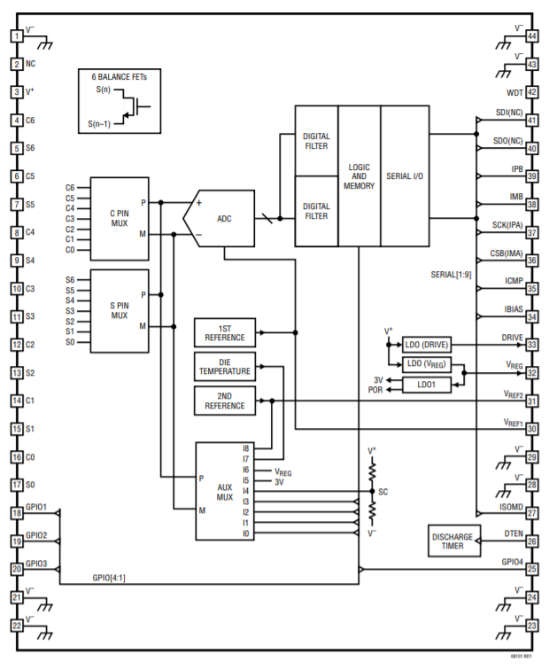

***Figure 5.20:*** *Block diagram of the LTC6810-1 battery stack monitor [50]*

The operation of the LTC6810-1 is described by the state machine of Figure 5.21. The states are as follows:

**SLEEP State:** The reference and ADC modulator are powered down. The watchdog timer (see Watchdog and Discharge Timer) has timed out. The discharge timer is either disabled or timed out. The supply currents are reduced to minimum levels. The isoSPI ports will be in the IDLE state. If a WAKEUP signal is received (see Waking Up the Serial Interface), the LTC6810 will enter the STANDBY state. **STANDBY State:** The reference and the ADCs are off. The watchdog timer and/or the discharge timer is running. VREG pin is powered to 5.2V through an external transistor controlled by the DRIVE pin. Alternatively, when V+ is less than 12V, VREG can be powered through the internal LDO to 4.7V. VREG can also be powered through an external source. In this case, the internal regulator must be disabled to avoid contention by floating the DRIVE pin. For more details see VREG Configurations. When a valid ADC command is received or the REFON bit is set to 1 in the Configuration Register Group, the IC pauses for tREFUP to allow for the reference to power up and then enters either the REFUP or MEASURE state. Otherwise, if no valid commands are received for tSLEEP (when both the watchdog and discharge timer have expired), the LTC6810 returns to the SLEEP state. If the discharge timer is disabled, only the watchdog timer is relevant.

**REFUP State:** To reach this state the REFON bit in the Configuration Register Group must be set to 1. The ADCs are off. The reference is powered up so that the LTC6810 can initiate ADC conversions more quickly than from the STANDBY state. When a valid ADC command is received, the IC goes to the MEASURE state to begin the conversion. Otherwise, the LTC6810 will return to the STANDBY state when the REFON bit is set to 0, either manually (using WRCFG command) or automatically when the watchdog timer expires (the LTC6810 will then move straight into the SLEEP state if both timers are expired).

**MEASURE State:** The LTC6810 performs ADC conversions in this state. The reference and ADCs are powered up. After ADC conversions are complete the LTC6810 will transition to either the REFUP or STANDBY states, depending on the REFON bit. Additional ADC conversions can be initiated more quickly by setting REFON = 1 to take advantage of the REFUP state [50].

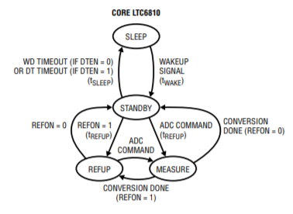

***Figure 5.21:*** *The core state machine of the LTC6810-1 [50]*

Passive balancing is achieved by connecting a balancing network between the cell and the C(n) and S(n) pins of the IC. The way in which cells are connected to the cell input and balancing MOSFETs are displayed in Figure 5.22. The input sample is best filtered for noise with an RC low pass filter consisting of a 100Ω resistor and 10nF capacitor. The dissipation resistor is calculated by dividing the nominal cell voltage by the maximum allowable balancing current. The internal MOSFETs have a maximum current rating of 150mA. Thus the resistance is 2.3V/150mA = 15.3Ω. Additionally that means that the resistor must dissipate a maximum power of 2.68V*175mA = 0.469W when a cell is being balanced while fully charged. Thus the dissipation resistors were chosen to be 1W, 2152 surface mount resistors.

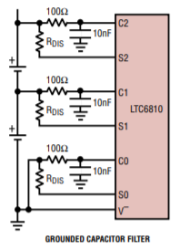

***Figure 5.22:*** *Battery cell balancing network configuration [50]*

To power the IC over a wide voltage range, in the case of SSDS 8.5V - 13.4V, an external transistor in the configuration shown in Figure 5.23 is needed. This is needed to limit the amount of power dissipated in the IC. Whenever the voltage of the battery stack exceeds 12V The external transistor is driven at the base by the regulated DRIVE pin voltage that sets VREG pin voltage to 5.2V typically. The internal LDO is designed to only source current, so when VREG pin is driven to 5.2V by the external transistor the internal regulator is gracefully shutdown [50]. The NPN transistor used is a 2N3904 transistor. The resistor and capacitor value used are the same as Figure 5.23.

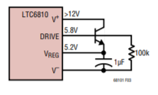

***Figure 5.23:*** *The external transistor network for limiting power dissipation in the IC [50]*

The GPIO pins of the IC are used to read in temperature data. Five cells need to be monitored yet there are only four GPIO pins. Thus three of the four GPIO pins are configured as digital output and the fourth is configured as an analog input. With this setup the three digital outputs can control the select line of an analog multiplexer while the analog input can read the output of the multiplexers. This allows for all five temperatures to be read by the IC. The temperature sensors and multiplexer also require a regulated voltage. Thus an external buck converter module is used to power these peripheral devices.

The final schematic of this system can be seen in Figure 5.24. The yellow block represents the buck converter module used to created the 5V rail needed for the temperature sensors and the analog mux. The four SPI communication pins connect to jumper pads. This connects to a ribbon cable that connects to the master controller allowing for master-slave and slave-master communication. The PCB layout of the board that contains this functionality can be seen in Figure 5.25.

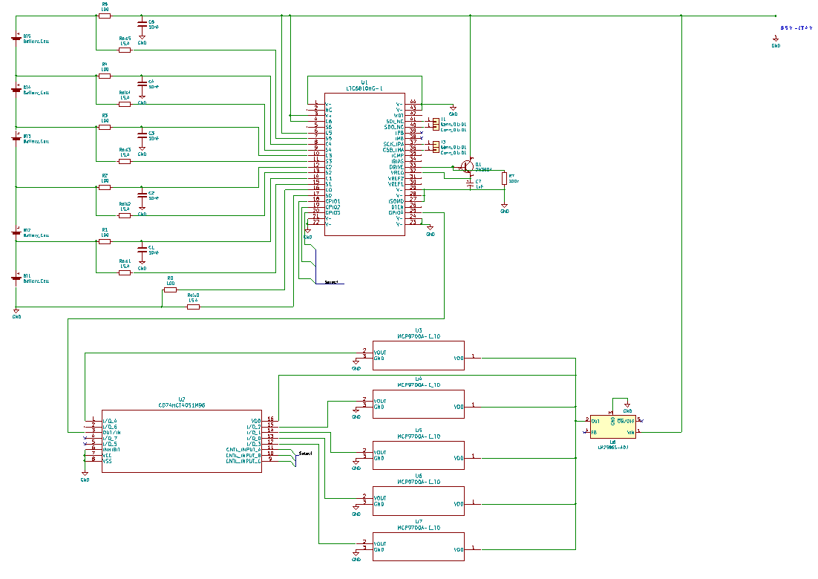

***Figure 5.24:*** *Resulting schematic of the circuitry surrounding the LTC6810-1 heart*

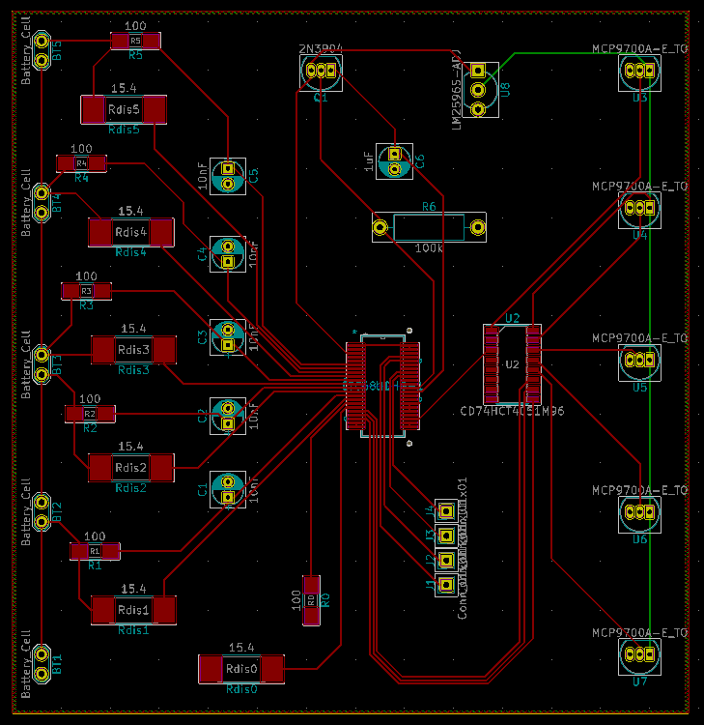

***Figure 5.25:*** *Resulting PCB layout of for the voltage sensing, balancing and temperature sensing board*

#### 5.4.3.3 Temperature Sensors

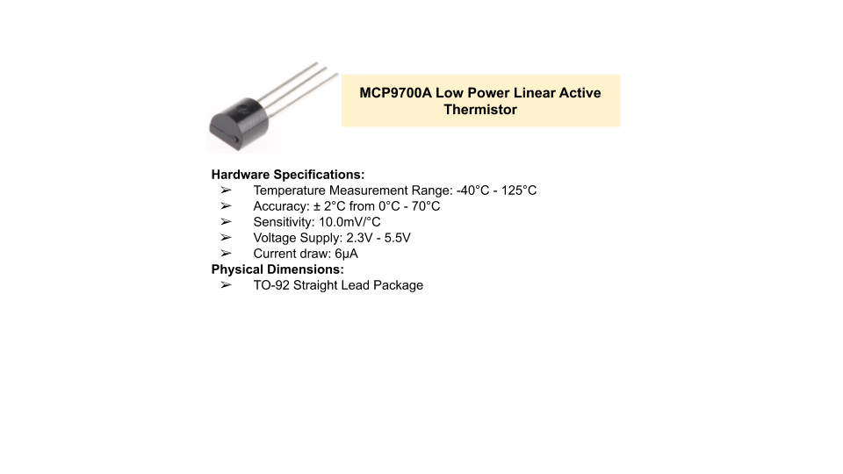

***Figure 5.26:*** *The MCP9700A Linear Thermistor*

Linear thermistor ICs are used to sense the temperature of the battery cells. The MCP9700A, as seen in Figure 5.26, is the linear thermistor used in this BMS. The linear response of the the thermistor removes the characterization phase needed in non-linear thermistors. These thermistors have a temperature measurement range larger than the safe operating range of the battery pack.

There are five cells and thus five temperatures that need to be measured. As mentioned in Section 5.4.3.2 Battery Monitoring IC, the temperature data is read in through the GPIO ports of the LTC6810-1. Three of the four GPIO pins are configured as digital output and the fourth is configured as an analog input. With this setup the three digital outputs can control the select line of an analog multiplexer while the analog input can read the output of the multiplexers. The multiplexer selected is the CD74HCT4051 high-speed CMOS logic analog multiplexer as seen in Figure 5.27. This allows for all five temperatures to be read by the IC. The temperature sensors and multiplexer also require a regulated voltage. Thus an external buck converter module is used to power these peripheral devices. The buck converter module used can be seen in Figure 5.31.

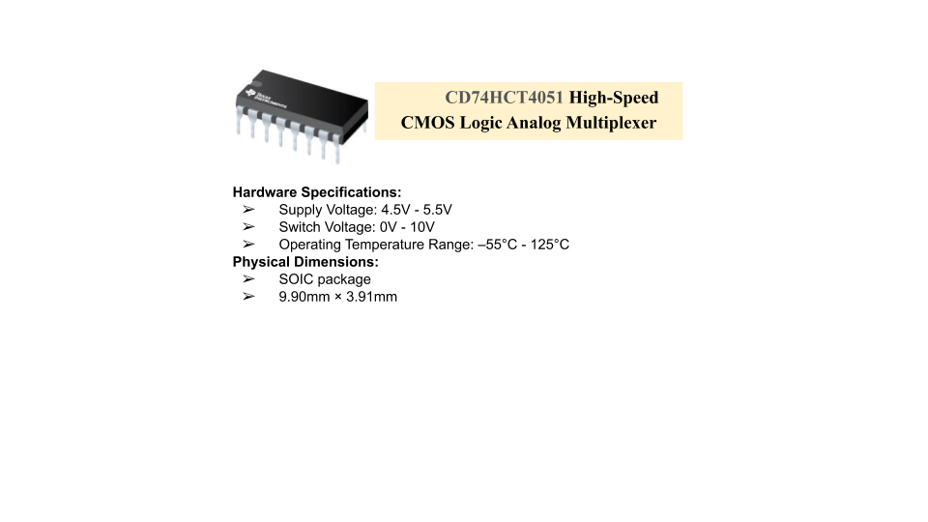

***Figure 5.27:*** *The analog multiplexer used to read in all five temperature sensors into the four GPIO pins of the LTC6810-1*

#### 5.4.3.4 Hall Effect Current Sensor Coulomb Counter

An accurate reading of the battery pack’s SoC is central in the healthy maintenance of the batteries. Because the power system must maintain constant power to the rest of the system, and SSDS is autonomous, there is no way for the open circuit voltage (OCV) of the batteries to be taken to determine the SoC without affecting the functionality of SSDS. To determine the SoC of the battery bank, SSDS implements a coulomb counting algorithm on the Uno. The first step in completing this calculation is measuring the current in and out of the pack [36]. This is accomplished with a bidirectional hall effect, linear current sensor IC that measures the current into and out of the positive terminal of the battery pack and outputs a linearly related voltage. The charge controller used in our system charges the battery bank with up to 15A, as discussed in Section 5.4.1**,** so the current sensor needed to be rated above this value. Additionally, the load of the system draws as low as 64mA when the system is in Critical Operation, as discussed in Section 5.2 Power Budget,so the chip selected also needed to be sensitive enough to sense this draw. With these requirements, the ACS711 ±15.5A linear hall effect current sensor**,** shown in Figure 5.28, was selected, with its 110 mV/A sensitivity being appropriate for the system. This sensitivity allows the chip to distinguish between as little as .009mA. The ACS711 measures the current into and out of the batteries and the corresponding voltage is fed into the Uno, where it is read as an analog input, and is later converted into the measured current. The Uno reads the input every 1msin an interrupt service routine (ISR) and saves the input into a moving average to stabilize the value used to determine the voltage input from the current sensor. However to take more advantage of the chip’s 4.6𝜇s, the current should be checked in a quicker interrupt. This average is converted into a voltage and that voltage is then converted into the measured current.

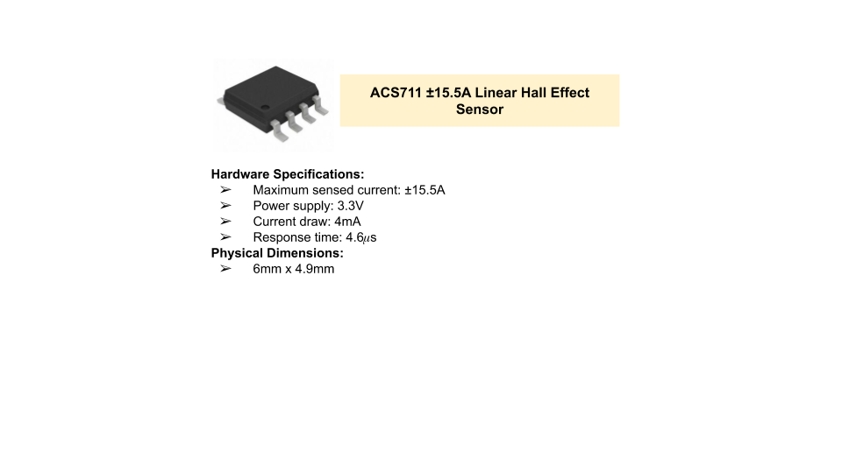

***Figure 5.28:*** *Current sensor used in SSDS*

To characterize the ACS711 current sensor, the sensor was placed in series with an ammeter and variable resistor and voltage vs current measurements were taken. The resulting data, shown in Figure 5.29 was taken. The data showed that the voltage-current relationship of the specific ACS711 chip used in the detection node prototype was given by

$i(V) = 9.3822V - 15.08$ (5.2)

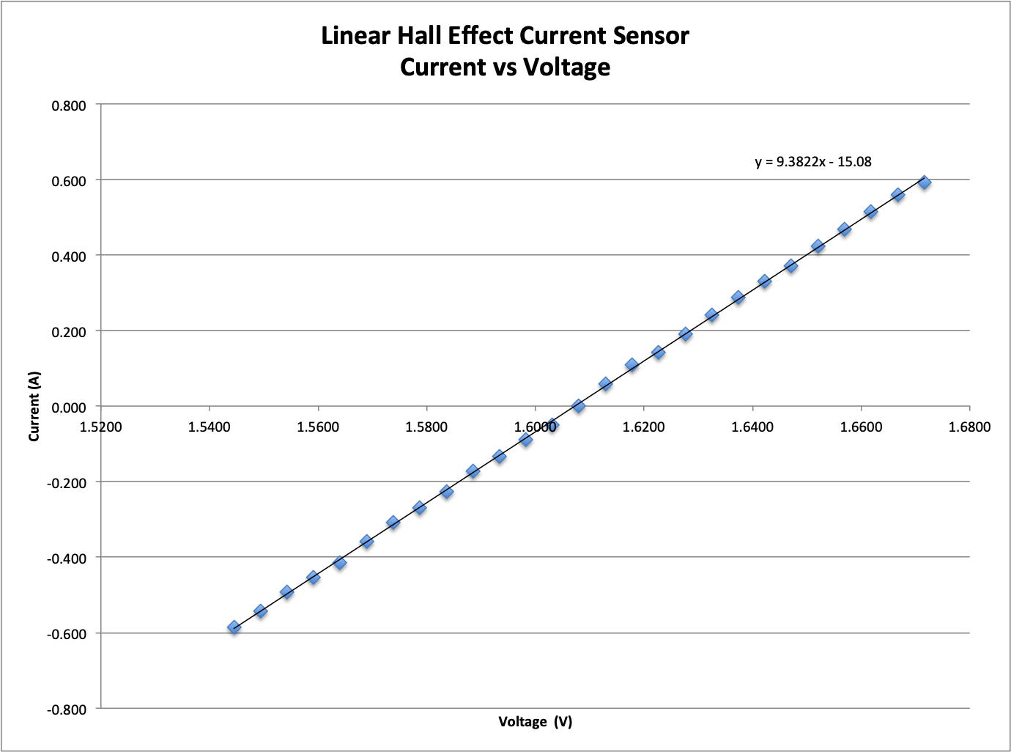

***Figure 5.29:*** *Current- Voltage data for the ACS711 15.5A current sensor. Voltage measurements collected by the Uno.*

### 5.4.4 Power Delivery (Buck Converter and FET Cutoff)

The main purpose of the power system of SSDS is to provide power to all components of the system. SSDS uses a 12V battery pack, but three voltage rails are required: 3.3V, 5V and 6V. The 3.3V rails come from the RPi and Uno supply the 3.3V rails and the 6V and 5V rails need to be created. A block diagram of voltage rail generation can be seen in Figure 5.30.

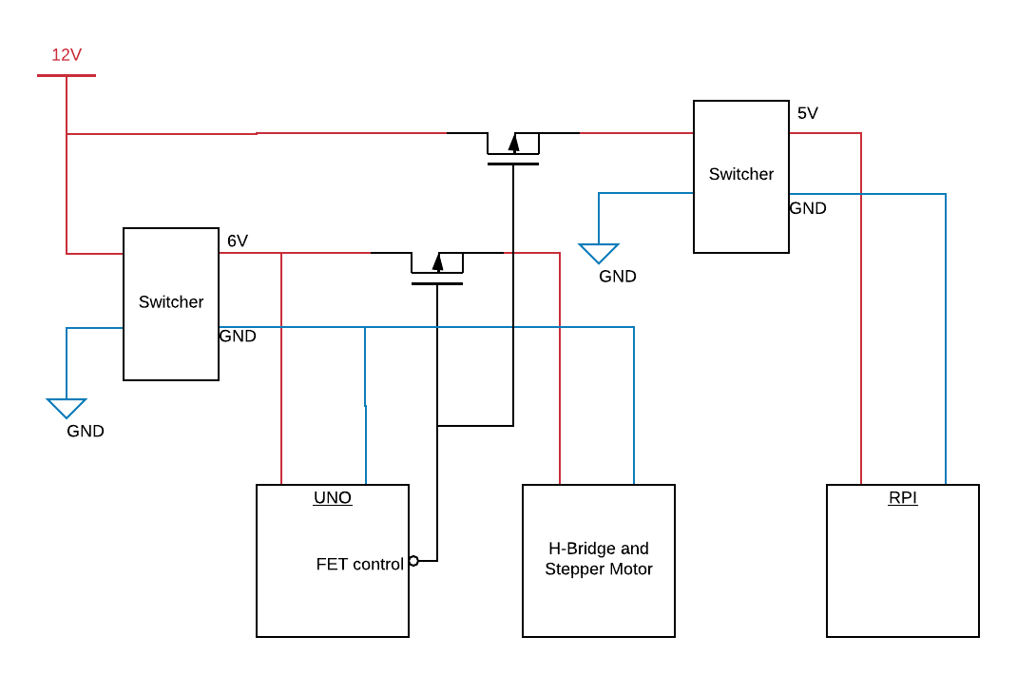

***Figure 5.30:*** *Block diagram of voltage rails and FET cutoff circuit used on the power board.*

The switchers selected for SSDS are the LM2596, a 3A step down voltage regulator, shown in Figure 5.31. The switcher needs to allow for the regulation of the DC-DC voltage from a 7.5-12V battery pack down to a 6V and 5V power rail. As seen in the power budget, the current draw must allow for currents up to 2.5A with clean signal output. The chosen switcher is an LM2596 DC to DC buck converter board**,** shown in Figure 5.31.The LM2596 is an adjustable voltage regulator that can step down a 3V to 40V input to a 1.5V to 35V output with a maximum current draw of 3.4A **.** With this board, the rail for the Uno and stepper are specifically set at 6.13V. At this input, the stepper motor has a peak current draw of 2.48Aand a continuous current of1.82A. The stepper is run off of the same switcher as the Uno, which draws less than 0.5A, so together they will at most draw draw 2.98A,under the 3.4A current limit of the LM2596. The RPi is powered by its own LM2596 which is set at 5V. The RPi and components powered off of it stay well under the 3.4A current limit, peaking at around 700mA.

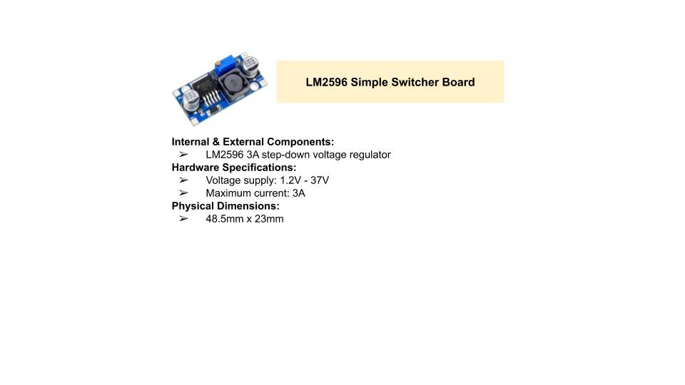

***Figure 5.31:*** *Switcher used to create the voltage rails for SSDS.*

In addition to the voltage rails, a cutoff circuit was required to cut power to all components of the system not used in battery management. In Critical Operation, the system only maintains the BMS and turns off all other components to keep the batteries healthy. To implement this cutoff, SSDS has uses a FET cutoff, the concept for which can be seen in Figure 5.30. We utilize PMOS transistors as switches. Each switch is controlled by the voltage on its gate, which is a digital output from the Uno, labeled in the diagram as FET Control. When FET Control goes high, the switch is opened and power cut to the stepper motor and RPi. It is kept low to close the switch and power the stepper and RPi. When a digital output from the Uno is high, it is 5.05V and is low at 0V. With the rail being at 6.13V on the PMOS’s source, the gate-source voltage threshold of the PMOS had to be at least 1.08V and at most 6V. Additionally, the PMOS has to handle a drain current of up to 3A, about the maximum current draw from the stepper motor.

The specific PMOS selected for SSDS is therefore the FDS8935, a dual P-channel MOSFET chip, shown in Figure 5.32. The gate-source voltage threshold on this chip is typically 1.8V, above the 1.08V minimum required by our system. The maximum drain current for a single PMOS on this chip is 2.1A, so two of the transistors in parallel are used to cut power to the stepper, resulting in a maximum current at 4.2A, which is safely above the 2.5A draw from the stepper. The FDS8935 is also used to cut power to the RPi. The schematic of the final power board can be seen in Figure 5.33.

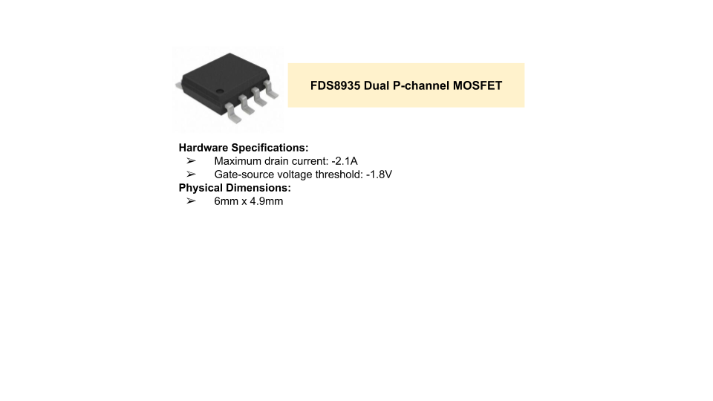

***Figure 5.32:*** *PMOS transistor used as the switches in the cutoff circuit of the SSDS power board.*

Just as it was required for the solar set up, safety considerations to protect the components of SSDS are needed. Three fuses are used to protect the three main components of the system: the Uno, RPi and stepper motor. The 5A fuse shown as F1 in Figure 5.33, protects the entire load. The Uno and stepper draw at most 2.98A while the RPi draws up to 700mA, so a 5A fuse is sufficient to protect the load as a whole.A 0.5A fuse protects the Uno, as shown as F2 in Figure 5.33, Finally, the RPi is protected by a 1Afuse, shown as F3 in Figure 5.33.

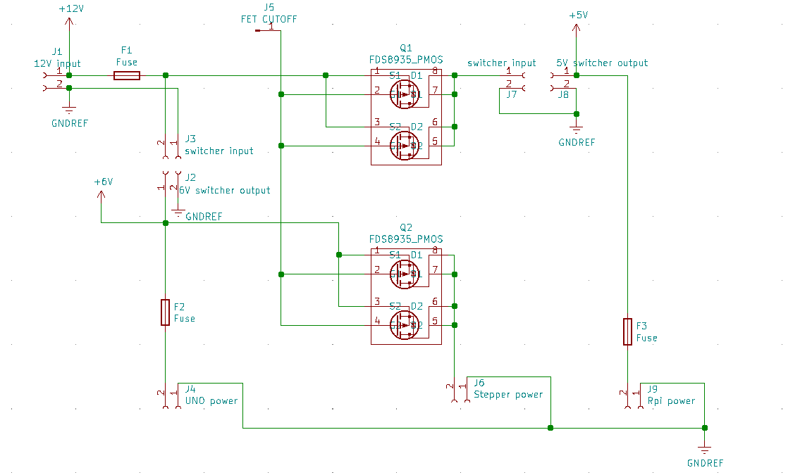

***Figure 5.33*** *Schematic for the power board for SSDS.*

## 5.5 Software Description

### 5.5.1 High Level Functionality

A major aspect of the power system for SSDS is to implement an intelligent battery management system. This system must not only monitor the batteries to ensure their health and safety, but must actively optimize the operation of SSDS as a whole to extend battery life. To do this, software, written on the Uno, interacts with the temperature, voltage, and current sensors to monitor the battery and uses this information to change the operation of the system into three operational modes: Typical Power, Low Power, and Critical Operation.

### 5.5.2 BMS

#### 5.5.2.1 LTC6810-1 Firmware and SPI Communication

The functionality of the LTC6810-1 is mainly controlled by setting bits in a configuration register group. Without instruction from the master controller the LTC6810 will not perform any functions. With SPI communication the configuration register groups can be written and read from using SPI communication. The ADC and GPIOs can also be polled by sending certain commands via SPI. Once the state machine is in the active state, an SPI message can be sent. When CPHA=1 and CPOL=1, the 4-wire serial port is configured to operate in a 4-wire SPI system. Consequently, data on SDI (input port) must be stable during the rising edge of SCK (system clock). The timing is depicted in the following figure. The maximum data rate is 1Mbps. The operation of the SPI communication is controlled by the isoSPI state machine Figure 5.34:

**IDLE State:** The isoSPI ports are powered down. When isoSPI port A or port B (LTC6810-1 only) receives a WAKEUP signal (see Waking up the Serial Interface), the isoSPI enters the READY state. This transition happens quickly (within tREADY) if the Core is in the STANDBY state. If the Core is in the SLEEP state when the isoSPI receives a WAKEUP signal, the it transitions to the READY state within tWAKE.

**READY State:** The isoSPI port(s) are ready for communication. Port B is enabled only for LTC6810-1, and is not present on the LTC6810-2. The serial interface current in this state depends on if the part is LTC6810-1 or LTC6810-2, the status of the ISOMD pin, and RBIAS = RB1 + RB2 (the external resistors tied to the IBIAS pin). If there is no activity (i.e. no WAKEUP signal) for greater than tIDLE = 5.5ms, the LTC6810 goes to the IDLE state. When the serial interface is transmitting or receiving data the LTC6810 goes to the ACTIVE state.

**ACTIVE State:** The LTC6810 is transmitting/receiving data using one or both of the isoSPI ports. The serial interface consumes maximum power in this state. The supply current increases with clock frequency as the density of isoSPI pulses increases.

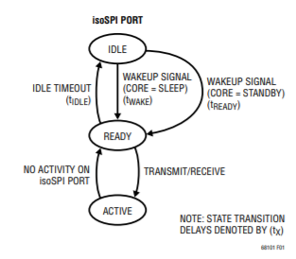

***Figure 5.34:*** *SPI state machine diagram*

The key configuration registers that need to be set are ADCOPT, GPIOx, VUV, VOV and DCCx. The ADCOPT controls the sampling frequency of the ADC. For this system it is set to the default of 0 which is normal mode, 7 kHz. GPIOx controls the configuration of the GPIO pins. Here this register is set to 1, 1, 1 and 0 so that GPIO1-3 are digital outputs and GPIO4 is an analog input. VUV and VOV set the under and overvoltage thresholds. These are 1.7V and 2.68V as discussed earlier. The DCCx register controls which MOSFET switch is closed so that cell can begin balancing. This register is updated every time a cell needs to be balanced.

The additional commands that the LTC6810-1 can receive and process can be seen in the LTC6810-1 datasheet. Message formatting and timing diagrams are also available in the datasheet [50].

#### 5.5.2.2 Coulomb Counting and SOC estimation

An accurate reading of the battery pack’s SoC is central in the healthy maintenance of the batteries. Because the power system must maintain constant power to the rest of the system, and SSDS is autonomous, there is no way for the open circuit voltage (OCV) of the batteries to be taken to determine the SoC without affecting the functionality of SSDS. To determine the SoC of the battery bank, SSDS implements a coulomb counting algorithm on the Uno. The coulomb counting algorithm keeps an estimation of how much charge has left and entered the batteries over time and uses this to estimate the remaining remaining charge of the batteries. Equation (5.3) shows the main idea of coulomb counting, where SOC0 is the initial SOC of the battery pack and Qmax is the maximum charge capacity of the pack.

$SOC={SOC}_{0}+\frac{\int_{t0}^{t}{}i(t)dt}{Qmax}$ (5.3)

The first step in completing this calculation is measuring the current in and out of the battery pack . This is accomplished with a bidirectional hall effect, linear current sensor IC that measures the current into and out of the positive terminal of the battery pack and outputs a linearly related voltage. As discussed previouslythe ACS711±15.5A linear hall effect current sensor was selected.

Once the current is measured, the coulomb counting algorithm can then use this current reading to estimate the SoC. The coulomb counting algorithm used in the SSDS is run on the Uno in an ISR that occurs every 1ms. In the ISR, the total charge out of the batteries, the numerator of the second term in equation (5.3), is estimated. This estimation is done using equation (5.4), where we keep track of the average current in and out of the batteries with an ACS711 ±15.5A linear hall effect current sensor and use it to estimate the charge in and out of the batteries.

$\int_{t0}^{t}{}i(t)dt ≃Σ(i∆ t)={∆Q}_{}$ (5.4)

∆*Q* is the approximated total amount of charge that has left the battery, *∆t* is the 1ms between samples, and *i* is the average current between samples. Equation (5.4) is substituted into equation (5.3), in place of the current integral. The SOC is then estimated using equation (5.5)

$SOC = {SOC}_{0}+\frac{∆Q}{Qmax}$ (5.5)

where the SOC0 and Qmax are constants based on the characterization of the battery pack. This SoC estimation is then used to determine the operational mode, discussed in the following section, of the SSDS as a whole.

#### 5.5.2.4 Power Modes of Operation and FET Cutoff Control

To optimize the operation of SSDS to extend battery life and protect the batteries, the system implements three main operational modes: Typical Power Mode, Low Power Mode and Critical Operation Mode. The top level state machine for the system is shown in Figure 5.35. In the Typical Power Mode state shown in Figure 5.35, the node will sample for fires every 5 minutes. In the Low Power Mode, the sampling frequency will decrease to 12 minutes**.** Lastly, Critical Operation Mode will turn off everything except for the charge controller and BMS to ensure the batteries are kept in a safe condition. There are two things that need to happen before entering Critical Operation. The first is that the stepper motor needs to be returned to the starting location so that when the node wakes up again, it can simply start a fresh cycle instead of having to keep track of previous movements. The second is that the RPi needs to know that it is being powered down. If power to the RPi is cut before it shuts itself down, it will corrupt the SD card and permanently halt the functionality of SSDS until it can be repaired. So before entering Critical Operation, the RPi is made aware that it needs to shut down, it returns an acknowledgement to the Uno, and the Uno waits one minute before cutting power. To do this, an additional transitional state is needed, as shown in Figure 5.35. For a more in depth discussion of each of the three main operational modes of the detection node, please refer to section 5.2 on the power budget.

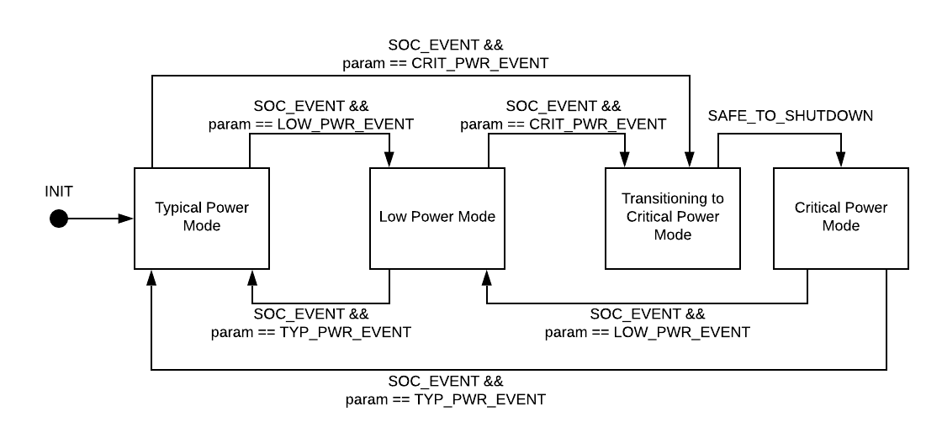

***Figure 5.35:*** *Operational modes FSM of the detection node.*

The state machine depicted above in Figure 5.35 controls the main functionality of the system as a whole. As previously mentioned, in Typical and Low Power modes, SSDS samples for fires. The frequency of which changes from 5 minutes to 12 minutes depending on the state. This time is kept track of using a second timer that is implemented in an ISR that occurs every one second. This timer is set to 300s (5 minutes) or 720s (12 minutes) after each sample. When the timer is up, the Uno sends a digital output to the RPi telling it to take a picture. It then checks for input from the RPi in an ISR that occurs every 1ms. When input from the RPi goes high, letting the Uno know that a picture has been captured, the Uno instructs the stepper motor to move 60°. When the movement is completed, it asks the RPi to capture another image. It does this six times before resetting the sampling frequency timer and having the system wait.

The transition events, labeled as SOC_EVENTS in Figure 5.35, are determined by the SoC of the batteries. The SoC is calculated using coulomb counting, discussed earlier in this chapter. The SoC is updated and checked for events every 1ms in an ISR. The transitions for the state machine are determined by the SoC crossing thresholds, shown in Figure 5.36*.* For example,when the SoC drops below the low to critical threshold, an SoC event is triggered with a CRITICAL_PWR_EVENT parameter to instruct the state machine to move to Critical Operation. When it rises above the critical to low threshold, an SoC event is triggered with a LOW_PWR_EVENT parameter. The same goes for the SoC dropping below or rising above the other two thresholds.

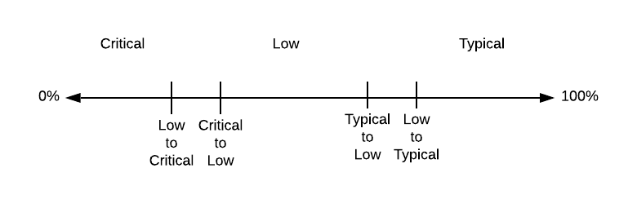

***Figure 5.36:*** *SoC thresholds*

When the state machine enters Critical Operation it cuts power to the stepper motor and RPi. It does this for one of two reasons: a battery fault is detected or a critical power SoC event occurs. The cutoff functionality is implemented using a single digital output to the FET circuit, discussed in Section 5.4.4 Power Delivery.In all states except Critical Operation, the FET Control output is high, keeping the PMOS switches closed and powering all components. In Critical Operation, FET Control is set low, opening the switches and cutting power to the RPi and stepper motor.

# Chapter 6: Mechanical Subsystem

The mechanical design must satisfy two purposes: first, it must provide a durable mounting and housing for all components of the probe and second, it must properly manage the moving parts of the probe. There are three probe designs, first is the SSDS detection probe. This probe is responsible for detecting fires and transmitting alerts. Those transmitted alerts reach a repeater node. The repeater node is responsible for receiving signal packages from the SSDS detection probe. Lastly, the repeater node transmits signal packages to the End User*,* which is placed indoors, connected to a wall outlet that powers the display. The End User emergency personnel to the presence of detected fires and other diagnostic messages.

The detection and repeater nodes will be implemented out in the open environment, exposed to a variety of weather conditions. The mechanical design of the probes must be durable and water resistant to ensure continued functionality of the system, as well as avoid any potential harm to wildlife and minimize the probe’s contributions to pollution.

In addition to the durable housing and mounting of the system, to minimize their environmental impact, the detection nodes must have a 360° field of view of their surrounding environments to maximize the detecting potential of a singular probe. The greater the field of view of a probe, the less probes are needed to survey the same area of land. Therefore, the mechanical system must also provide a rotating rig for the detection system to achieve this.

For prototype purposes, parts are constructed using 3D printing for the designs that would be difficult to create otherwise. 3D printing allows for the manufacturing of three dimensional solid parts from a digital file. The Ultimaker 2 was chosen because of its reliable, efficient, and user-friendly interface and because it is readily available to our team for use. For a part to be 3D printed it must first be designed and prepared. Solidworks was used in the designing process for probe components. Solidworks files are converted to .STL files, allowing the part to be prepared in the Ultimaker Cura program. Cura is an open source 3D printer slicing application that allows the part to be printed to specifications of printer and part. In the Ultimaker Cura program the part files are converted to .GCODE files. Finally the part is ready to be printed from the Ultimaker 2.

The material used for 3D printing for the prototype is 2.85mm Polylactic acid (PLA), which has a melting temperature of 205-215°C . Ideally, the material used would be Polyethylene Terephthalate Glycol (PETG). PETG offers a higher melting point of 210°C – 250°C over PLA and a higher print success rate than ABS[52]. Although ABS offers a higher melting point, printing ABS requires the base heating plate to be 85-90°C compared to the 60-70°C plate for PLA and PETG[52]. Without a heated bed, the bottom of the print will cool at a different rate than the rest of the print, resulting in print defects. Additionally, PETG has minimal odor while printing versus ABS, with low particle emission, making it safer to use in our lab setting. Furthermore, every component 3D printed is printed at 90-100% infill, resulting in a solid construction that can assembled with screws.[52]

## 6.1 Housing

### 6.1.1 SSDS

The probe housing of the detection node of SSDS can be broken up into three main parts, as seen in Figure 6.1.1. the top of the probe called the hat. The hat will house the exposed antenna, while providing a waterproof seal for all wiring of the antennas. This would fulfill the communication system requirement of SSDS. The portion below the hat this is called the eyes. The eyes is where the rotating device, camera and the two microcontrollers will be placed. This section will be houses by a glass cylinder that protects the cameras and devices inside but does not impede the detection processes. Thus, fulfilling the detection system requirement of SSDS. The rest of the probe is called the body. This needs to be sturdy enough to hold the hat and eyes, as well as be able to support the solar panels that are mounted on the sides. Additionally, the body will be responsible for also carrying the LTO battery module. Power cables and the BMS data bus will run through the center of the body, so the body must be hollow. The charge controller will be mounted on the outside of the body to display the charging status of the battery pack, finally covering the power system of the probe.

SSDS must be able to support the solar panels for the system. Initially, we considered placing the solar panels on the ground near the probes, but it was determined that leaving the solar panel on uneven surface ground would invoke problematic complications such as wildlife interference, unstable surface if the ground was damped, and low sun exposure. So, the solar panels for SSDS are mounted on the body of the probe. To balance the probes, two solar panels on opposite sides of the probe are ideal. The dimensions of the solar panels used for SSDS are 40 inches x 27 inches x 1.40 inches. The panels each weigh approximately 16.5 lbs. SSDS probe must be able to support to these panels. The selected housing of the SSDS probe is therefore a 10.3 pound, five foot tall PVC with an outer diameter of 12.75in and inner diameter of 11.90in. The wall of the PVC 0.4in wide. The large PVC allowed for a robust material that allows the SSDS probe to endure harsh environmental elements. Although PVC has the ability to survive over a long period of time outdoors, it is still prone to UV rays. The PVC will be coated latex paint to prevent the PVC from UV rays for many years from becoming more brittle over time [51]. Additionally, the 0.4inch thick walls allowed the solar panels to be supported by the probe by means of a fitted metal pole. Having a large, durable and hollow PVC housing allows for all components of SSDS to be placed within probes.



***Figure 6.1.1:*** *Smokey The Slug Detection Probe*

### 6.1.2 Repeater Node

The repeater node’s main objective is to receive and transmit signals, utilizing solar power to maintain a self-sustaining system. Similar to the design constraints of the detection node, the repeater node housing must survive varying weather conditions while offering a tall structure to properly receive and transmit signals. The repeater node will be designed to hold a RPi, LoRa transceivers, solar panels, a battery supply and a yagi antenna. As seen in Figure 6.1.2, the repeater node prototype uses a dome enclosure to fit the criteria that can house all internal components, offering a wind resistant architecture. This design is easy to maintain, with all components housed within the dome. The antenna mount of the repeater node will be placed at the center of the base of the dome. By having the antenna mount at the center of the base, the base will provide structural support to the weight of the yagi antenna. The final design for the repeater node will be mounted to a metal pole approximately 6 feet tall in a mechanically stable location, powered by solar panels and an LTO battery supply.

A compact design for the repeater node is ideal as it will reduce the amount of space needed to place these probes.The overall size of the housing should be just large enough to fit all the components comfortably while taking up minimal extra space. After simulating all parts required for the repeater nodes in Solidworks, having a 7.80in diameter base, as seen in Figure 6.1.2, allows enough room for the antenna mount while also including comfortable room for placement of all onboard components. The base of the repeater node is 0.5in thick. This provided a strong base for the antenna mount. The antenna mount to fit the antenna wiring harness within the mount to properly connect the RG58 coaxial SMA connectors from the transceiver to the antennas. As seen in Figure 6.1.2 the antenna mount is designed to be 7.25in tall to provide extra height for the antennas to properly receive and transmit signals. If the antenna mount is too tall the structural support of the repeater node will be compromised. Lastly, the outer dome safely houses all onboard components while offering a wind resistant structure.



***Figure 6.1.2:*** *Repeater Node*

**6.1.3 End User**

The final node needing housing is the end-user. The end-user needs to be compact and user-friendly. It needs to be as simple as possible to avoid confusing the user with unclear features. It must consist of a single unit that requires a minimal amount of setup and is compact to reduce the amount of space needed to place the system within a room. The overall size of the housing should be just large enough to fit all the components comfortably with minimal extra space. A display for the user needs to clearly display messages in all lighting conditions. Power usage is not an issue as it will be placed indoors with accessibility to power outlets. The alerts about detected fires need to sound an audio alarm loud enough to clearly hear it within a 30ft radius. The end-user housing meets these criteria, a model of which can be seen in Figure 6.1.3. It is housed in a 3D printed box using Polylactic acid (PLA) with the dimensions of: 5.5in x 3.5in x 2in with each piece being 0.10in thick consisting of 90% infill. Within the housing, an RPi, LoRa transceiver with a SX1276 chip and a printed circuit board that controls an audible buzzer are present. A 6in x 2in LCD screen using a Hitachi HD44780 driver is secured on the top center portion of the box. Additionally, an 8-element Yagi antenna, not shown in the diagram, is connected to the transceiver and mounted to a mechanically stable location.

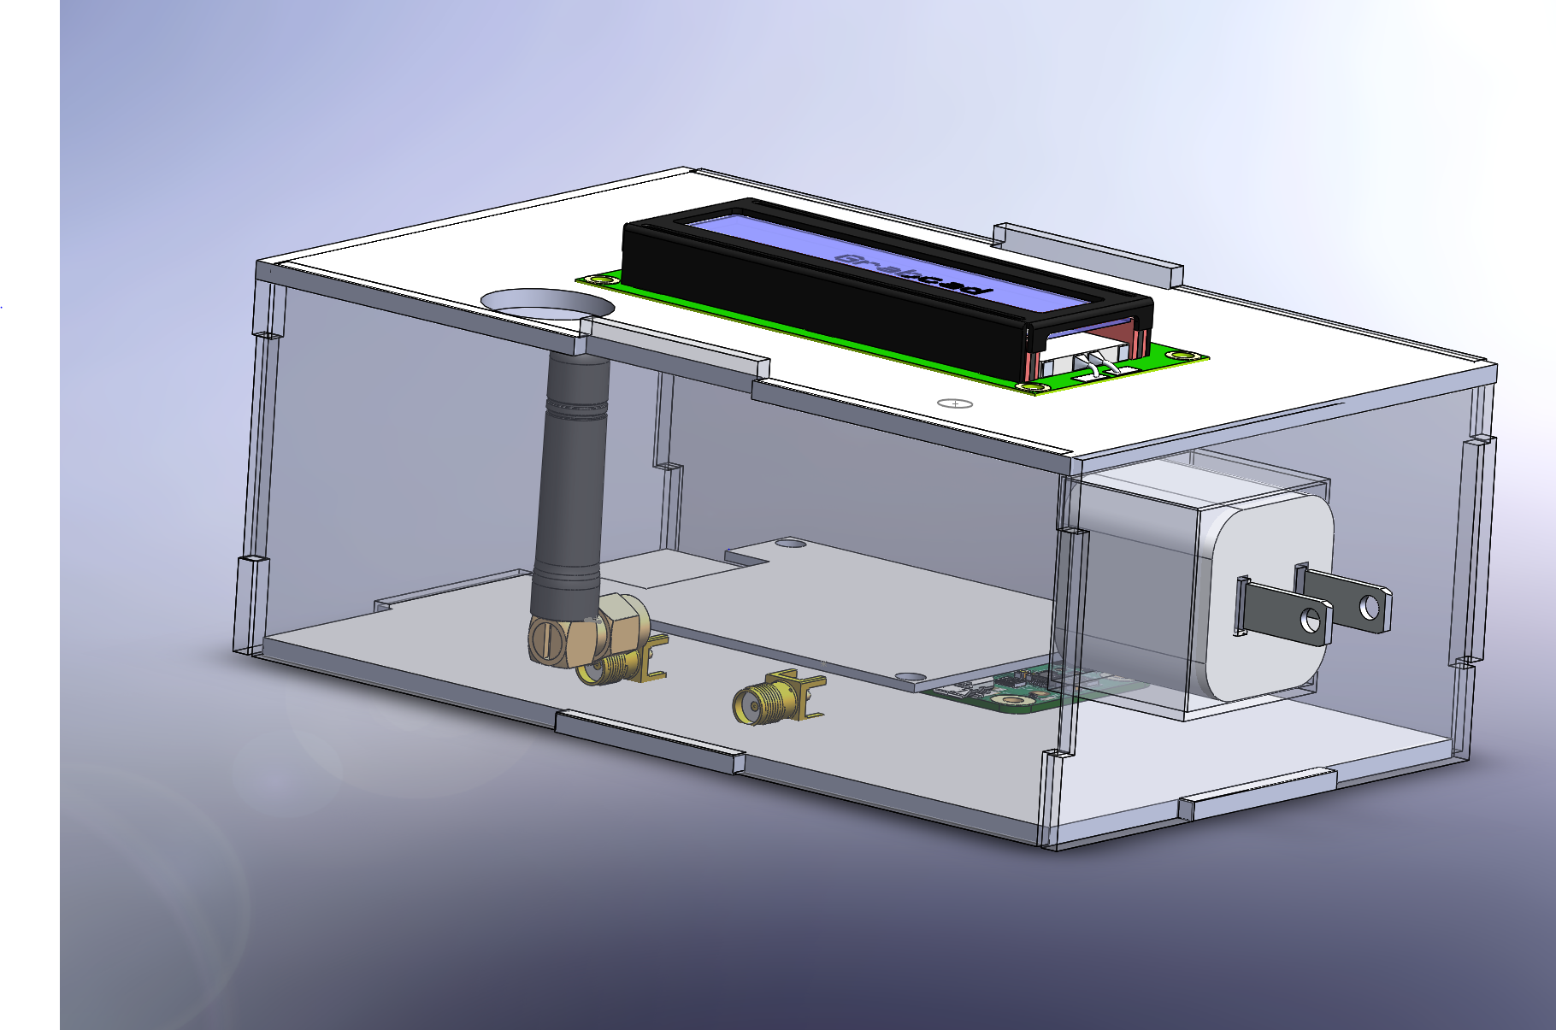

***Figure 6.1.3:*** *End-User System*

## 6.2 Mounting

**6.2.1 Solar Panel Mounting**

Having to power a self-sustaining fire detection probe, the solar panels must be mounted in a way that allows for the most sun exposure to them, that does not interfere with the image processing used to detect fires, and that is safe. Because reflections and heat radiated off of the panels may trigger anomalies in fire detection, the panels must be mounted either above or below the field of view of the cameras. Due to the large size of the panels, it was determined that mounting them on the sides of the probe we the best option. The prototype solar panel mounting design incorporates a ¾” steel dowel that is horizontally mounted to the PVC through two holes drilled on either side as seen in Figure 6.2.1. The dowel is secured to the PVC using L brackets. The brackets are secured to the PVC with large wood screws and keep the dowel in place with machine screws and washers. The solar panels are then secured to the dowel with pipe supports. Figure 6.4 shows the mounted panels on the prototype of the detection node of SSDS.



***Figure 6.2.1:*** *The mounted solar panels on the SSDS probe. They are supported*

*by a ¾” steel dowel that is fastened in place by two right angle brackets.*

**6.2.2 Rotating Rig Mounting**

The rotating rig with all components of the detection and communications systems needs to be securely mounted within the PVC. In order to fasten the entire mechanical rig to the 12” PVC housing, the rotating rig has a base platform. The platform was constructed using four 2in x 4in wooden studs adjacently fastened together and cut into a circular shape to fit snugly within the PVC as seen in Figure 6.2.1. Wood was chosen as it dampened the vibration of the stepper motor and provided sturdy base for all components. A hole that runs through the entire mechanical rig was cut using a 1.5in hole saw. This hole secures a 1.5in PVC where the antenna is mounted above the rig. The PVC secured the wiring harness to the spinning cameras from the RPi and runs wires to the antenna from the RPi.



***Figure 6.2.1:*** *Mounting of Rotating Rig on the PVC*

**6.2.3 Battery Mounting**

Finally, the batteries require a durable, well ventilated housing. For the prototype, a temporary battery housing solution is used. The Toshiba LTOs used in SSDS require that the terminals be laser welded to the bus bar. We were unable to complete this at this time, so a temporary pressure connection is used and can be seen in Figure 6.2.3. The five battery cells in series are held together by a 3D printed battery case that is 8.15in x 4.60in. The 3D printed battery case has a 2 cm spacing between each battery to adhere to the ambient temperature of each individual LTO cell. Strips of a sheet of aluminum 6061 alloy are used to connect terminals. These strips are secured to a piece of acrylic. This acrylic is tightened using wingnuts on threaded metal rods to create a firm pressure contact between the aluminum strips and battery terminals, allowing voltage and current to run from terminal to terminal. This setup is mounted onto a circular wooden base that is constructed and mounted within the PVC in a similar manner as was done with the mechanical rig. The battery back is mounted to this platform using a metal bracket to keep it in place.



***Figure 6.2.3*** *Prototype mounting of battery pack*

## 6.3 Rotating Rig and Camera Functionality

**6.3.1 Rotation System Overview**

SSDS looks to maximize the area surveyed by each detection node. To do this, the system must be capable of detecting fires 360° around each probe as well as be able to optimize the angle of the cameras for each individual probes location. Looking first at the 360° requirement of the system, the cameras on each probe, from a stationary position ,have a field of view of 60°. The system therefore rotates these cameras into six different positions, shown in Figure 6.3.1, to capture a 360° view of the probe’s surroundings.

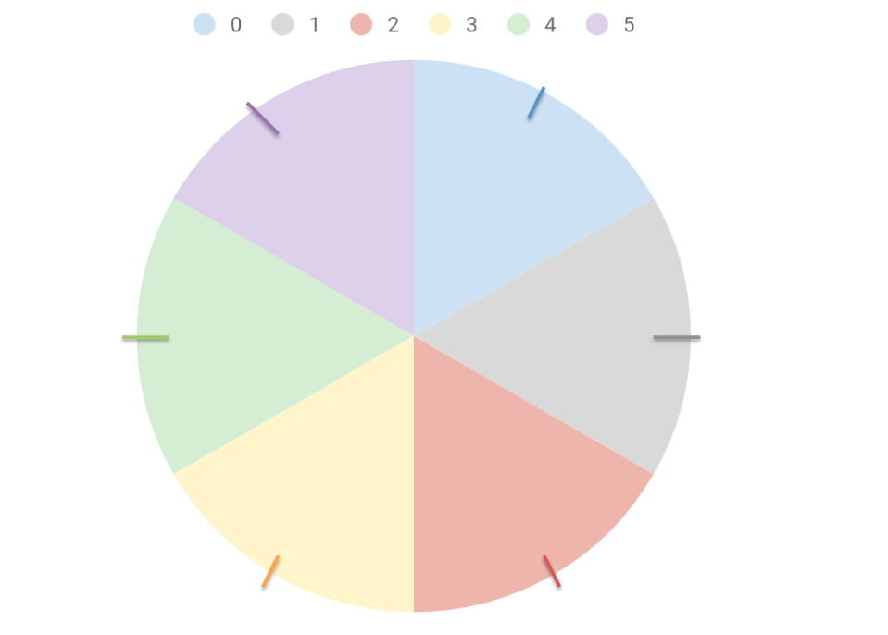

***Figure 6.3.1:*** *The six areas that the stepper motor will position the cameras into for 360° sampling. The stepper stops the camera at the center of each area.*

Each probe must keep track of the position it is in when an image is captured so that if a fire is detected, the probe knows which sextant the fire is in and can relay that information to emergency services. These positions must be consistent over the lifetime of the probe, so a stepper motor is used to achieve this motion. The stepper motor steps a set number of steps, in our case 77 steps, to achieve each 60° motion. It moves the cameras from position 0 up through position 5, capturing images and performing image processing along the way, and then moves the cameras back down from position 5 to position 0, again capturing and processing images along the way. Because each position is a set number of steps away from the last, the cameras are returned the same positions**.**

To achieve this movement, SSDS uses a rotating rig to spin the cameras into each position. This rig must not only allow for camera rotation, but must also allow for easy and stable wiring to the cameras from the microcontrollers that are performing the image processing and sending alarms when necessary.

**6.3.2 Rotating Rig**

Figure 6.3.2 shows the rotating rig and mechanical housing that holds all of the devices of the detection probe. This design offers the necessary 360° spin for the camera. The large open radius of the driving gear provides plenty of space for the wiring harness of the antenna and cameras. The components used to rotate the rig are mounted on the sides of the housing for the convenience of the wiring while offering more airflow. The Rpi, used for the detection and communication systems, is mounted inside the housing to provide the necessary wiring to the cameras and antenna. The gears are perpendicular, meaning the teeth of the driving gear will have to be cham to match the driving gears parameters for proper rotation. The driving gear spins the cameras with the help of the ball bearing lazy susan. The lazy susan sits between the housing and the driving gear. For the prototype, the gears are constructed by 3D printing them with PETG material. The 3D printed gears will have a 90% infill ratio to provide a long lifetime for our prototype, while being lightweight for our stepper motor. The rig is rotated by a NEMA 23 stepper motor, discussed in Chapter 3.Beyond the prototype, SSDS will contain gears made out of stainless steel to ensure a longer lifetime compared to that of that of PETG or PLA. Creating the rotating rig of steel also provides a higher melting point, meaning the SSDS could endure a higher extreme temperature.



***Figure 6.3.2:*** *Detection node’s rotating rig and mechanical layout of components. The Rpi is locating inside of the bottom box*

In addition to the 360° radial capability of the system, the system must also optimize the field of view of the cameras vertically. With each placement of the detection probe being different from another, the ability to adjust the camera for the most optimal field of view is extremely important; therefore, the system has a variable camera mount, shown in Figure 6.3.3. The camera mounting of each probe can be set upon installation of the probe to vary the horizontal angle of the cameras. The legs of the mount will be secured to the large driven gear of the rotating rig. The body of the mount is secured to the legs using screws and washers, allowing the angle of the mount to be adjusted and permanently set upon installation so that the cameras are positioned

.

***Fig 6.3.3:*** *Camera Housing mount*

## 6.3.3 Software Discussion of Stepper Motor

To control the stepper motor, a stepper motor control function is written in the Arduino IDE. The NEMA 23 is a bipolar stepper motor. We use an L298N H-bridge to safely charge and discharge the coils of the motor to make it move. As discussed in Chapter 3, this stepper draws a maximum current of 2.5A and a continuous current of 1.8A when it is moving. This is safely below the 3A peak, 2A continuous current rating of the L298N. We utilized the stepper motor functions provided in the open source libraries of the Arduino IDE. The Stepper.h file provides a function that will full-step drive the motor. This works for our system as the rig is rotated 60° at a time. One step of the NEMA 23 is 1.5°, so we do not need microstepping to achieve the required movement.

Stepper movement is achieved through implementing the state machine shown in Figure 6.3.4. This state machine is called by the operational control code detailed in Chapter 5.5**.** When it is time to make a movement, the state machine is called and the stepper moves. The machine takes in an event and direction. If there is no event, then the stepper does not move. If there is a MOVE_EVENT, then the stepper moves in the direction that it is told to. When the movement is complete, the machine returns a Movement_Complete event.

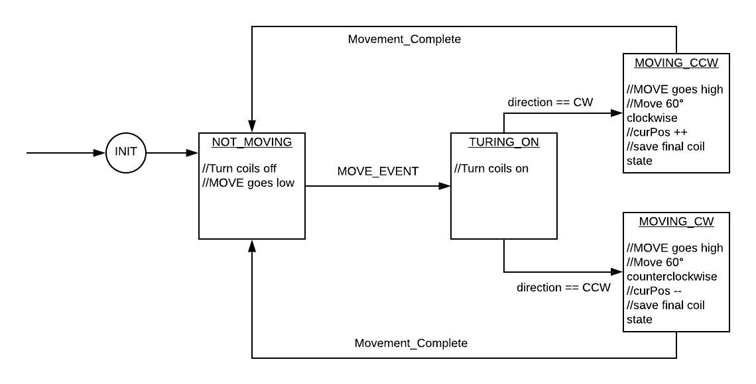

***Figure 6.3.4:*** *Stepper motor control state machine*

# Chapter 7: Results

## 7.1 Detection Range

The detection system achieved a maximum range of 1000 ft for a 1ft ${}^{3}$ without physical objects obstructing line of sight and with less than 250 lux ambient brightness. At higher lux levels the maximum detection range is 200ft. This detection range would increase proportional to the inverse squared of the flame area due to light propagation. This did not reach our objective of objective of 5000ft. Our range maxed out at 1000 ft mainly due to the limitations of the FLIR Lepton. The Lepton has a very poor image resolution, so if the fire takes up less than one pixel, it will likely not be detected. At 1000 ft, the 1ft ${}^{3}$ fire took up a single pixel and can be seen in Section 3.4.5. An IR camera with higher resolution would increase the maximum range but was more expensive than our budget allowed. The maximum range was also limited by our daytime color detection. The red light of the flame propagates less than the IR light detected by the Lepton.

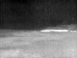

***Figure 7.1:*** *This image was captured by the FLIR Lepton from 1500ft. A 1ft ${}^{3}$ beach fire is present near the middle of the image but is too far away to be discernible. The pixel value have been scaled for human understanding, actual maximum values from the image are closer to 8200.*

## 7.2 Detection Accuracy

The algorithms devised were always able to detect fires within our maximum range with false positives. However, we do not have sufficient testing for our false positive algorithm. The false positive algorithm has successfully rejected moving or stationary detections that did not grow in size, but has not been tested on a real forest fire. Further testing needs to be done to characterize a growing forest fire to verify the false positive suppression algorithm.

## 7.3 Communication Range

The range of the LoRa transceiver was tested using an electrically short monopole antenna and determined to be 1.4 km with a near 100% successful packet rate transmission. However when this range was exceeded, packet corruption began to take a more prevalent effect. This range is expected to be extended if the monopole antenna were switched for the yagi antenna that was designed and built. Field testing was not performed with the yagi antenna and therefore a characterization of its effect is not available.

## 7.4 Communication Software Protocol implementation

The detection node was completed. That can transmit as well as receive messages from other LoRa modules currently operating at 868Mhz. It is planned however that because the LoRa modules are hardware optimized for 915Mhz that modifications would be made to the software to have it operate at 915Mhz. Currently the functions of the communications software can be called by the detection state machine. When called in TX mode the software will actively look for a send file containing the message type and message to be sent to the end user. In the case of receive mode the software will take in the parameter RX and a time constant that can be in terms of a long. This long will determine how long the system will stay in the RX mode in seconds. In this mode the software will take incoming messages and attach them to the receive file so that the detection team can review it. Simultaneously the software will add that message to the communications history file so that duplicates and expired time stamps may be checked. In the case of a duplicate the system will send out an acknowledge for that message and in the case of an expired timestamp the software will effectively delete that particular message. The software will also actively look for the receive file that the detection team will look at at the start of every cycle so that it will be actively deleted so that every run messages for review by the detection team will consist of messages received only during that time period.

The end user software debugging to implement the protocols and display information was not completed. All the functions for linked list manipulation were written and tested. However, when incorporated into the state machine and ran on the raspberry pi, a memory leak occurred resulting in a segmentation fault. Debugging was attempted but ultimately not completed. The error is most likely due to memory allocation and data structure manipulation. The team does have software that is capable of receiving and displaying messages however, it does not implement the communication protocols.

## 7.5 Power System Capability

The limits of the battery pack were not physically tested, but an analysis using the most up to date power budget allows to estimate the battery life of the system. SSDS uses a 20Ah,12V battery pack. From the power budgets, the system typically uses about 16Ah in the Typical and Low Power Modes, and 1.71Ah in Critical Operation Mode. We transition to Critical Operation when the capacity of the pack reaches 5Ah. Starting at full capacity, 20Ah, and assuming that the pack does not charge, without a Critical operation, the system can only be run for 30 hours. However, with the implemented Critical Operation state, the system can run for 92.5 hours, 22.5 hours sampling for fires and 70 hours in critical operation, which is almost four days.

The BMS can monitor the current in and out of the batteries and, using coulomb counting, estimate the charge of the batteries. It can use this charge to switch between the three operational modes of the system. Although the functionality of the PMOS cutoff was tested and works as expected, the current iteration of the operational control code does not set the FET Control high, cutting power to the RPi as we did not test powering down the RPi and did not want to risk damaging it.

We successfully interface with detection to run the sampling cycle. The second timers implemented on the Uno work to keep track of the 5 minute and 15 minute cycles and communicates with RPi to let detection know when to take pictures. The 1ms ISR that checks for input from the RPi and successfully determines when the stepper motor should move. Although power is not cut, the Critical Operation mode can be entered and the system stays at a stand still until it returns to Low or Typical Power modes.

Finally, the 5V and 6V rails required are successfully implemented and can provide power to the RPi, UNO, and stepper motor, with all other components being powered off of the 3.3V rails on the RPi and Uno.

## 7.6 Mechanical System

Initial designs for the three SSDS probes are completed and fabricated. The detection probe’s mechanical design is built and has been successfully tested to work as a prototype; however, the hat part of the probe is exposed due to the inability to find an affordable, durable enclosure capable of transmitting in the spectrum required by the cameras on the detection system. The end user has a fully functional housing able to house all onboard components, while being small enough to be powered by a wall outlet. The repeater node has been designed, fabricated, and assembled; however, the probe is just a prototype and will need to be redesigned to better fit as the final repeater probe.

# Chapter 8: Continuation Work

## 8.1 Detection Continuation

### 8.1.1 Thermal Camera Resolution

An IR camera with higher resolution would improve our design. The FLIR Lepton’s resolution is a limiting factor in the range and accuracy of our design. The Lepton has a resolution of 60x80, which resulted in a 1ft ${}^{3}$ taking a single pixel when viewed at 1000 ft. The FLIR Lepton was the best camera for our budget at the time of the project, but a project that has more funding to allocate to camera selection would be able to purchase a IR camera with higher resolution. There is a steep increase in the price of cameras that perform better than the FLIR Lepton. Most improvements over the Lepton do not list a price online, and cameras that list a price is more than $1000. The FLIR VUE 640 Thermal Imaging Camera has a resolution of 512x640. The FLIR VUE is listed at $3200.

### 8.1.2 Thermal Camera Wavelength

Noting that fires burn hotter than the typical temperature on the surface on the earth, the heat radiated from the flame becomes an optimal source for detecting fires. With the LWIR camera used in this detection system, it is capable of detecting hotspots comparative to the ambient environment. Thus, while a flame has only begin to burn, the LWIR camera will be able to detect the dynamic change in temperature from the environment and capture the flame in its images. All other capabilities and impacts on this detection system by the LWIR camera were mentioned in Chapter 4. However, further work on this project would call for a different infrared spectrum to identify heat and energy radiated from a flame. Because LWIR cameras also detect thermal radiation from black-body objects, it may detect non-fire objects if their temperatures become greater than the ambient temperature. Since temperatures typical of a wildfire have radiant energy peaks in the infrared spectrum of 3 microns to 5 microns, a midwave infrared(MWIR) camera will be more optimal to capture these heat signatures. While no other objects in the environment reach temperatures to have a radiant energy peak in the MWIR spectrum like a wildfire, those objects will be dismissed during detection [42]. In addition, combustion of biomass releases chemical compounds such as CO2 into the environment, which propagates in the midwave spectrum [34]. Therefore, the MWIR camera will not only be capable of identifying fire temperatures than a LWIR camera, but also verify the presence of a flame by detecting the chemicals released from combustion.

### 8.1.3 Testing Procedures

One of the biggest challenges faced throughout the development of the detection system was the way in which our team evaluated the effectiveness of our designs. For obvious reasons, we could not feasibly test them using a genuine wildfire. We also had a particularly difficult time devising an appropriate experimental analog that could be responsibly used for our field testing. Ultimately, our team elected to test our detector in a controlled setting along Rio del Mar beach located near Aptos and La Selva. This provided a suitable area to test our mechanism in an idealized environment that lacked any visible obstruction. This gave us limited understanding of the efficacy of our design as it prevented us from determining the impact of obstacles on our detection ability. With the variety of environmental settings in which we plan on deploying our system in mind, this is surely information that potential investors and clients will want to be aware of prior to their investments. As such, outlining more effective testing procedures will be paramount if the development of this project were to continue beyond this year.

### 8.1.4 C Code Implementation

The speed of each cycle is an important feature to implement fast and reliable wildfire detections. However, the Python image processing algorithms run on the RPi took about 20 seconds each, varying depending on the number of anomalies present in each image. This processing time was longer than expected and could be theoretically be reduced by implementing the algorithms in C code. The main differences between C and Python for functionality are speed and available sources. Python has numerous high level packages and methods for accomplishing tasks, making Python ideal for prototyping and experimenting. However, C provides greater control over functionality and speed. The implementation of C code would require the image processing algorithms to be redesigned in OpenCV C functions or as MATLAB converted code.

The switch to C code would also change how the RPi handles receiving and transmitting information. Additionally, the transceiver C executable could be integrated into the same program as the image processing and state machine, rather than an executable that needs to be called. This single program would eliminate the need for large sections of blocking code when calling the transceiver executable.

### 8.1.5 Actuated Camera Window

It is incredibly important to the longevity of our detection node design that its protective external housing be completely weatherproof. To accomplish this, we originally planned the addition of a transparent, cylindrical acrylic window at the top of our PVC housing. In theory, this would grant our camera array the 360° unobstructed view of the surrounding environment that it needs while still being sufficiently weatherproof. However, upon further investigation with the help of Lepton 2.5 thermal camera, we discovered that transparent acrylic is an absorber of infrared radiation. This would have little impact on our visible light camera, but would render the Lepton effectively useless. This in turn compromises the overall functionality of our detection scheme. Forms of glass or acrylic exist that do in fact pass infrared radiation, but they are much too costly for our design team’s financial situation. Should the project be continued, we recommend the pursuit of an actuated camera window design that can be opened and closed on command. Such an apparatus would afford the necessary weatherproofing at a much more reasonable expense to the team. This cheap and easy solution would likely be more attractive to potential investors by increasing the profitability of our proposed design.

## 8.2 Communications Continuation

### Overview

A full communications pipeline was completed from detection node to end user however, the necessary network protocols weren’t implemented at the end user node. Additionally, the Yagi antennas were not characterized nor actually field tested and the end user display was not integrated with the end user node and fully tested for functionality.

### 8.2.1 Antenna Development

Performing field tests with the Yagi antennas would be the first step in continuing the antenna portion of the system. Data for range and RSSI would be valuable information for adjusting and improving the antenna design. Based on short range testing, a dual-Yagi system provides an improvement of +26 dB to the RSSI compared to the dual quarter-wave-whip system. The results are promising and field testing will determine if the 3 km transmission range is possible with the Yagi antennas.

Improvements to the Yagi could be performed by using a more secure method of attaching the elements to the boom. The prototype version would not hold up long-term in the forest because the masking tape would degrade. In addition, the wire elements could be bent by mechanical forces, such as a tree branch falling on them. This would be resolved by the use of thicker metal rods to act as elements. Weatherproofing the antenna was not addressed with the prototype design and should definitely be implemented in the next iteration of the antenna.

### 8.2.2 Software Development

In terms of the software there is much that can be improved in two general areas; the network protocol and the message assembly protocol.

In terms of the network protocol the primary issue with it are that currently from the message standpoint since messages can fit in one packet the protocol is designed to transmit only one packet at a time meaning that long messages cannot be sent in a way that ensures that all parts of the message are sequentially received. This could be addressed through the addition of an expected number of packets field with incrementally decreasing number in accordance with each incremental packet sent. This could be a way to check that packets arrive in the correct order and that none are missing at the end of the transmission.

The message assembly protocol also has innate issues as currently if a message is too long currently what happens is that it would overwrite what is currently inside the message. This can easily be remedied through taking the length field and performing such cutoffs in the message with the addition of the aforementioned packet number field. The implementation of both of these features would result in a communications system that can transmit multiple packets for any length messages.

Outside of these two general areas specifically there are also issues with both the detection node software and the end user node software that must be addressed in order for the project to be remotely commercially viable.

In terms of the detection system while the C file system implemented is functional a better way of doing this would be to code so that both the detection state machine and the communications system could run in parallel. This could be done through the adoption of fully non-blocking code on the RPi.

In terms of the end user node the software for this could be more polished in that the memory leaks could be fixed. Additionally the end user state machine could be more hashed out, polished, and tested in a full pipeline. Adding to this the repeater nodes software should be added to or scrapped and redone so that it actually follows network protocols and sends and receives appropriately. Currently the best that it might be capable of is simply forwarding every message corrupted or not indiscriminately.

Overall however for both cases the worst case operating cost should be found to determine exactly how much time each operation in terms of TX and RX takes to better optimize the runtime so that more time could be spent listening to incoming packets in RX mode.

### 

### 8.2.3 Hardware Development

In terms of the detection node while wires were soldered to the actual SX1276 a much better way of doing it would be to design and possibly 3D print out a proper mount for the transceiver. Additionally for the advantages of the CC1101 in tandem with the CC1190 range extender the software for these should be continued and eventually they should replace the SX1276 LoRa modules due to their vastly superior ability to transmit with considerable vegetation clutter present. With the continuation of the project newer more available technology could be present such as NB-Iot that should be considered against the CC1101 and SX1276.

The end user node also has a fair number of issues that should be resolved should the project be continued. The design of the end user node is such that it must be plugged directly into a wall outlet meaning that the actual unit itself is tied directly to the wall outlet unless an extension cord is used. This means that in most scenarios the end user node would be free floating off the ground or near the ground in a very inconvenient position for the end user to actually read from. Additional to this issue however is the question of whether the LCD display should be replaced with a more user friendly approach i.e. a raspbian natively supported HDMI monitor running in place of stretch lite a full version of stretch with a GUI for the end user to interface with. In fact the end user system is not really constrained with any particular flavor of linux for it as long as it retained the ability to compile C code it could be almost any OS or even a simple command line program that simply would run forever. The goal of which being more user friendly to the end user.

### 8.2.4 FCC License Obtainment

To extend the range of the communication system, obtaining a license from the FCC could be a viable option. As mentioned before, the system operates on frequency bands that are free to use as long as the rules and regulations set by the FCC under Part 15 are followed. These rules limit the output power of wireless communication and as such, limit the possible range of transceivers. Obtaining a license from the FCC would allow for these output power limits to be exceeded and also expand the options of viable transceivers.

If the FCC license cannot be obtained for whatever reasons from convenience to cost then increasing the current output of the SX1276 to the maximum permissible FCC output power could be observed. In this case hardware would have to be designed to take a signal and amplify it in terms of power then transmit it.

## 8.3 Power Continuation

### 8.3.1 Reducing Power Consumption

Having focused on reducing the time that the stepper motor was active as it was the most obvious consumer of power in SSDS, we overlooked the power consumption of the FLIR Lepton LWIR thermal camera. As it exists in our system now, the thermal camera is always on, drawing between 150mA to 650mA at around 3V. It dissipates between 1W and 2W, making it the second highest consumer of power in the system. However, if we turn the camera off while it is not being used to capture images, we can cut our total energy consumption nearly in half. As shown in Figure 8.1, the new energy consumption of the system would therefore drop to 33.73Wh, compared to the 58.49Wh currently used by our system.

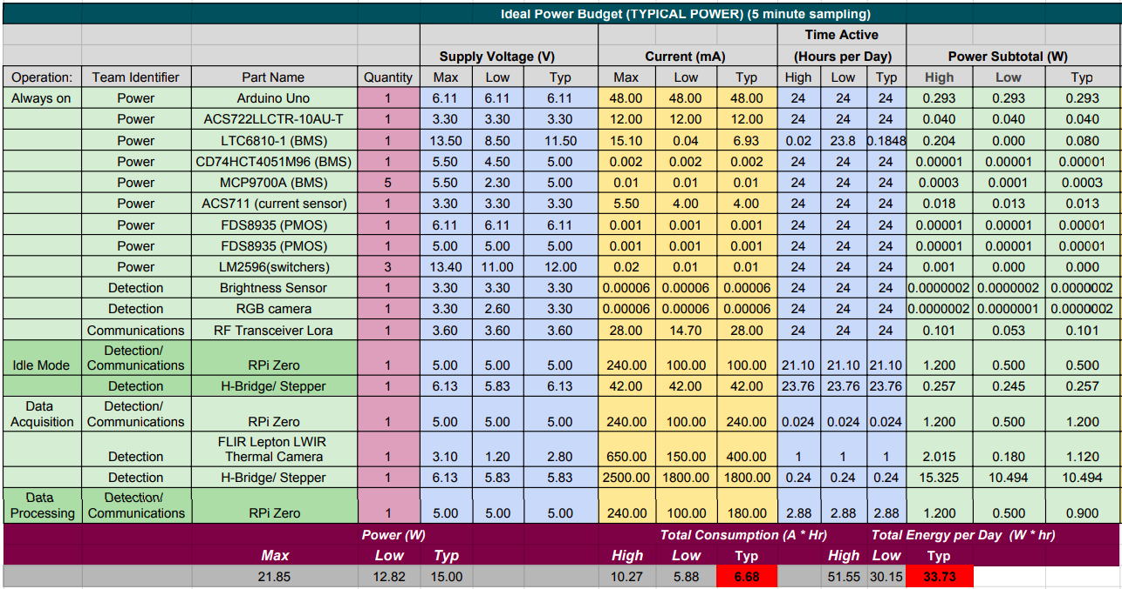

***Figure 8.1:*** *Ideal power budget for the typical operation of SSDS.*

### 8.3.2 Completion of BMS Software and Implementation of Fault Analysis

Software to communicate with the LTC6810-1 6-channel battery stack monitor to evaluate the temperature and voltage of the battery pack was not completed. With the completion of voltage and temperature monitoring, the fault analysis can be implemented in the operation control of the system. Currently, only the SoC is used to determine the state transitions between the operational modes of the system. Currently there is not an implemented way to cut power to all components not critical in the monitoring of batteries if a fault occurs. If there is a voltage or temperature fault, the system as it is continues running. Ideally, if there was a battery fault, we would cut power to all non-power related components to protect them and the batteries. If a Critical Operation transition was triggered by a battery fault, we would also need to send and alert to the user that the battery may need maintenance. It would have to do this by communicating the alert from the Uno to the RPi to alert the end user.

### 8.3.3 Charge Controller Design

As discussed in Section 5.4.1 Solar Panels and Charge Control, the charge controller and solar panels we are currently using in SSDS can charge the batteries at a much higher rate than is required by the power usage of the system. To continue using the buck converters that are currently implemented in our power system, assume the continued use of our 12V, 20Ah, LTO battery pack. If we were to design our own PWM charge controller, taking into account that the system at most uses 97.9Wh and the system was to be implemented in Santa Cruz, which receives about 5.4 hours of peak sunlight, the power need to run the system is 97.9Wh/5.4hours, which is 18.1W. Polycrystalline panels are 15% efficient, so we need at least a 20W panel to power the system. With a 25W solar panel and 12V battery pack, the current needed to charge the batteries is 2.4A, as calculated below. We could, therefore design a 2.4A, 12V, PWM charge controller that worked with a 25W solar panel that would sufficiently power the system in place of our current 15A, 12V PWM controller with 100W solar panels.

$\frac{Power}{Voltage}+15\% = Current$

$\frac{25W}{12V}+(\frac{25W}{12V})(0.15) = 2.4A$

## 8.4 Mechanical Continuation

### Overview

The mechanical prototype probes are complete. The knowledge learned from the first prototype should be taken into heavy consideration in the next iteration of design.

### 8.4.1 Redesigning Probes

Redesigning SSDS from the information gathered in the construction of the first prototype is the first step of future continuation. The redesigning process will allow for a slimmer detection probe design that can better fit the criteria demanded by the system and will last many years in a real environmental setting.

The first redesign would focus on the Hat of the detection probe. Instead of a transparent enclosure, a more viable and affordable option would be to have a linear actuator that would open and close the top of the probe. A linear actuator would lift the hat whenever SSDS is sampling for fires and drop it down to protect all components while the probe was not sampling. This would offer a weatherproof housing for SSDS that is far less expensive than using a material that is transparent in the wavelengths used in detection.

Moving on to the redesign of the repeater. Though the repeater node is designed to have an LTO battery pack, we were unable to accomplish the fabrication of a second pack. Because we were unable to produce this second pack, the redesign of the repeater node would have to consider the placement of the battery pack and solar panels. Additionally with a specifically designed charge controller for our system, the repeater node could have slimmer solar panels. Finally, redesigning the repeater node to be taller than seven feet would allow for a better effective range of communication.

Both the detection and repeater probes of SSDS would need to also focus on designing a proper mounting scheme for the implementation of the probes in real outdoor terrain. Having metal poles connected to the probes for mounting could be a viable option; however, more research will need to be done before a final consideration.

Although the end user prototype housing is a good representation of the final product, a redesign to have a yagi mounted near the end user would need to be considered for the next iteration. Along with better placement of onboard components offering a slimmer and cleaner design.

### 8.4.2 Battery Pack Development

As seen from the mechanical section the battery pack was never laser welded. A CAD layout of the ideal laser welded pack can be seen in Figure 8.2. However, the battery housing depicted in 8.2 could be improved to detail exact placement of required fuses and the wiring harness to and from the battery pack.

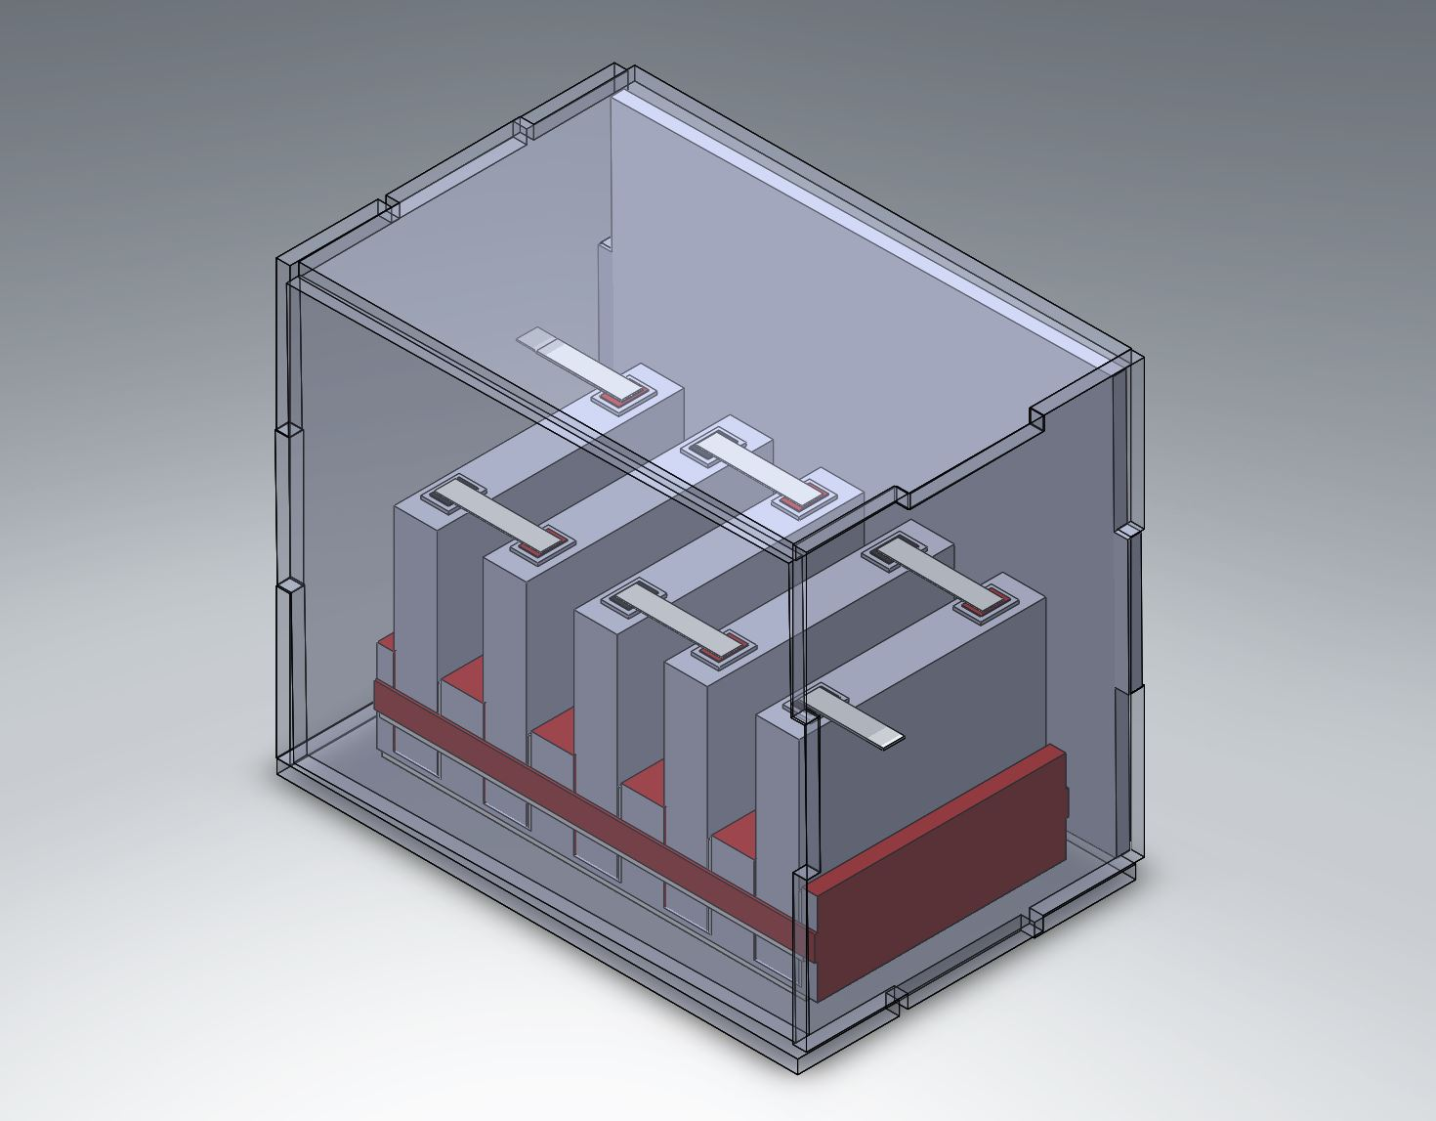

***Figure 8.2:*** *CAD of laser welded battery pack.*

### 8.4.3 Probe Testing

Testing of the completed mechanical system needs to be continued. Due our inability to laser weld our battery pack and the open top of the probe, we were unable to extensively test the probe outdoors. The temporary battery pack does not fit in the probe and the open top leaves all internal components of the system exposed so we could be simply leave the porbe outdoors, alone for an extended period of time. Fully weatherproofing the probe by installing the batteries inside the PVC and sealing the top will allow for full outdoor testing our the system.

# 

# Chapter 9: Conclusion

The Smokey The Slug Detection design team set out to create a revolutionary autonomous system capable of identifying wildfires and notifying the appropriate authorities. After 25 weeks of work with the combined efforts of nine team members with various skills and technical backgrounds, a functioning prototype was fabricated capable of detecting fires, relaying this information wirelessly, and powering itself sustainably. The detection range is dependant on the brightness of the given environment where above 250 lux, the range is nominally 200ft and below 250 lux the range is roughly 1000ft. The wireless communication range in ideal conditions is about 1.4 kilometers and deteriorates when line of sight is lost and when adverse clutter conditions due to objects or vegetation is encountered. The battery system is capable of powering the full system indefinitely with adequate sunlight and without it, will be able to run continuous monitoring 22.5 hours while actively keeping the battery pack healthy for another 70 hours. Although there is room for improvement on each individual subsystem, overall the system has achieved the initially proposed design specifications.

# Annotated Bibliography

1. **3M Gas & Flame Detection. “A Guide to Optical Flame Detection – How UV, IR and**

**Imaging Detectors Work.” *AZoSensors.com*, 27 Aug. 2018,**

**www.azosensors.com/article.aspx?ArticleID=815.**

This source goes into granular detail about several methods of flame detection. It discusses devices such as optical detectors, including ultraviolet detectors, infrared detectors, and mixed spectrum detectors with respect to their advantages and limitations. It also touches on the idea of imaging flame detectors and informs readers about the impact of weather on these methods, and how to go about selecting one for application.

Given the variety of flame detectors at our disposal, we will need to put careful thought into our selection process. This source will allow us to make an effective selection and gives good advice about how to proceed once we have done so.

**2) Abu-Al-Saud, Wajih. “Vestigial Side Band Modulation.” 14 Dec. 2018.**

**http://faculty.kfupm.edu.sa/EE/wajih/files/EE%20370/EE%20370,%20Lecture%2013.pdf**

This lecture from a professor goes into detail about vestigial sideband modulation, which is one of the modulation methods that our team has considered for wireless communication. It is easier to implement than single sideband and uses less power than double sideband, making it a viable choice for modulating our signals. This lecture provides mathematical equations on the output signals that would result from vestigial sideband modulation, which will be useful for us to analyze.

**3) Black, Dave, et al. “Understanding Focal Length.” *Nikon Df | Classic Nikon DSLR***

***with Modern Features Inside*,**

**www.nikonusa.com/en/learn-and-explore/a/tips-and-techniques/understanding-foc**

**Al-length.html.**

This website gives insight into the role of lensing in photography. It does so by highlighting the relationship between magnification and field of view before relating them both to the focal length of the camera’s lens. It concludes by showing examples of photos taken using lenses of varying focal lengths, along with a graphic showing how lens focal length corresponds to field of view.

From the outset of this project our team has known that detecting fires at long range will be challenging, we will likely be utilizing different lenses to detect fires at distinct ranges, and this source will be instrumental in that process.

**4) “BU-205: Types of Lithium-Ion.” Lithium-Based Batteries Information – Battery**

**University, 31 May 2018, batteryuniversity.com/learn/article/types_of_lithium_ion.**

From comparing many times of Lithium-Ion batteries this resource was a great to compare because of their intuitive charts. This resource has great summary between each battery describing cost,lifespan,specific power, specific energy, safety, and performance of each lithium ion battery.

This source puts into perspective how there are many times of lithium ion batteries, this information document clearly identifies the benefit and disadvantages of each battery, our team prioritizes the lifespan, and operable temperature of the lithium ions because it would require less maintenance and be able to operate with low temperatures.

**5) “BU-209: How Does a Supercapacitor Work?” *Lithium-Based Batteries Information –***

***Battery University*, 21 Apr. 2017,**

**batteryuniversity.com/learn/article/whats_the_role_of_the_supercapacitor.**

Supercapacitors were a huge interest for this project because of their ability to be quickly charge and quickly dissipated. This resource was a great tool to describe the usability of supercapacitors describing their charge cycles, and discharge cycles proving that this tool could be used for our project. This resource also allows the reader to compare lithium ions vs supercapacitors describing cost, lifecycles, and temperature efficiencies.

Our team has decided to pursue a power source such as supercapacitors because it incorporates a combination of fast charges and fast discharges that the wildfire detector will need to have frequencent discharge from a power source. Due to the concern about the complexity of supercapacitors working with a lithium ion battery it is extremely important to have a system that would work cohesively therefore having this resource is a great description of what is needed.

**6) “BU-203: Nickel-Based Batteries.” Lithium-Based Batteries Information – Battery**

**University, 31 May 2018,**

**batteryuniversity.com/learn/article/nickel_based_batteries.**

Having this source of nickel-based batteries helped to determine the usability of potential batteries like nickel cadmium batteries. The source showed the advantages and disadvantages between each nickel battery. From this source the power team was able to determine whether nickel cadmium batteries were a viable option for this team source of battery.

The discovered from research nickel cadmium had an incredible life span, but however lacked power efficiency, and overall project integration; therefore, not much research went into looking into nickel cadmium batteries

**7) “CAL FIRE Jurisdiction Fires, Acres, Dollar Damage, and Structures Destroyed.”**

***CALfire.gov*, CALfire, 1 Aug. 2018,**

**calfire.ca.gov/communications/downloads/fact_sheets/firestats.pdf.**

This is a spreadsheet documenting the annual fire damage in the state of California from 1933 to 2016. It assesses damage in terms of the number of fires, the total acreage burned, fiscal damage and the number of structures destroyed.

This source puts in perspective how damaging fires have been in recent years, this document clearly identifies the upward trend in the amount of damage caused annually by fires in the state of California, demonstrating the marketability of our project.

**8) Dellsperger, Fritz. “Analog Modulation.” 13 Dec. 2018.**

**http://www.fritz.dellsperger.net/downloads/V7a_2.1-Amplitudemodulation_en.pdf**

These notes are written by a professor of RF and microwave engineering from the Bern University of Applied Sciences, which makes them a credible source. The article focuses on amplitude modulation as well as covering topics such as vestigial sideband, single sideband, and double sideband modulation. It includes block diagrams and circuit schematics of these different types of modulation techniques. In addition, there are calculations provided that describe power and signal behavior resulting from modulation. Charts and graphs are there to show such behavior over time. This source will be useful as a guide for designing an RF system that allows several nodes in the detection system to communicate wirelessly.

**9) “Environment and Natural Resources.” *Fire Behaviour, Government of the***

***Northwest Territories*,**

**www.enr.gov.nt.ca/en/services/fire-operations/fire-behaviour.**

This website, curated by a part of the Canadian government, confers information about how wildfires ignite and spread. In particular, it explains how available fuel, atmospheric weather conditions, and topography can all factor into assessing the risk posed by a fire after it has been started.

While each member of our design team has dedicated years of our lives familiarizing ourselves with the principles of electrical engineering, none of us have the knowledge about the dynamics of wildfires necessary for this project. The information gathered in this source will inform our design in ways that we might not otherwise consider.

**10) Evanczuk, Stephen. “Specialized Charger ICs Manage Supercapacitors in**

**Energy-Harvesting Designs.” Digikey, ElectronicProducts.com, 26 Mar. 2014,**

**www.digikey.com/en/articles/techzone/2014/mar/specialized-charger-ics-manage-s**

**Upercapacitors-in-energy-harvesting-designs.**

This source has an incredible amount of information of how to charge supercapacitors using the proper IC. The main part of this resource describes the Internal DC/DC converters a simple chargers using a conventional buck or boost. Describing the DC/DC converter applications could reduce the component count, eliminate the need for additional circuits to provide a safe charging process.

Because charging supercapacitors requires careful attention to the charge/discharge characteristics of these devices, it is important to have all the information needed from this resource. This resource allowed the power team to have the IC they would like to research to hit the criteria of this project.

**11) “Insight Robotics Wildfire Detection System.” Insight Robotics,**

**www.insightrobotics.com/en/services/wildfire-detection-system/.**

This is the webpage for a company called Insight Robotics. They have created a design that features a detection method that is much more similar to our own than others we have come across. This design has the added functionality of being able to interact remotely with cameras in the event that a fire is detected. Notably, the site mentions very little about how the design is powered.

As a potential competitor in this field, it is important that our team stay informed about any rival companies or designs to the best of our ability. Another design that we found, called the Vigilys system, has a radically different detection mechanism. Consideration of these two methods and their various drawbacks will be important for our team.

**12) Love, John. “How to Assess Thermal Camera Range Capability for Site Design**

**Purposes.” *DRS Technologies, Commercial Infrared Systems.***

**http://www.drsinfrared.com/Portals/0/docs/201409_TruthAboutRangeData_MR-201**

**4-10-683A.pdf**

This white paper provides our design team with a wealth of information about how to apply infrared cameras to detect, recognize and identify anomalies for surveillance purposes. It also expanded our understanding on the impact of weather on the range capability of thermal imaging, and gave advice about how to apply image processing to infrared images.

Our team has decided to pursue a multi-tier detection system that incorporates a combination of regular and thermal imaging. Due to our concern about properly ranging the thermal cameras, this source will be very important to the detection subteam going forward.

**13) “MATLAB 6.5 Image Processing Toolbox Tutorial.” *Matlab IPT Tutorial for EE5880*,**

**www.cs.otago.ac.nz/cosc451/Resources/matlab_ipt_tutorial.pdf.**

This document is a collection of technical examples from the Matlab image processing toolbox. The examples show both the Matlab code and the resulting images, accompanied by a brief description of what the filter does and how it might be practically applied.

Image processing is an incredibly powerful technology that has the potential to make fire detection a much easier task. We can devise multiple processing algorithms to apply to both our thermal and regular imagers.

**14) “MPPT vs PWM Solar Controllers.” Enerdrive Pty Ltd, 4 Oct. 2017,**

**www.enerdrive.com.au/mppt-vs-pwm-solar-controllers/.**

Comparing charge controllers for a potential hybrid pack between supercapacitors and lithium ion batteries was narrowed down to PWM and MPPT charge controllers. This resource particularly explains the benefits of each controller with pros and cons weighing heavily on this project describing cost, durability, solar input, and overall establishment between the two.

Because the general purpose of this source is to demonstrate the commercial usage solar panels there is actually great information regarding if were used in the forest. Our team has decided on a microcontroller from this source to while incorporating a combination of useful information on the other.

**15) Patel, Punam, and Shamik Tiwari. “Flame Detection Using Image Processing**

**Techniques.” *International Journal of Computer Applications*, vol. 58, no. 18, Nov.**

**2012, pp. 13–16.**

This article details how the image processing techniques discussed in other sources can be applied to the task of algorithmic flame detection. It describes in detail how to differentiate pixels in an image that contain a flame from a variety of other common background textures.

Image processing will be central to the detection system we have designed. Image processing techniques have nearly limitless applications and this source provides information that is specifically pertinent to our team goals with this project.

**16) “Personal Radio Services.” *Federal Communications Commission*, 7 Dec. 2018,**

**www.fcc.gov/consumers/guides/personal-radio-services-prs-keeping-touch.**

This website from the Federal Communications Commission explains the regulations that everybody must follow regarding communications by wire or radio. It is a credible source because the FCC controls the laws of communications. The website provides a brief overview of all the laws and regulations that must be followed when sending radio signals. Designing a communications system that stays within the bounds of the regulations listed on the website is imperative. Our team needs this information as a guideline for implementing a system that will not negatively interfere with other broadcast signals.

**17) “Polycrystalline Solar Cells or Monocrystalline: Which Is Better?” Solar Power &**

**Geothermal Energy Systems Rochester NY | Geotherm, 18 Oct. 2018,**

**geothermhvac.com/mono-vs-poly-better/.**

This source goes into detail about Poly and Mono crystalline about cost. This source has a more precise information about the cost differences between the two solar panels. In addition to the cost specificity this resource goes into specific detail about the space these solar panels requires.

For the power team this is incredibly important resource to have because cost per watts and the amount of space the two solar panels offer could be the overall decision maker for this project. Also having these two solar panels being very similar having the right information will lead for a overall power efficiency for the panels.

**18) “Raspberry Pi: Power Consumption Benchmarks.” *Power Consumption***

***Benchmarks | Raspberry Pi Dramble*,**

**www.pidramble.com/wiki/benchmarks/power-consumption.**

This source evaluates the power consumption benchmarks for all of the different models of Raspberry Pi, in the form of a data table.

Our team plans to use a Raspberry Pi as a hardware platform to conduct our image processing on. Raspberry Pis are notorious for drawing lots of power, so this source will help us select the right one for our design. We did have some concerns about the reputability of this source, but we were able to corroborate its information with several other sources with a fair amount of ease.

**19) Sendy, Andrew. “Pros and Cons of Monocrystalline vs Polycrystalline Solar**

**Panels.” Solar Reviews, Solar Reviews, 23 Aug. 2017,**

**www.solarreviews.com/blog/pros-and-cons-of-monocrystalline-vs-polycrystalline-**

**Solar-panels.**

When comparing solar panels this website gives detail about several different types. It discusses Thin Film, Polycrystalline, and Monocrystalline with their respective advantages and disadvantages when it comes to our project. It also goes into detail about the topics of weather conditions the panels will be able to sustain, which this project will highly prioritize over pricing.

Given the variety of solar panels, the team will need to properly pick the right one for this project. This source will allow the power team to give good suggestions, and reasons why their respective solar panel was chosen.

**20) “Single Sideband – the Phasing Method, or Sapere Aude.” *Redeyeprep*, 20 July**

**2017,**

**redeyeprep.wordpress.com/2017/01/27/single-sideband-the-phasing-method-or-sapere-aude/.**

This article provides an in depth guide on the phasing method of single sideband modulation. It includes block diagrams that show different designs that can be implemented. There are also detailed descriptions that explain the aspects of this method of modulation.

Our team considered single sideband modulation as a possible solution to our wireless communications problem. It uses less power than other types of modulations such as double sideband. This source contains practical and useful information that could help us design a communications system using single sideband modulation.

**21) “Wildfire Detection.” *Vigilys*, vigilys.com/technology/firealert/.**

This webpage offers insight into an existing design for a device with a premise similar to that of our own design team. The authors of the page give a brief but comprehensive look into basic design aspects, as well as point out key limitations. The source also provides a suitable platform from which to initiate further research. Provided contact information will also facilitate any necessary inquiry about design and implementation.

Because the general purpose of this source is to advertise a product for profit, the reliability of the claims it makes regarding the effectiveness of various design choices is limited. In all likelihood, benefits are overstated and drawbacks are downplayed in an attempt to spur additional sales. That said, the information that our team gathered about the general design it describes will go a long way towards informing our own design. Aspects our team deems effective can be replicated, and deficiencies will be overhauled in our interpretation of the design.

**22) “Thermal Imaging Technical Resource.” Davis Instruments.**

**https://pim-resources.coleparmer.com/data-sheet/thermalimagingtechresource.pdf**

This manual provides technical information that explains how a thermal camera works and how different image resolutions compare. In turn, this information is helpful in selecting viable thermal cameras for this project as well as what specifications should be considered when purchasing.

**23) “An Engineer’s Introduction to Thermal Imaging.” *AZoSensors.com*, 1 Jun**

**2018.**

**https://www.azosensors.com/article.aspx?ArticleID=1157**

This article provides an introduction to how thermal imaging works and how they are applied. Furthermore, it includes informations and guidelines that help determine the resolution and lens needed to achieve the goal of this project’s detection system.

**24) Petitweg, Charles. “Cooled versus uncooled cameras for long range**

**surveillance.” FLIR.**

**http://www.flirmedia.com/MMC/CVS/Tech_Notes/TN_0005_EN.pdf**

This document defines what a cooled and uncooled thermal camera is and compares their effectiveness in detecting IR. It continues to mention the range capability of cooled thermal cameras to see up to 50 kilometers though it’s expensive to maintain the cryogenic cooling system it needs. However, uncooled thermal cameras are still viable to achieving a working detection system. The price of an uncooled camera is cheaper than a cooled camera since it excludes the cooling system but it can get more expensive as the lens will need to be adjusted to a larger size. The cost of Germanium lens will play a big part in the cost of implementing an uncooled thermal camera.

**25) “Chapter 5: Thermal Cameras.”**

**https://www.axis.com/files/articles/Ch5_thermalcameras.pdf**

In this document, it compares the different thermal sensors, cooled and uncooled, and breaks it down more into calculating the focal length of the lens. Since cooled and uncooled cameras have their respective lens preferences, it provides examples of possible sensor grid sizes available for use in this project design. Furthermore, it explains what kind of information thermal images present.

**26) Cole, Matthew. “A Tedious Explanation of Depth of Field.” 5 Apr 2016.**

**http://www.uscoles.com/depthoffield.html**

This article covers the fundamentals and defines how a camera’s focal length and depth of field behaves. Since thermal cameras have limited lens size due to the material they are made from, understanding how focal lengths can determine the range capability of the thermal cameras used in this project design. The ratio of the focal length and aperture size will contribute to the effects it will have on the camera’s depth of field. With depth of field affected by focal length, f/stop, and distance from the camera to the object, it all contributes in choosing a viable camera and auxiliary lens to improve the thermal camera range capability.

**27) “Understanding Infrared Camera Thermal Image Quality.” *Electrophysics***

***Infrared Inspection.***

**https://blog.lk-shop.com/wp-content/uploads/2015/06/WP-Understanding_IR.pdf**

This white paper discusses the quality of a thermal image in terms of pixel resolution and thermal sensitivity of the camera.It provides information of the tests they performed to observe the thermal sensitivity of the camera they used. From there, the tests leads to results that contributes to obtain an image that is uniform and have little noise to be processed.

**28) Geerling, Jeff. “Power Consumption Benchmarks.”**

**https://www.pidramble.com/wiki/benchmarks/power-consumption**

This article provides the power consumption benchmarks of the Raspberry Pi. This processor will be a part of the image processing system to detect heat signatures in the thermal images. The amount of power consumed during different states of operation provides the necessary information when designing the power budget for the project.

**29) “Introduction to Ad hoc Networks” Drs. Baruch Awerbuch & Amitabh Mishra Department of Computer Science Johns Hopkins University https://www.cs.jhu.edu/~cs647/intro_adhoc.pdf**

This pdf gives a good explanation of Ad Hoc networks and their advantages. It also gives some insight into the technical aspect, functionality, and protocols of these types of networks.

This source will be a good reference for the communications sub-team specifically as we will try to implement an Ad Hoc network between the devices.

**30) “Use Forward Error Correction To Improve Data Communications” August 20th 2000 https://www.cs.jhu.edu/~cs647/intro_adhoc.pdf**

This website gives a good introduction and technical talk to the subject of ECC. This technique of communication will be a valuable asset to the comms team as we try to improve the reliability of the devices communication.

**31) Kauffmann, Tony. “Solar Power for Raspberry Pi.” *Voltaic Solar Blog*, 13 Feb. 2018,**

**www.voltaicsystems.com/blog/powering-a-raspberry-pi-from-solar-power/.**

This source sheds light on some of the considerations that we will need to account for if we are going to successfully power a raspberry pi using solar cells as a primary power source.

As we have discussed previously in this document the Raspberry Pi is a very power hungry component. If we are going to successfully power it using a limited power supply like a solar array, it will take careful planning a forethought. This source grants us that ability.

**32) Sun. H, et al. “*Spectral characteristics of infrared radiation from forest fires*.”**

**Remote Sensing and Modeling of Ecosystems for Sustainability III. 25 September**

**2006.**

**http://uvb.nrel.colostate.edu/UVB/publications/Fire.pdf**

In this document, it explains methods on detecting a flame using IR spectral radiances, birthness, temperature, brightness and the visible spectrum. Their system detected 2 emission peaks in the MWIR band where one peak represents the CO emission at 4.17microns. This suggests that the midwave infrared wavelengths are more sensitive to detect a fire.

**33)“Pi NoIR Camera Module.” *Raspberry Pi.***

**https://www.robotshop.com/media/files/pdf/70812917-datasheet.pdf**

The datasheet for the Raspberry Pi NoIR camera provides the information about which infrared wavelengths it is sensitive to.

**34) A. Vodacek, et al. “Spectral Features of Biomass Fires.” Rochester Institute of**

**Technology Center for Imaging Science Digitial Imaging and Remote Sensing**

**Group.**

**https://www.cis.rit.edu/~rlkpci/PDFs/OPTONe_SPectral.PDF**

This presentation discusses methods to detect trace elements emitting at certain wavelengths during combustion to detect a flame. Most of the mass of vegetative biomass consists of Carbon, Hydrogen, Oxygen and Nitrogen along with other trace elements such as K, Na, P and Ca.

**35) Carryer, J. Edward, et al. Introduction to Mechatronic Design. 4th ed., Pearson,**

**2018.**

Chapter 26 of this textbook discusses stepper motors. Section 26.5 compares the different stepper motor types while sections 26.7 and 26.8 specifically have information describing how to drive stepper motors, detailing different stepping sequences for energizing the coils of the motor.

**36)Jiang, Jiuchun, and Caiping Zhang. Fundamentals and Applications of**

**Lithium-Ion Batteries in Electric Drive Vehicles. Wiley, 2015.**

Chapter 3 of this source goes over different SoC determination methods. For this project, coulomb counting is used, called Ampere-hour counting in this source. Chapter 7 was also helpful in deciding which current sensing IC to use in our system.

**37)“Q & A: Types of Flames III.” *Department of Physics | University of Illinois at***

***Urbana-Champaign*,**

**van.physics.illinois.edu/qa/listing.php?id=1555&t=types-of-flames-iii.**

This source, excerpted from a question and answer session with a physics professor at the University of Illinois at Urbana-Champaign, goes into great detail about the difference between luminous and non-luminous flames.

**38) “ArduCAM NOIR Raspberry Pi camera with Motorized IR Cut Filter.” Arducam.**

***Arducam Store.* 12 Aug 2017.**

[**http://www.arducam.com/arducam-noir-raspberry-pi-camera-motorized-ir-cut-filter/**](http://www.arducam.com/arducam-noir-raspberry-pi-camera-motorized-ir-cut-filter/)

This web article discusses the functionality of the Raspberry Pi IR cut camera. It also shows what the image outputs are like with and without the IR cut filter.

**39)Reucroft, Steven, and John Swain. “Why Do Certain Elements Change Color over a**

**Flame?” *Scientific American*,**

**www.scientificamerican.com/article/why-do-certain-elements-c/?redirect=1.**

Authored by two professors of physics at Northwestern University, this source elucidates why burning wildfires exhibit the coloration patterns stereotypical of a burning wildfire.

**40)“Thermal Radiation.” *Department of Physics | University of California, San Diego*,**

**2017, topex.ucsd.edu/rs/thermal.pdf.**

This presentation slide show was used as a visual lecture aid for a physics class taught last year at the University of California, San Diego. It goes into great detail regarding the physics of infrared or thermal radiation and was extremely useful when it came to researching infrared imagers.

**41)Wong, Wei-Chih. “Electromagnetic Wave Theory.” *Department of Physics |***

***University of Washington*, courses.washington.edu/me557/sensor/day1a.pdf.**

Written by a professor of mechanical engineering at the University of Washington, this set of presentation slides offers great insight into the principles of electromagnetic wave theory. Specifically this provided useful information that went into authoring our discussion on the concept of electromagnetic diffraction.

**42) SparkFun Electronics, “Raspberry Pi Zero W v1.3,” Raspberry Pi Zero W v1.3**

**Datasheet.**

Datasheet of Raspberry Pi Zero showing pinout diagrams, hardware and software specifications.

**43) Allison, Robert S., et al. “Airborne Optical and Thermal Remote Sensing for**

**Wildfire Detection and Monitoring”. MDPI. 18 Aug 2016.**

**https://www.mdpi.com/1424-8220/16/8/1310/pdf**

This documentation covers the key features of identifying a fire such as heat, light and flicker. It discusses the effects of heat radiation and how different infrared sensors can detect these heat signatures.

**44)Toshiba, ”The lineup of SCiB™ cells and their characteristics,” SCiB™ Cells**

**datasheet. https://www.scib.jp/en/product/cell.htm**

This is a data sheet for SCiB cells from Toshiba showing all the characteristics of the Toshiba SCiB 20Ah cell.

**45) Microchip, “Low-Power Linear Active Thermistor™ ICs”, MCP9700/9700A MCP9701/9701A datasheet. https://www.mouser.com/datasheet/2/268/20001942F-461622.pdf**

This a datasheet for low power linear active thermistor ICs.

**46) Texas Instruments, “High-Speed CMOS Logic Analog Multiplexers and Demultiplexers,” CDx4HC405x, CDx4HCT405x datasheet. http://www.ti.com/lit/ds/symlink/cd74hct4051.pdf**

This is the data sheet for the CDx4HC405x logic analog multiplexer and demultiplexer IC.

**47) Jiang, J., & Zhang, C. (2015). *Fundamentals and applications of lithium-ion batteries in***

***electric drive vehicles*.**

Jiang & Zhang book covers the topic of battery management systems for lithium ion batteries. Introducing background theory of the state of charge of batteries.

**48)Toshiba, “SCiB Energy Storage System“**

**https://www.toshiba.com/tic/power-electronics/uninterruptible-power-systems/three-phase-**

**end-to-end-solutions/scib-ess]**

This document discusses the features of the Toshiba SCiB 20Ah cell, focusing on the lifespan and safety of each cell.

**49) Boston Consulting Group, “Batteries for Electric Cars: Challenges, Opportunities, and**

**the Outlook to 2020,” https://www.bcg.com/documents/file36615.pdf**

This document discusses the current state of battery technology in electric vehicles and its tradeoffs amongst different lithium ion batteries

**50)Analog Devices, “6-Channel Battery Stack Monitors,” LTC6810-1/LTC6810-2 datasheet.**

**https://www.analog.com/media/en/technical-documentation/data-sheets/LTC6810-1-6810-2.**

**Pdf**

This is a datasheet for the LTC6810 6-Channel Battery Stack Monitors IC.

**51)Instructables, Garret H. “Fast Weatherproofing (Painting) Your PVC Structures.” *Instructables*, Instructables, 13 Oct. 2017,**

**www.instructables.com/id/Fast-Weatherproofing-painting-your-PVC-structures/.**

This resource instructs how to apply latex paint to protect the PVC from UV radiation.

**52)Ed, Tyson. “PETG Filament - Overview, Step-by-Step Settings & Problems Resolved.” *Rigid.ink*, Rigid, rigid.ink/blogs/news/175700615-petg-filament-heres-what-you-need-to-know.**

This document compares different plastic filaments such as PLA, ABS and PETG.

**53)“Solar Panel Efficiency.” Evergreen Solar, Evergreen Solar, evergreensolar.com/how/efficiency/.**

This resource discussed solar panel efficiencies.